**CMCW**  Badge 2: Collaboration, Marketplace & Cost Estimation Workshop

**🥋 Edit Your Profile**

Find your user name in the lower-left corner of the Snowflake Account screen.

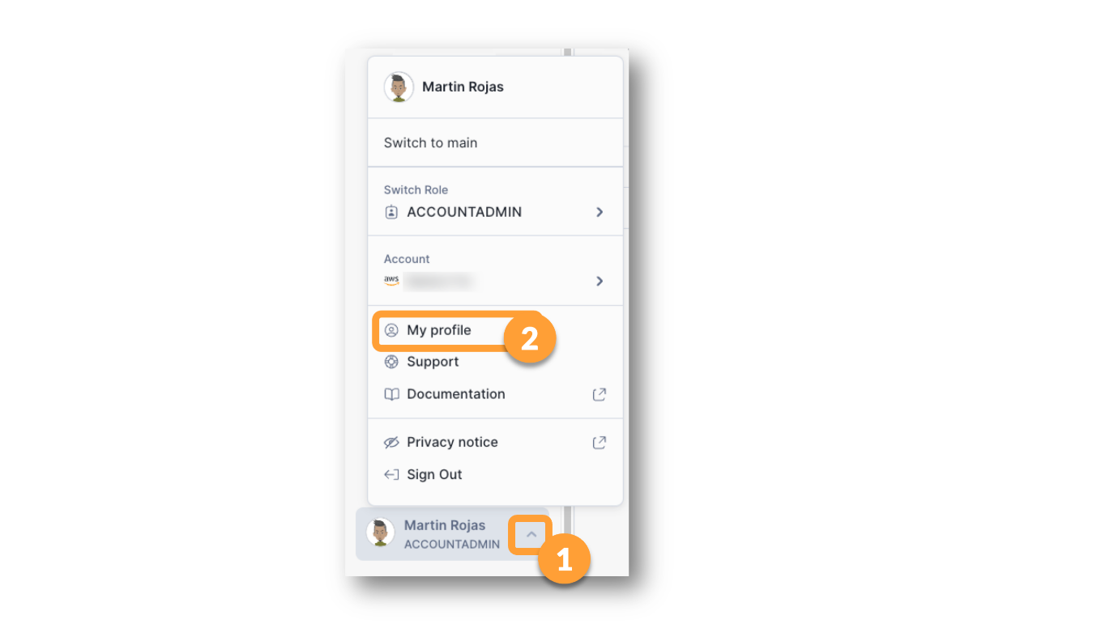

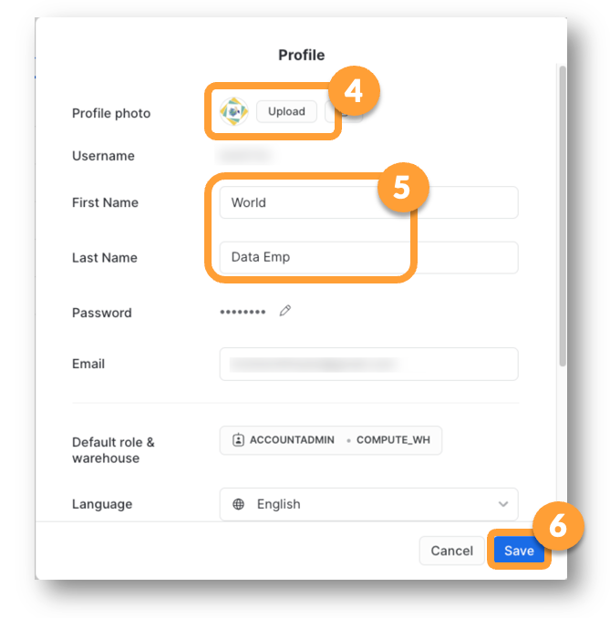

**🧰 Find More Details about account**

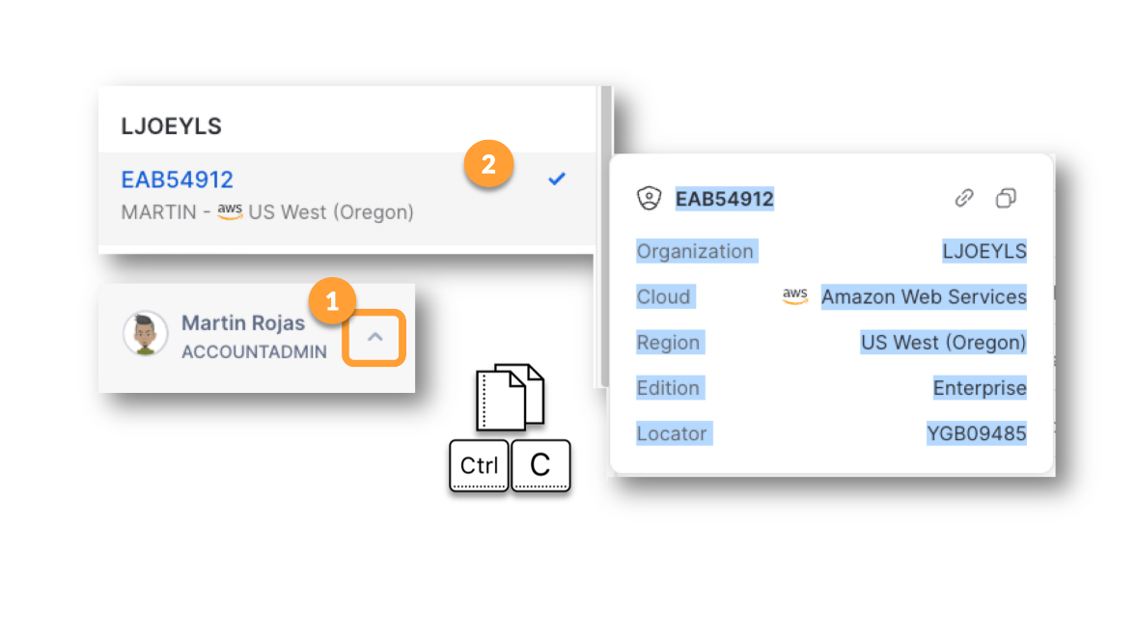

**🥋 Exploring the Data and App in Your Trial Account**

📓  In your trial account, navigate to the [Data] -> [Databases] area.

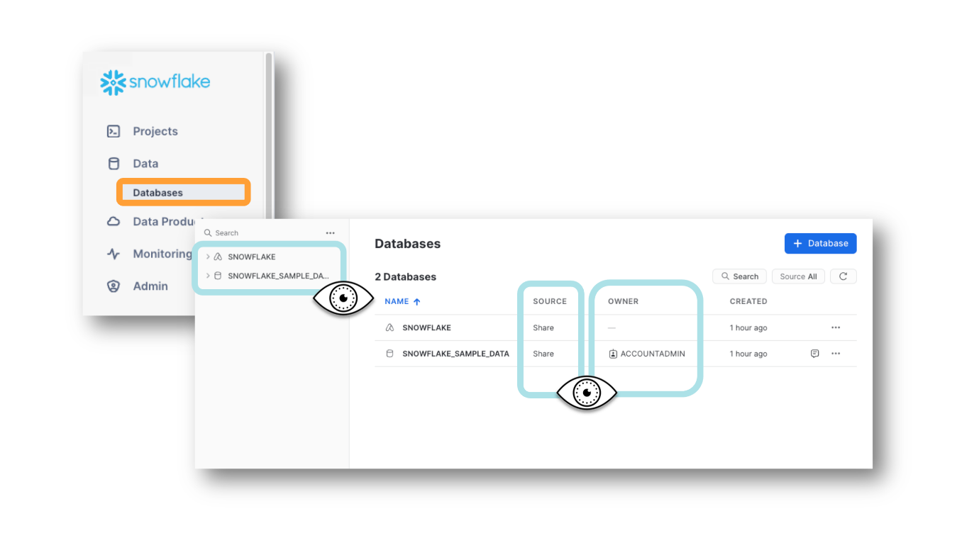

**🥋 Exploring the Source of the Databases**

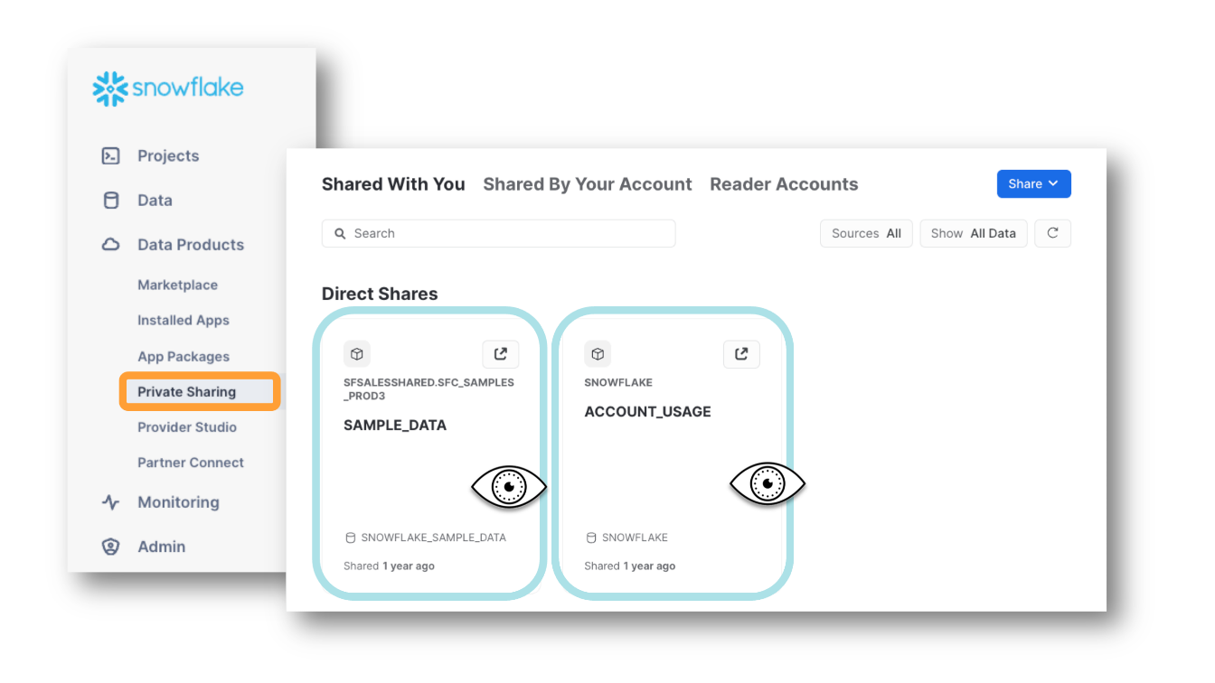

Notice that the database called SNOWFLAKE_SAMPLE_DATA is coming from an account called SFSALESSHARED (followed by a schema that will vary by region).

This account named their outbound share "SAMPLE_DATA."

It is only in *our* account that this data appears under the name**SNOWFLAKE_SAMPLE_DATA**.

**📓 The Account Usage Share**

Every Snowflake account has **THE** SNOWFLAKE database included in the account. This database sometimes has a database icon, but sometimes has an app icon.

But let's pause for a minute here. The name of the database is SNOWFLAKE?

A Snowflake database, named SNOWFLAKE. (!!!!?!?!?!?!?!?!)

When we talk about THE SNOWFLAKE database it can be confusing. After all, there are many Snowflake databases. Are we talking about **A** Snowflake database (any database in Snowflake) or **THE** Snowflake Database (the one shared with us BY Snowflake the Company, called SNOWFLAKE)?

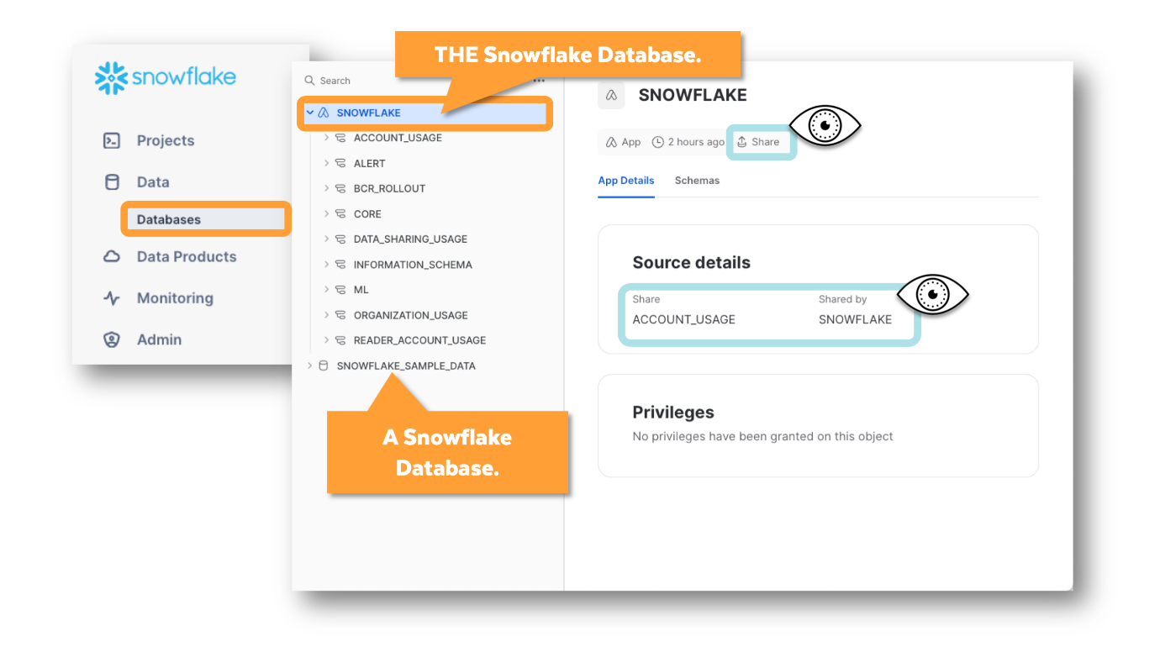 For this reason, people at Snowflake often fall into the habit of calling it "**the Account Usage Share**" -- because it's a share given to every account and behind the scenes it's based on a direct share called **ACCOUNT_USAGE**. Originally, the Account Usage Share had one schema called ACCOUNT_USAGE  and not much else. Over time, it's come to include other schemas that are intended to help customers manage and understand their billing and usage.

It is good to be aware that another name for "THE SNOWFLAKE database" is "the Account Usage Share." At one time, this question was on the SnowPro Core Certification exam.

**🥋  Grant Privileges to the Share for the SYSADMIN Role?**

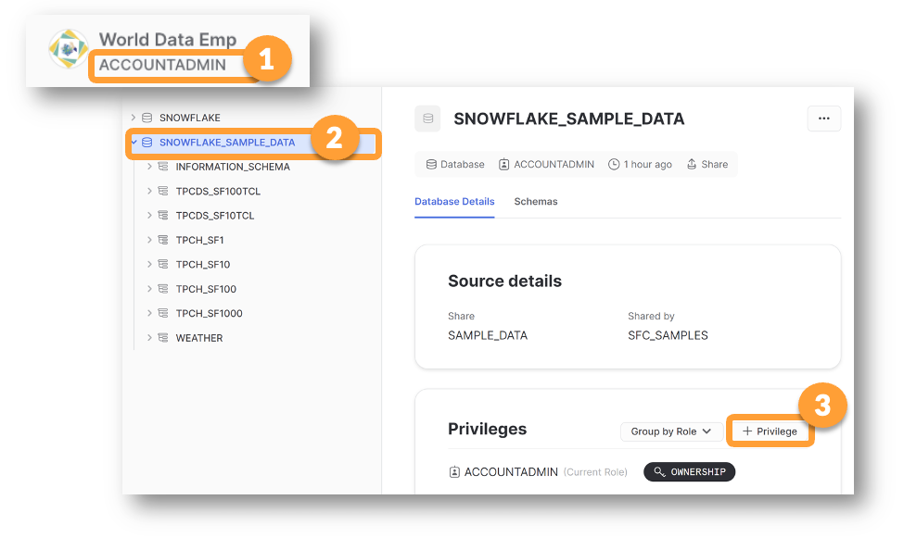 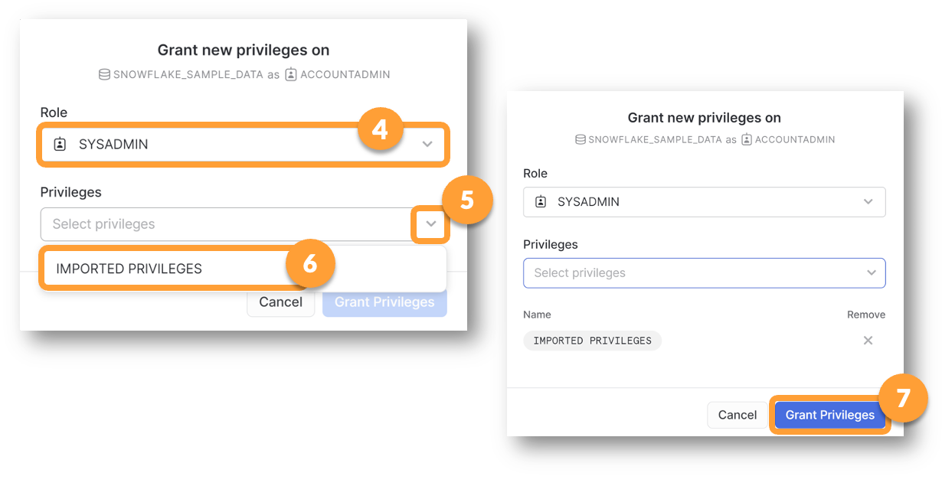 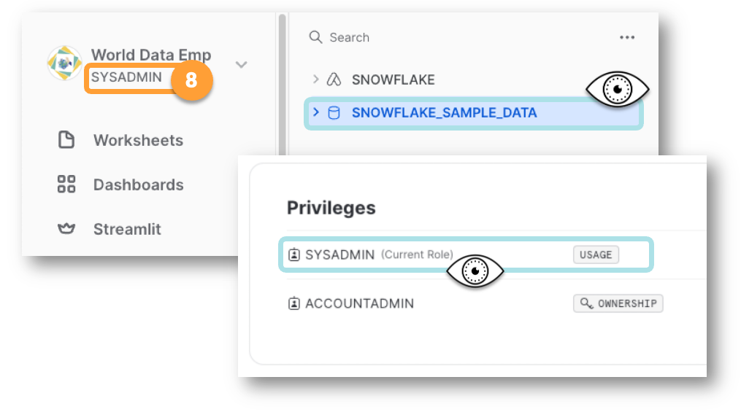

**📓 Granting The Same Rights - But Using Code**

If you wanted to use code to carry out the task above, this is what it would look like:

**grant imported privileges**  
**on database SNOWFLAKE_SAMPLE_DATA**  
**to role SYSADMIN;**

**🥋 Use Select Statements to Look at Sample Data**

**--Check the range of values in the Market Segment Column**

**SELECT DISTINCT c_mktsegment**

**FROM SNOWFLAKE_SAMPLE_DATA.TPCH_SF1.CUSTOMER;**

**--Find out which Market Segments have the most customers**

**SELECT c_mktsegment, COUNT(*)**

**FROM SNOWFLAKE_SAMPLE_DATA.TPCH_SF1.CUSTOMER**

**GROUP BY c_mktsegment**

**ORDER BY COUNT(*);**

🥋 Join and Aggregate Shared Data

**-- Nations Table**

**SELECT N_NATIONKEY, N_NAME, N_REGIONKEY**

**FROM SNOWFLAKE_SAMPLE_DATA.TPCH_SF1.NATION;**

**-- Regions Table**

**SELECT R_REGIONKEY, R_NAME**

**FROM SNOWFLAKE_SAMPLE_DATA.TPCH_SF1.REGION;**

**-- Join the Tables and Sort**

**SELECT R_NAME as Region, N_NAME as Nation**

**FROM SNOWFLAKE_SAMPLE_DATA.TPCH_SF1.NATION**

**JOIN SNOWFLAKE_SAMPLE_DATA.TPCH_SF1.REGION**

**ON N_REGIONKEY = R_REGIONKEY**

**ORDER BY R_NAME, N_NAME ASC;**

**--Group and Count Rows Per Region**

**SELECT R_NAME as Region, count(N_NAME) as NUM_COUNTRIES**

**FROM SNOWFLAKE_SAMPLE_DATA.TPCH_SF1.NATION**

**JOIN SNOWFLAKE_SAMPLE_DATA.TPCH_SF1.REGION**

**ON N_REGIONKEY = R_REGIONKEY**

**GROUP BY R_NAME;**

**🥋 Export Native and Shared Data try to save the output of shared data**

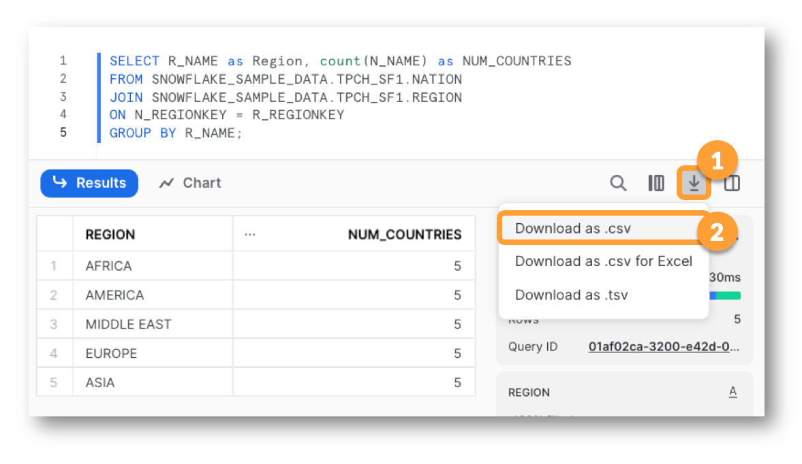

Yes, I was able to save the results to a CSV.

It might shock you that shared data can be exported. What will stop people from "pirating" shared data?

Of course there are legal restrictions on most shared data sets, but a person could probably get away with downloading shared data and uploading it to their own account as local data. Pirating data is time consuming, impractical, and inefficient.

The real value of consuming shared data is:

* Someone else will maintain it over time and keep it fresh
* Someone else will pay to store it
* You will only pay to query it

**🥋 Set Your Default Role to SYSADMIN**

Can you also set your default warehouse? If not, click Save and continue.

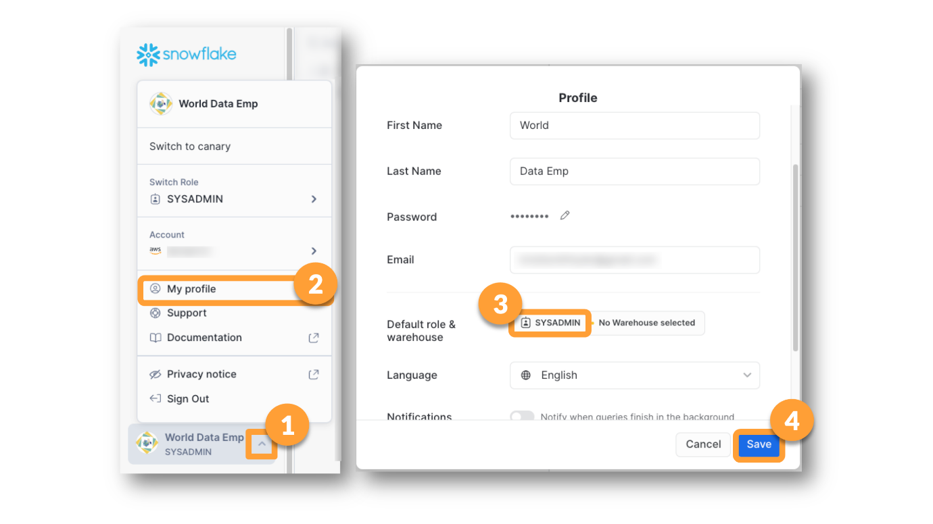

**🎯 Give SYSADMIN Access to COMPUTE_WH**

Warehouses can be costly when not carefully managed, so their use is restricted to Administrative users. Because of this, **Warehouse** functions are under the **Admin** menu.

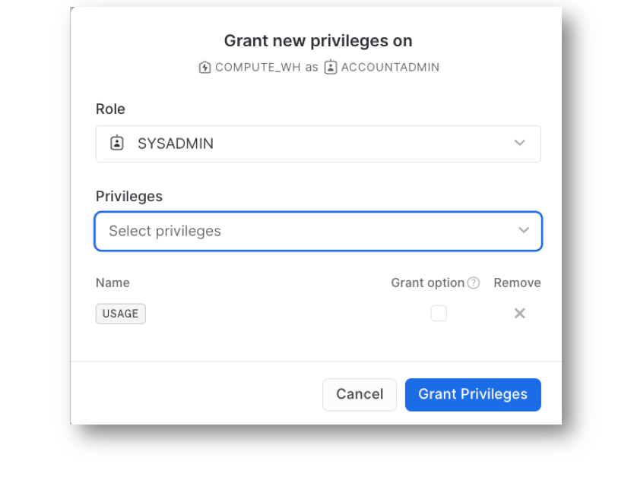

**🥋 Create a Local Database Named UTIL_DB**

**Note:** If you are using the same Trial Account for this workshop, as you used for an earlier workshop, you may not need to complete some steps.

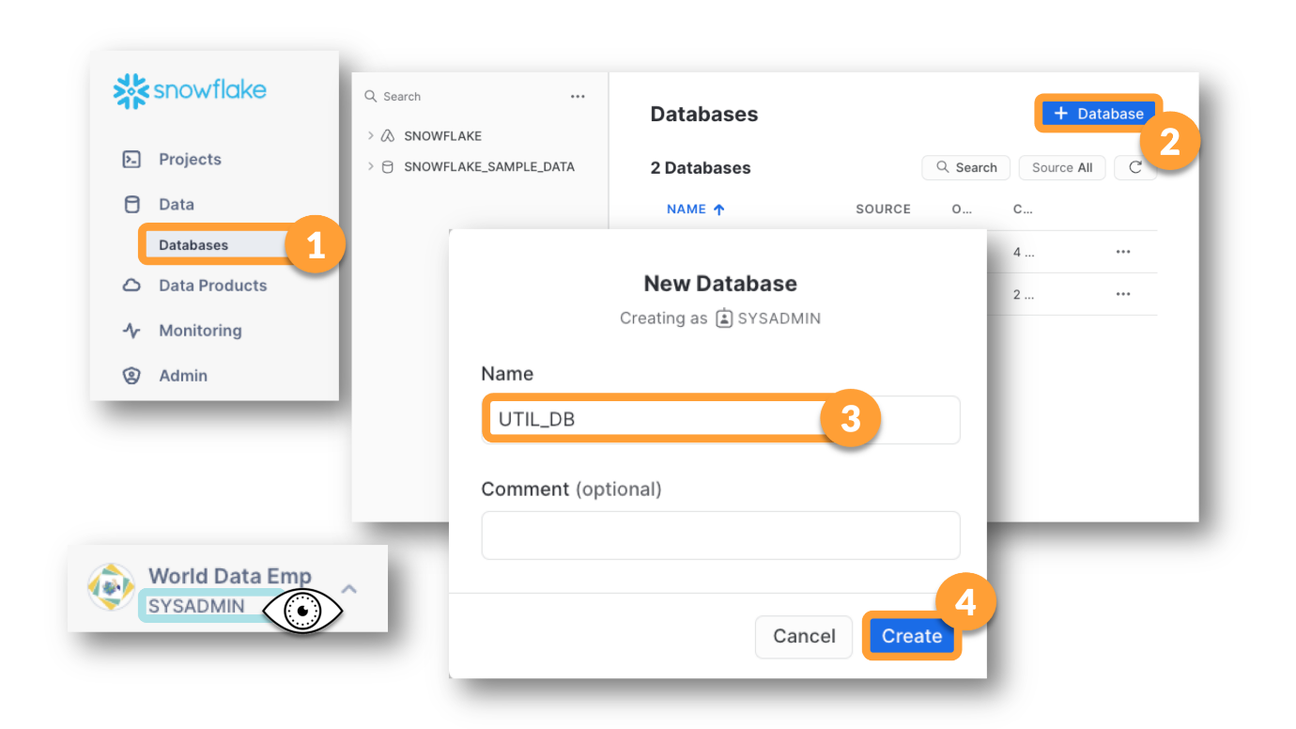

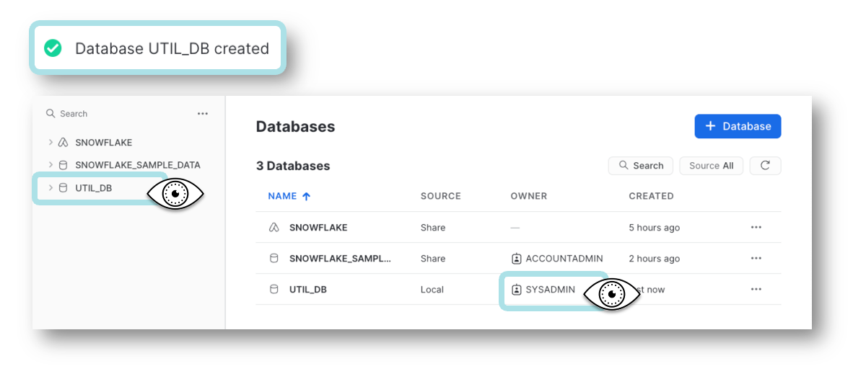

**🧰 Run the Two Dora Setup Scripts**

DORA API integration

create or replace api integration dora_api_integration

api_provider = aws_api_gateway

api_aws_role_arn = 'arn:aws:iam::321463406630:role/snowflakeLearnerAssumedRole'

enabled = true

api_allowed_prefixes = ('https://awy6hshxy4.execute-api.us-west-2.amazonaws.com/dev/edu_dora');

create or replace external function util_db.public.grader(

step varchar

, passed boolean

, actual integer

, expected integer

, description varchar)

returns variant

api_integration = dora_api_integration

context_headers = (current_timestamp, current_account, current_statement, current_account_name)

as 'https://awy6hshxy4.execute-api.us-west-2.amazonaws.com/dev/edu_dora/grader';

-- where did you put the function?

show user functions in account;

-- did you put it here?

select *

from util_db.information_schema.functions

where function_name = 'GRADER'

and function_catalog = 'UTIL_DB'

and function_owner = 'ACCOUNTADMIN';

You cannot grant access to a function using a button. You have to use code. Edit the code below to grant usage to the function to the SYSADMIN role.

grant usage

on function UTIL_DB.PUBLIC.GRADER(VARCHAR, BOOLEAN, NUMBER, NUMBER, VARCHAR)

to <role>;

**🥋 Is DORA Working? Run This to Find Out!**

select GRADER(step,(actual = expected), actual, expected, description) as graded_results from (

SELECT 'DORA_IS_WORKING' as step

,(select 223 ) as actual

,223 as expected

,'Dora is working!' as description

);

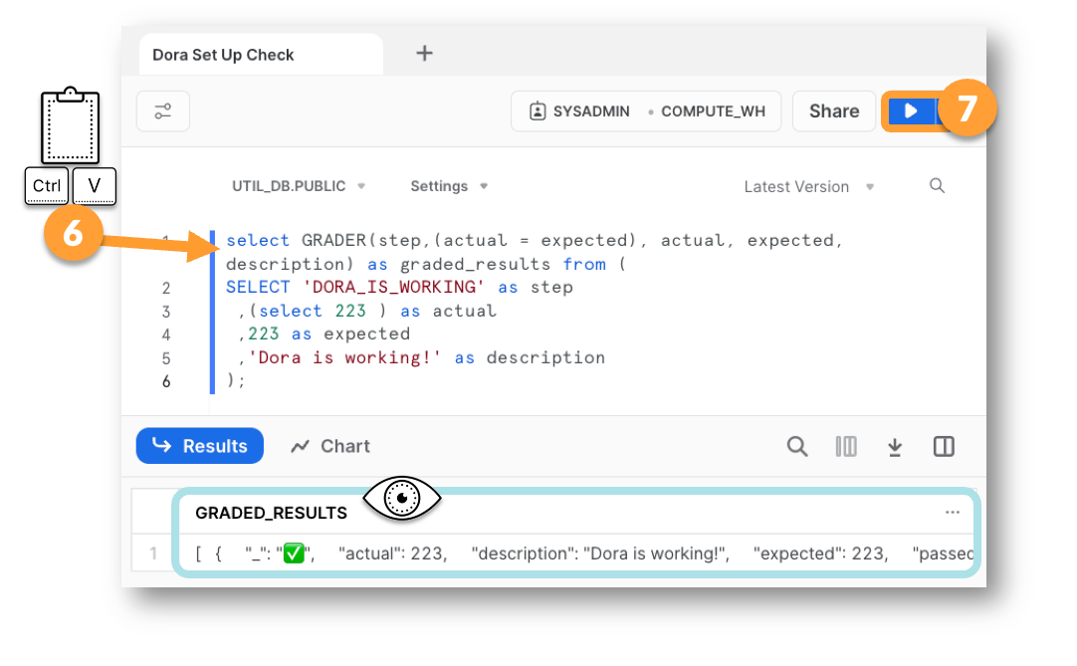

**🥋 Set Up a New Database Called INTL_DB**

use role SYSADMIN;  
create database INTL_DB;  
use schema INTL_DB.PUBLIC;

**🥋 Create a Warehouse for Loading INTL_DB**

use role SYSADMIN;  
  
create warehouse INTL_WH

with   
warehouse_size = 'XSMALL'

warehouse_type = 'STANDARD'

auto_suspend = 600 --600 seconds/10 mins

auto_resume = TRUE;

use warehouse INTL_WH;

**🥋 Create Table INT_STDS_ORG_3166**

create or replace table intl_db.public.INT_STDS_ORG_3166

(iso_country_name varchar(100),

country_name_official varchar(200),

sovreignty varchar(40),

alpha_code_2digit varchar(2),

alpha_code_3digit varchar(3),

numeric_country_code integer,

iso_subdivision varchar(15),

internet_domain_code varchar(10)

);

**🥋 Create a File Format to Load the Table**

create or replace file format util_db.public.PIPE_DBLQUOTE_HEADER_CR

type = 'CSV' --use CSV for any flat file

compression = 'AUTO'

field_delimiter = '|' --pipe or vertical bar

record_delimiter = '\r' --carriage return

skip_header = 1 --1 header row

field_optionally_enclosed_by = '\042' --double quotes

trim_space = FALSE;

**🎯 Load the ISO Table Using Your File Format**

Data files for this course are available from an s3 bucket named **uni-cmcw.**  There is only one s3 bucket in the whole world with that name and it belongs to this course.

Check to see if you have a stage in your account already

**show stages in account;**

You can create a new stage using the wizard, or you can use the code below.

**create stage util_db.public.aws_s3_bucket url = 's3://uni-cmcw';**

The file you will be loading is called **iso_countries_utf8_pipe.csv**. BUT remember that AWS is very case sensitive, so be sure to look up the EXACT spelling of the file name for your COPY INTO statement. Remember that you can view the files in the stage either by navigating to the stage and enabling the directory table, or by running a list command like this:

**list @util_db.public.aws_s3_bucket;**

copy into my_table_name

from @util_db.public.like_a_window_into_an_s3_bucket

files = ( 'IF_I_HAD_A_FILE_LIKE_THIS.txt')

file_format = ( format_name='EXAMPLE_FILEFORMAT' );

ALTER DATABASE INTRL_DB  
RENAME TO INTL_DB;

ALTER TABLE INTRL_DB.PUBLIC.INT_3166

RENAME TO INTL_DB.PUBLIC.INT_STDS_ORG_3166;

--DO NOT EDIT BELOW THIS LINE

select grader(step, (actual = expected), actual, expected, description) as graded_results from(

SELECT 'CMCW01' as step

,( select count(*)

from snowflake.account_usage.databases

where database_name = 'INTL_DB'

and deleted is null) as actual

, 1 as expected

,'Created INTL_DB' as description

);

**📓  How to Test Whether You Set Up Your Table in the Right Place with the Right Name**

select count(*) as OBJECTS_FOUND  
from INTL_DB.INFORMATION_SCHEMA.TABLES   
where table_schema='PUBLIC'  
and table_name= 'INT_STDS_ORG_3166';

**📓  How to Test That You Loaded the Expected Number of Rows**

select **row_count**  
from INTL_DB.INFORMATION_SCHEMA.TABLES   
where table_schema='PUBLIC'  
and table_name= 'INT_STDS_ORG_3166';

--DO NOT EDIT BELOW THIS LINE

select grader(step, (actual = expected), actual, expected, description) as graded_results from(

SELECT 'CMCW02' as step  
 ,( select count(*)   
 from INTL_DB.INFORMATION_SCHEMA.TABLES   
 where table_schema = 'PUBLIC'   
 and table_name = 'INT_STDS_ORG_3166') as actual

, 1 as expected

,'ISO table created' as description

);

-- DO NOT EDIT BELOW THIS LINE

select grader(step, (actual = expected), actual, expected, description) as graded_results from(

SELECT 'CMCW03' as step   
 ,(select row_count

from INTL_DB.INFORMATION_SCHEMA.TABLES

where table_name = 'INT_STDS_ORG_3166') as actual

, 249 as expected

,'ISO Table Loaded' as description

);

**🥋 Join Local Data with Shared Data**

select

iso_country_name

,country_name_official,alpha_code_2digit

,r_name as region

from INTL_DB.PUBLIC.INT_STDS_ORG_3166 i

left join SNOWFLAKE_SAMPLE_DATA.TPCH_SF1.NATION n

on upper(i.iso_country_name)= n.n_name

left join SNOWFLAKE_SAMPLE_DATA.TPCH_SF1.REGION r

on n_regionkey = r_regionkey;

**🥋 Convert the Select Statement into a View**

create view intl_db.public.NATIONS_SAMPLE_PLUS_ISO   
( iso_country_name  
 ,country_name_official  
 ,alpha_code_2digit  
 ,region) AS  
 *<put select statement here>*  
;

create view intl_db.public.NATIONS_SAMPLE_PLUS_ISO

( iso_country_name

,country_name_official

,alpha_code_2digit

,region) AS

select

iso_country_name

,country_name_official,alpha_code_2digit

,r_name as region

from INTL_DB.PUBLIC.INT_STDS_ORG_3166 i

left join SNOWFLAKE_SAMPLE_DATA.TPCH_SF1.NATION n

on upper(i.iso_country_name)= n.n_name

left join SNOWFLAKE_SAMPLE_DATA.TPCH_SF1.REGION r

on n_regionkey = r_regionkey

;

select *  
from intl_db.public.NATIONS_SAMPLE_PLUS_ISO;

--DO NOT EDIT BELOW THIS LINE

select grader(step, (actual = expected), actual, expected, description) as graded_results from(

SELECT 'CMCW04' as step  
 ,( select count(*)

from INTL_DB.PUBLIC.NATIONS_SAMPLE_PLUS_ISO) as actual

, 249 as expected

,'Nations Sample Plus Iso' as description

);

create file format util_db.public.CSV_COMMA_LF_HEADER  
 type = 'CSV'

field_delimiter = ','

record_delimiter = '\n' -- the n represents a Line Feed character

skip_header = 1   
;

create table intl_db.public.COUNTRY_CODE_TO_CURRENCY_CODE   
 (

country_char_code varchar(3),

country_numeric_code integer,

country_name varchar(100),

currency_name varchar(100),

currency_char_code varchar(3),

currency_numeric_code integer

)

comment = 'Mapping table currencies to countries';

copy into intl_db.public.COUNTRY_CODE_TO_CURRENCY_CODE

from @util_db.public.aws_s3_bucket

files = ('country_code_to_currency_code.csv')

file_format = ( format_name=util_db.public.CSV_COMMA_LF_HEADER);

--DO NOT EDIT BELOW THIS LINE

select grader(step, (actual = expected), actual, expected, description) as graded_results from(

SELECT 'CMCW05' as step  
 ,(select row_count

from INTL_DB.INFORMATION_SCHEMA.TABLES

where table_schema = 'PUBLIC'

and table_name = 'COUNTRY_CODE_TO_CURRENCY_CODE') as actual

, 265 as expected

,'CCTCC Table Loaded' as description

);

--DO NOT EDIT BELOW THIS LINE

select grader(step, (actual = expected), actual, expected, description) as graded_results from(

SELECT 'CMCW06' as step  
 ,(select row_count

from INTL_DB.INFORMATION_SCHEMA.TABLES

where table_schema = 'PUBLIC'

and table_name = 'CURRENCIES') as actual

, 151 as expected

,'Currencies table loaded' as description

);

create view intl_db.public.simple_CURRENCy

(CTY_CODE, CUR_CODE)

as

select country_char_code, currency_char_code from intl_db.public.COUNTRY_CODE_TO_CURRENCY_CODE;

--DO NOT EDIT BELOW THIS LINE

select grader(step, (actual = expected), actual, expected, description) as graded_results from(

SELECT 'CMCW07' as step   
,( select count(*)

from INTL_DB.PUBLIC.SIMPLE_CURRENCY ) as actual

, 265 as expected

,'Simple Currency Looks Good' as description

);

To check the Credit usage

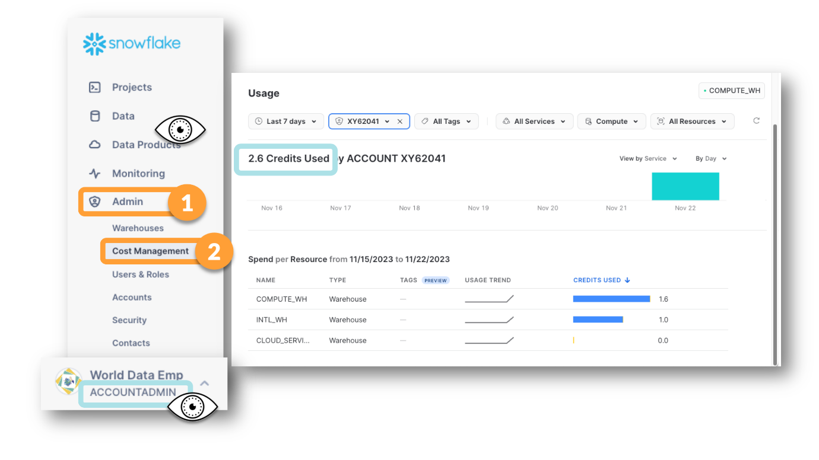

**🥋 Create an Azure Snowflake Account for ACME**

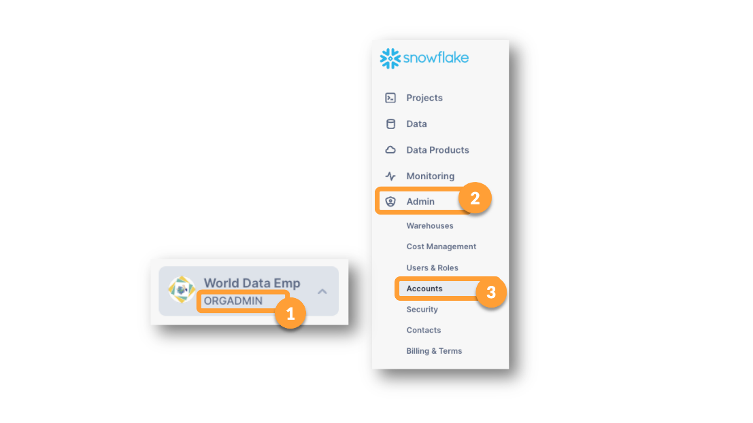

If the ORGADMIN Role does not appear on the list of roles available for you to choose from, go to**ADMIN > Users & Roles**. Find**your USER** login, click on the row that represents your USER. Scroll to the bottom of the page where it says **Granted Roles**.  Click **Grant Role** and choose **ORGADMIN**. Once you have the role, you should be able to set your current role to it.

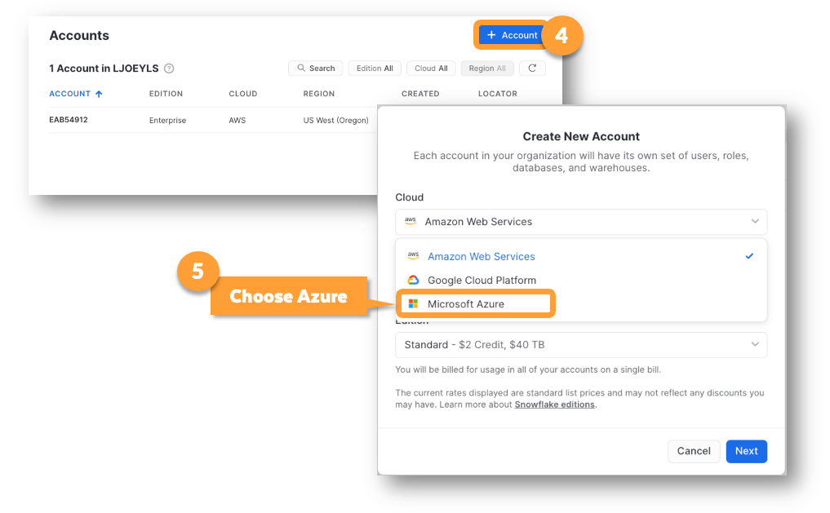

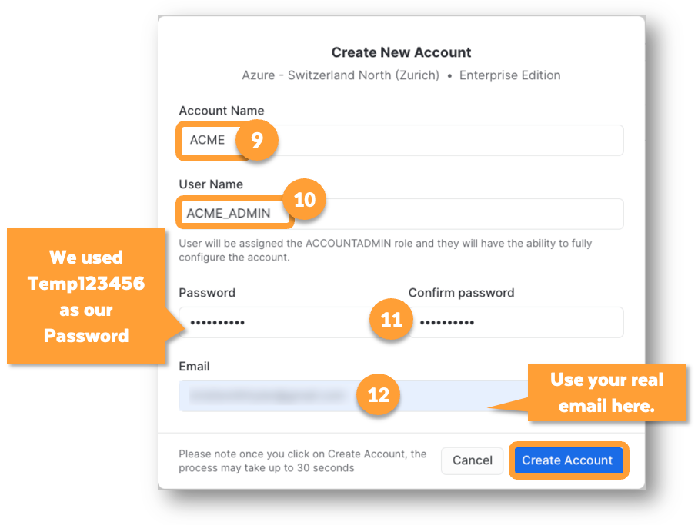

**🥋 Martín Sets Up World Data Emporium as a Listing Provider**

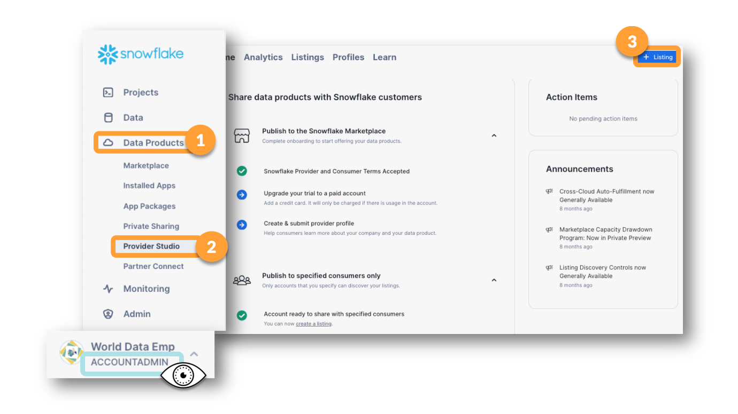 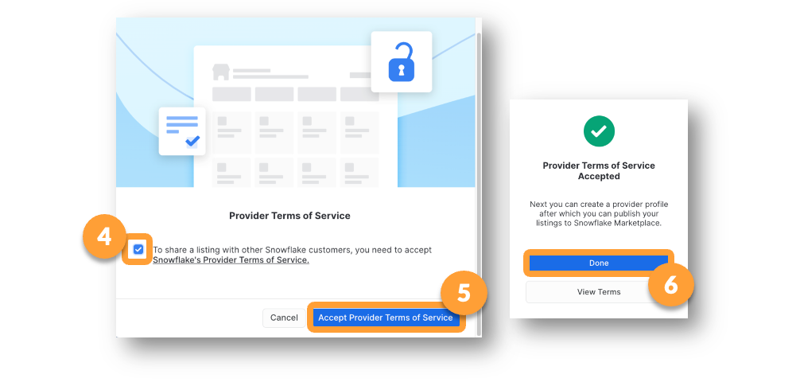

**🥋 Martín Creates a Listing**

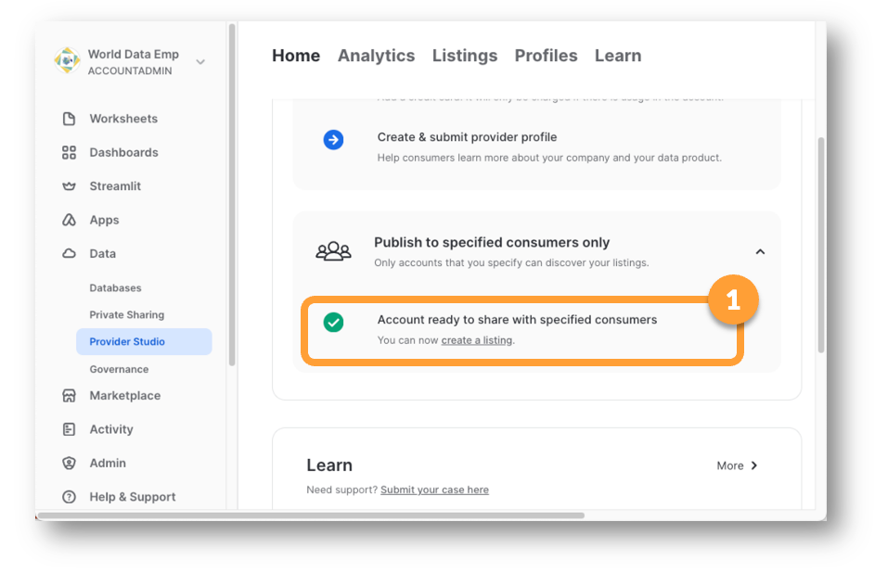 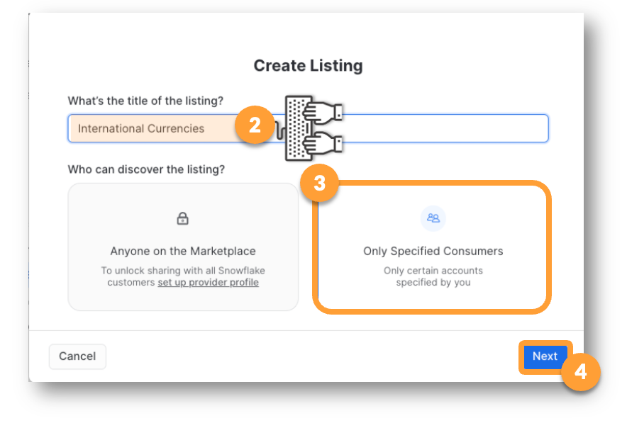 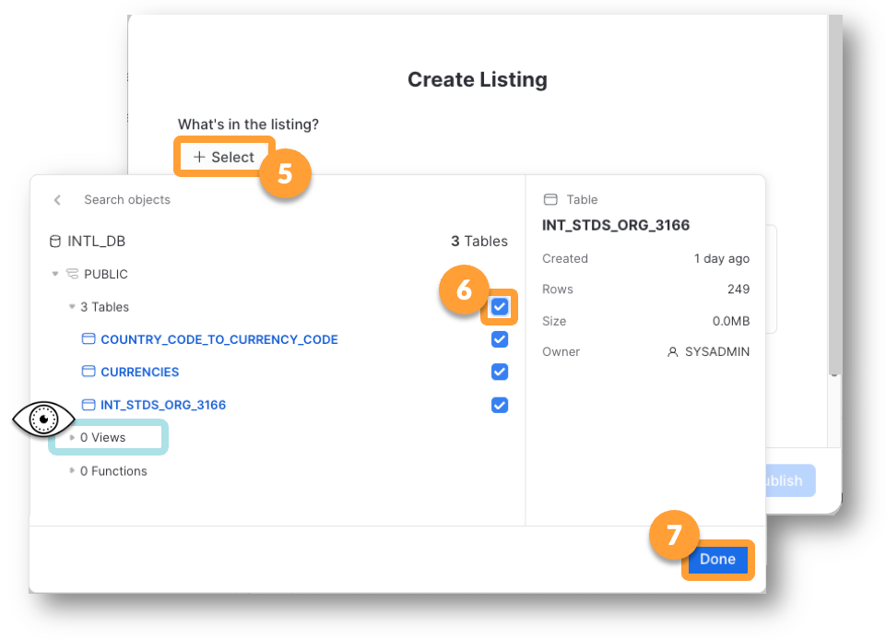 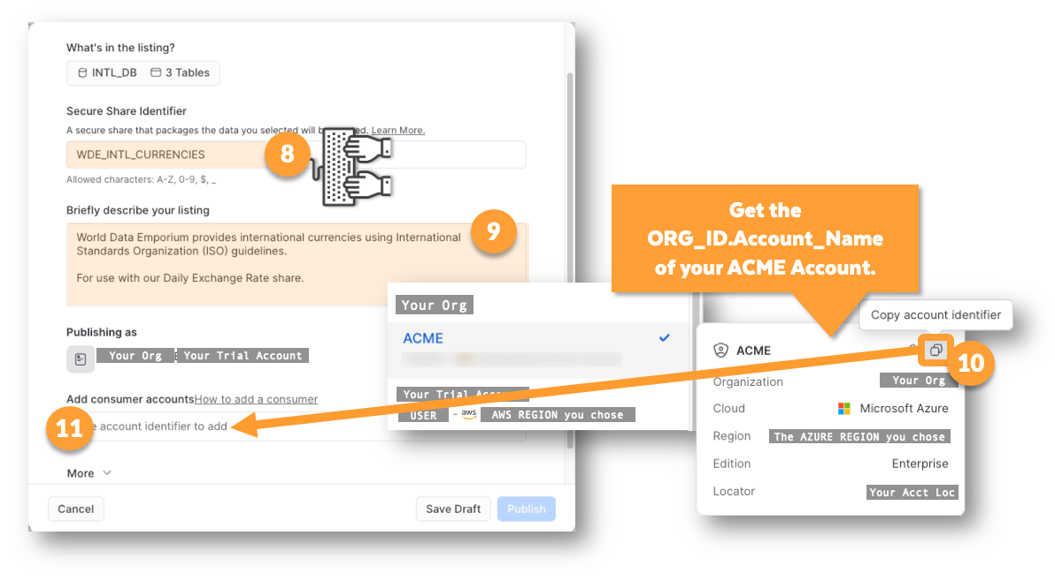

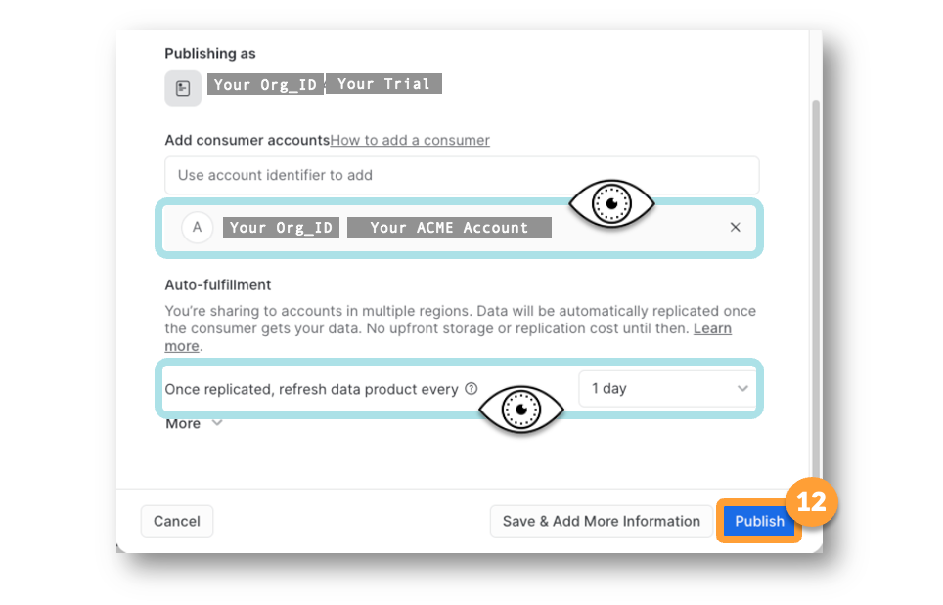

**🥋 "Get" the WDE Listing from ACME account with whom data is shared**

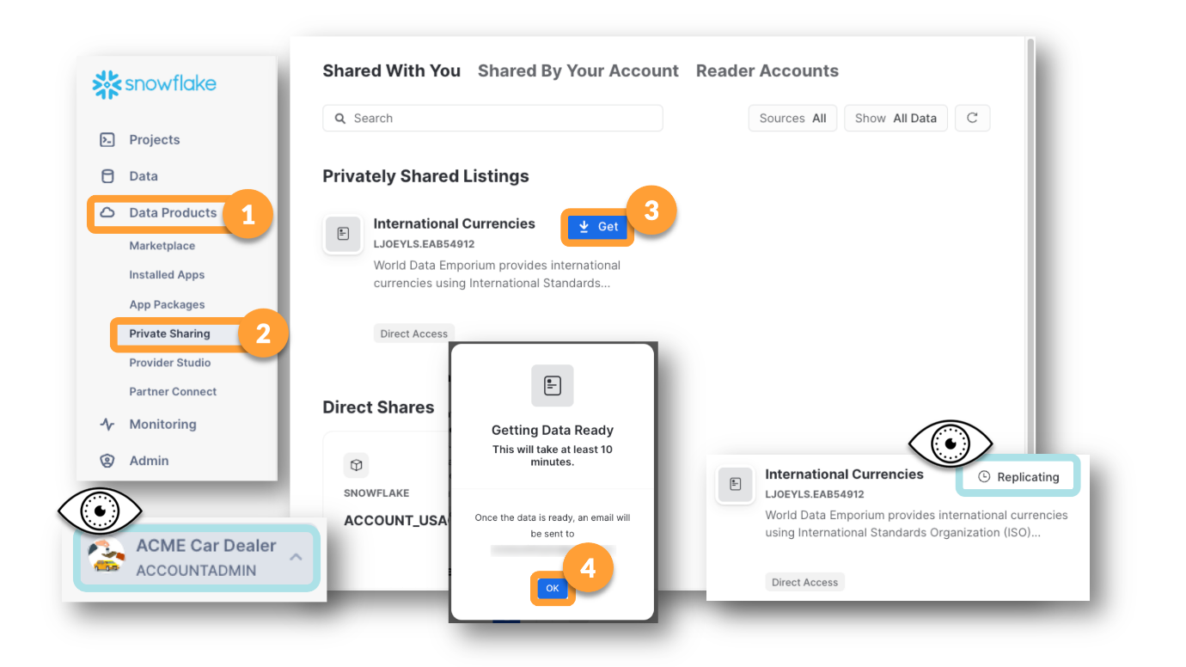

**📓 How Sharing Will Work**

If we look at the WDE Account (your original trial account) we see that a new database with an odd name has been created.

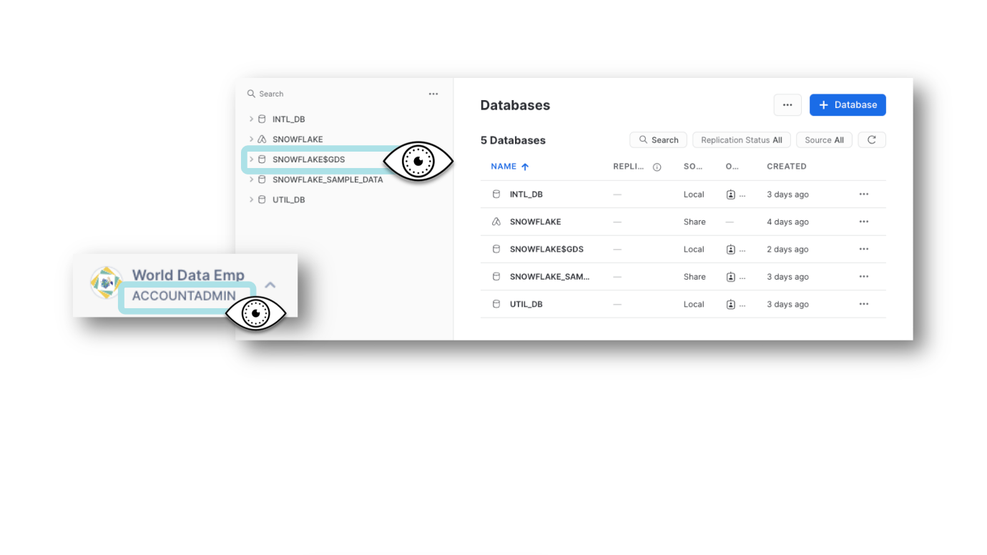

**📓 What is a Listing?**

A listing is a vehicle for sharing. As we've seen, we were able to create a data share named WDE_INTL_CURRENCIES and enclose it in a listing named "International Currencies."

A listing not only allows for a nicer name, you can also add information into the listing that will make it much easier for consumers to use your data. One thing that might make the data easier to use would be adding a Data Dictionary and sample quries.

**🥋 View the Listing in the ACME Account**

Now that the listing has had some time to replicate,

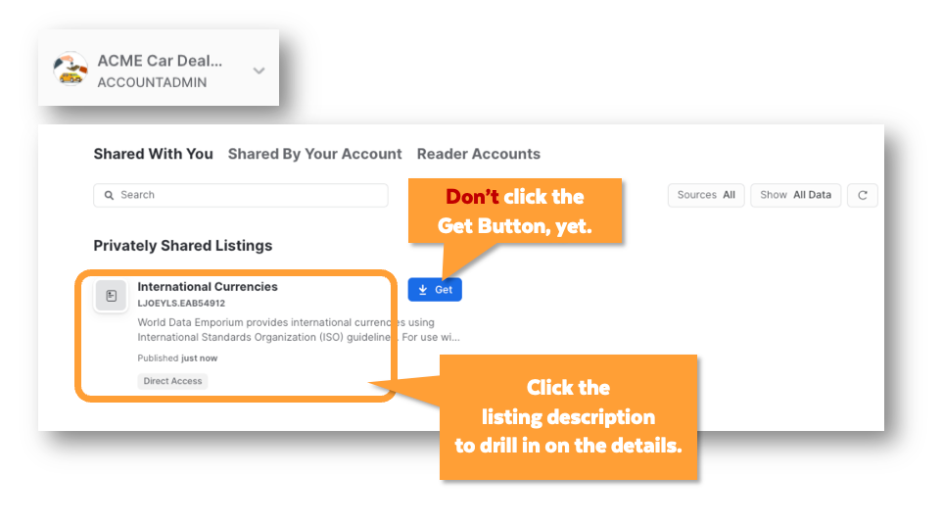 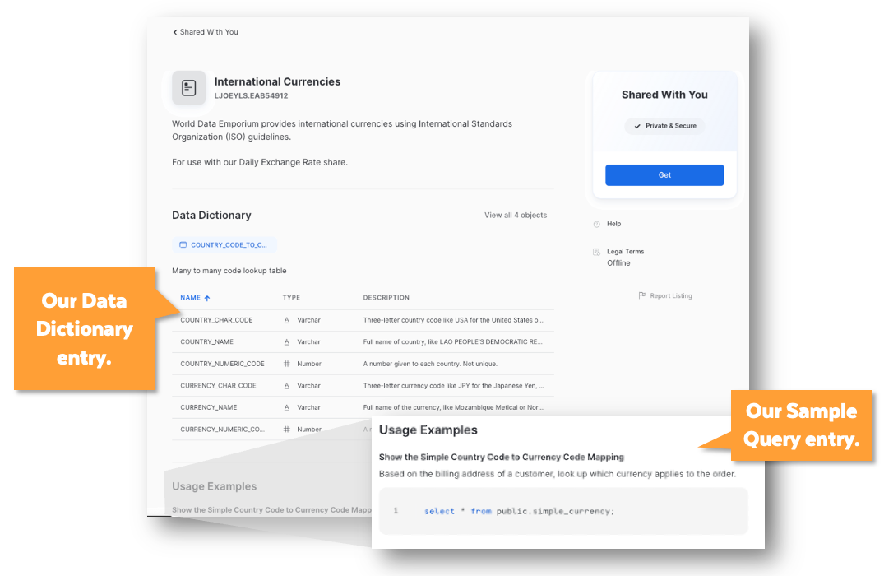

**🎯 Get the Listing for the ACME Account**

If the listing now shows a blue Get button, go ahead and "get" the listing. If you need to change roles to get it, change roles.

Be sure to **grant privileges to SYSADMIN.**

When you click the Query Data button, Snowflake will create a worksheet, fill it with your Sample Queries and open the worksheet for you (pretty cool).

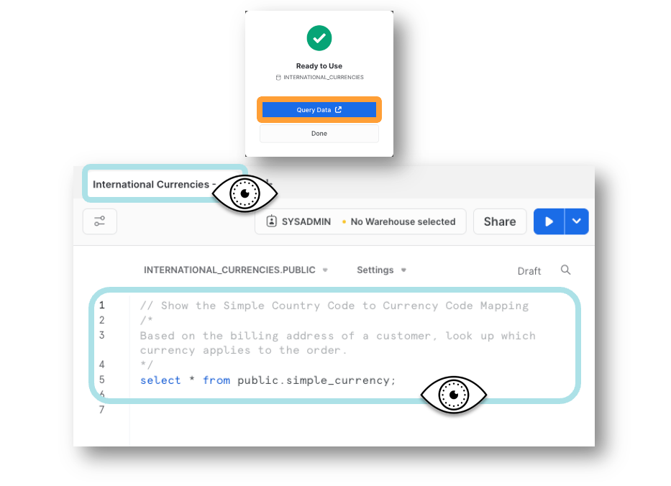

You can also navigate away from the Worksheets and find the new database in the picker on the Home page.

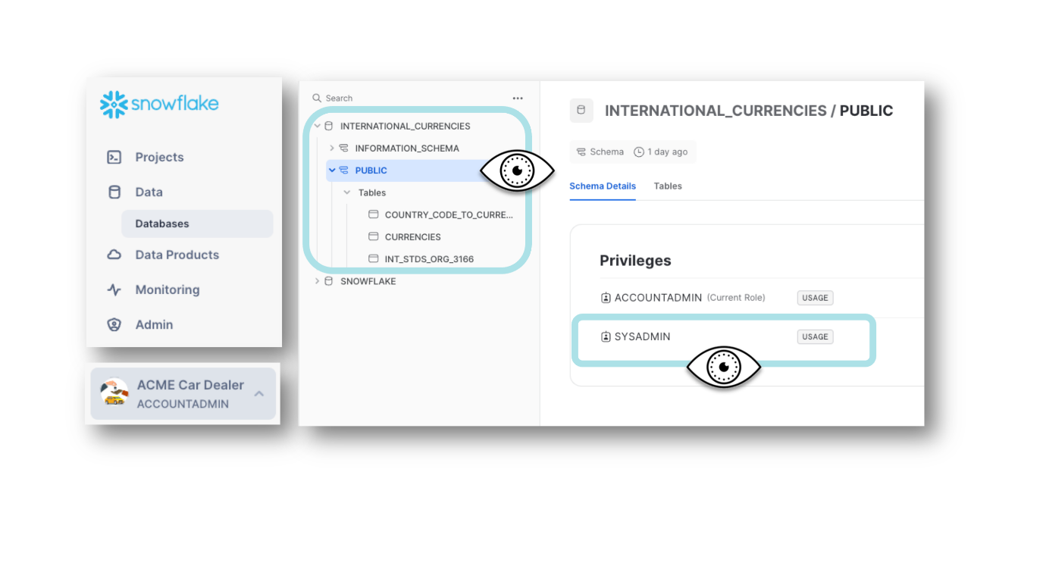

**🥋 Convert "Regular" Views to Secure Views**

Views can be shared only when they are secure

alter view intl_db.public.NATIONS_SAMPLE_PLUS_ISO

set secure;

alter view intl_db.public.SIMPLE_CURRENCY

set secure;

**🥋 Add the Newly created Secure Views to Your Outbound Share**

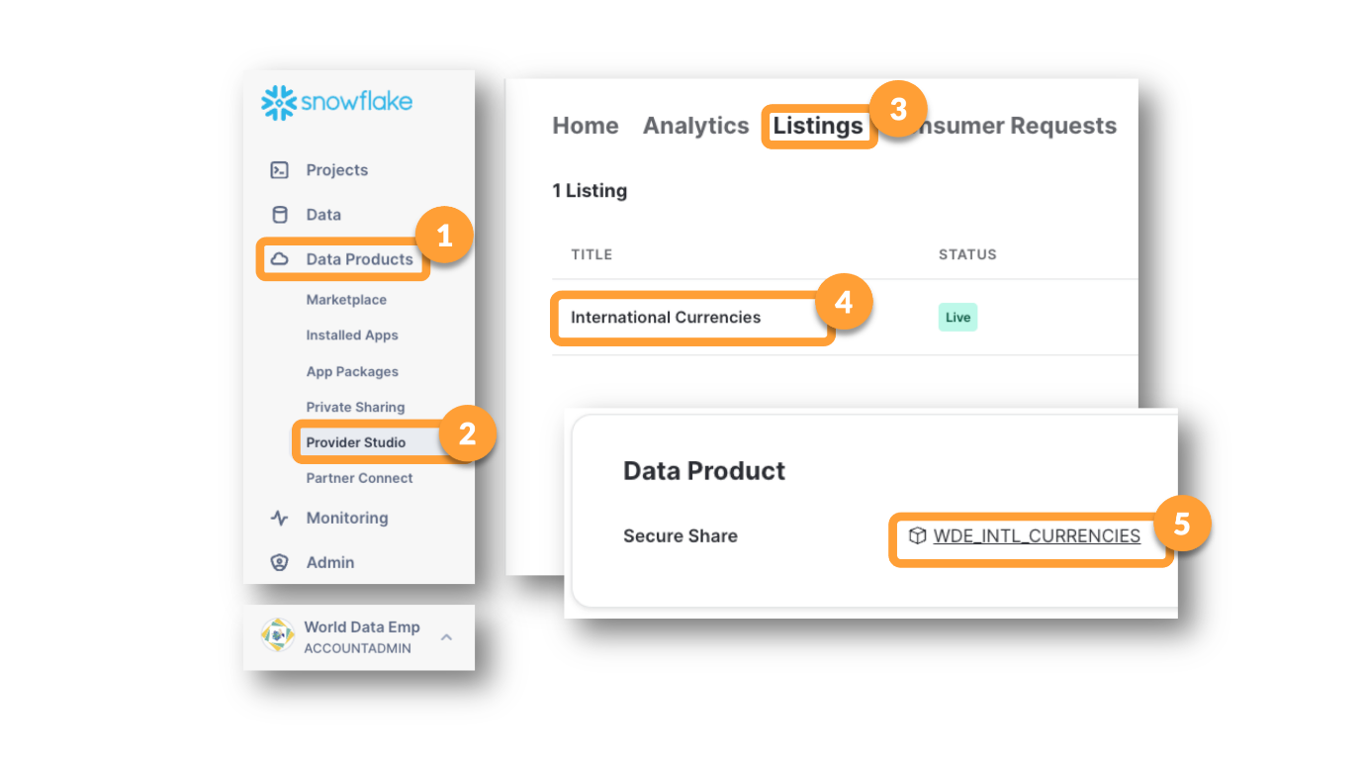

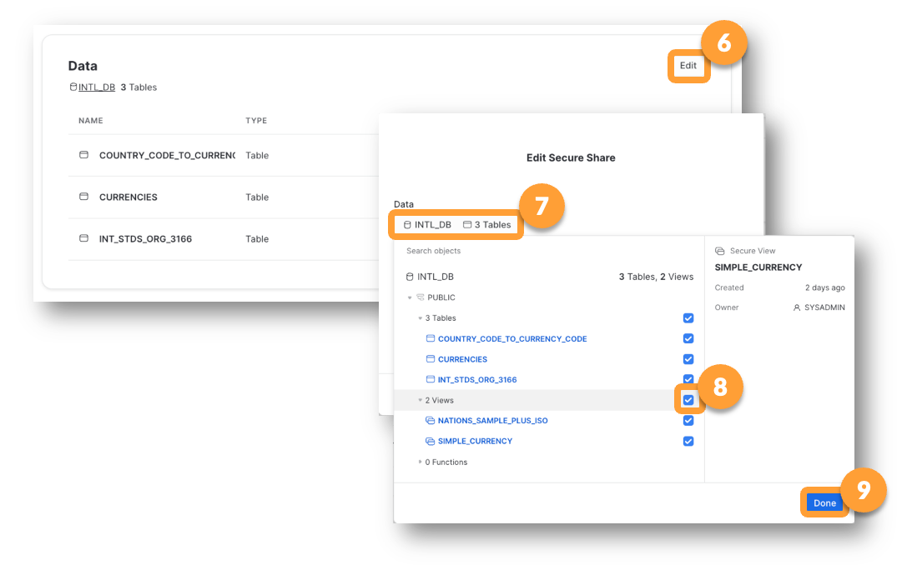

Why couldn't the view that includes the NATIONS table be added to the share?

Because you can't share a share. Because the NATIONS table comes from an Inbound Share (SNOWFLAKE_SAMPLE_DATA)

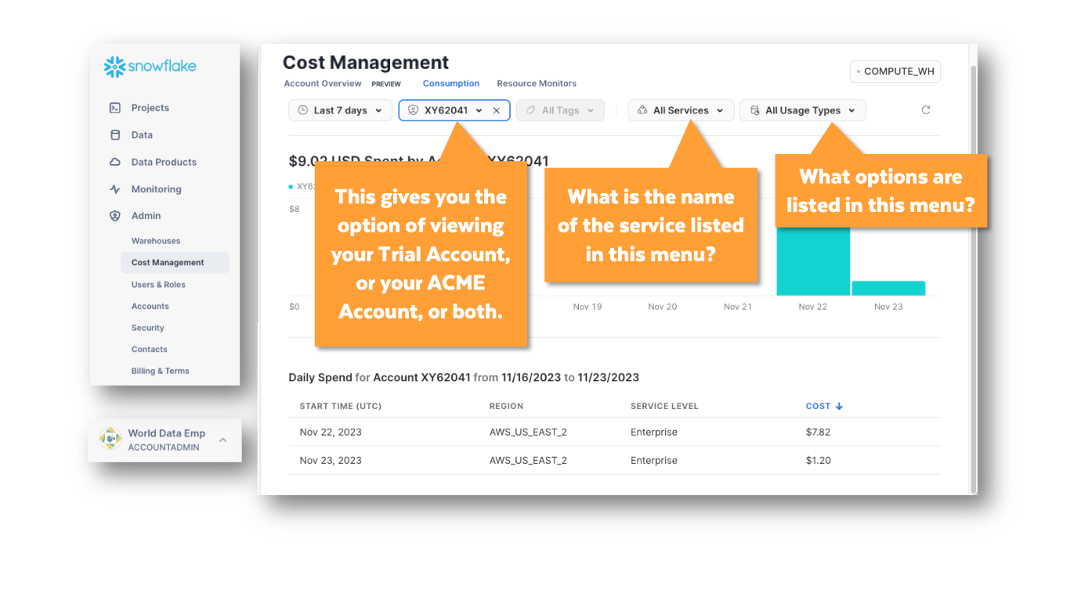

The menu that starts out saying [All Usage Types] can cause other menu options to appear after it depending on which Usage Type you select.

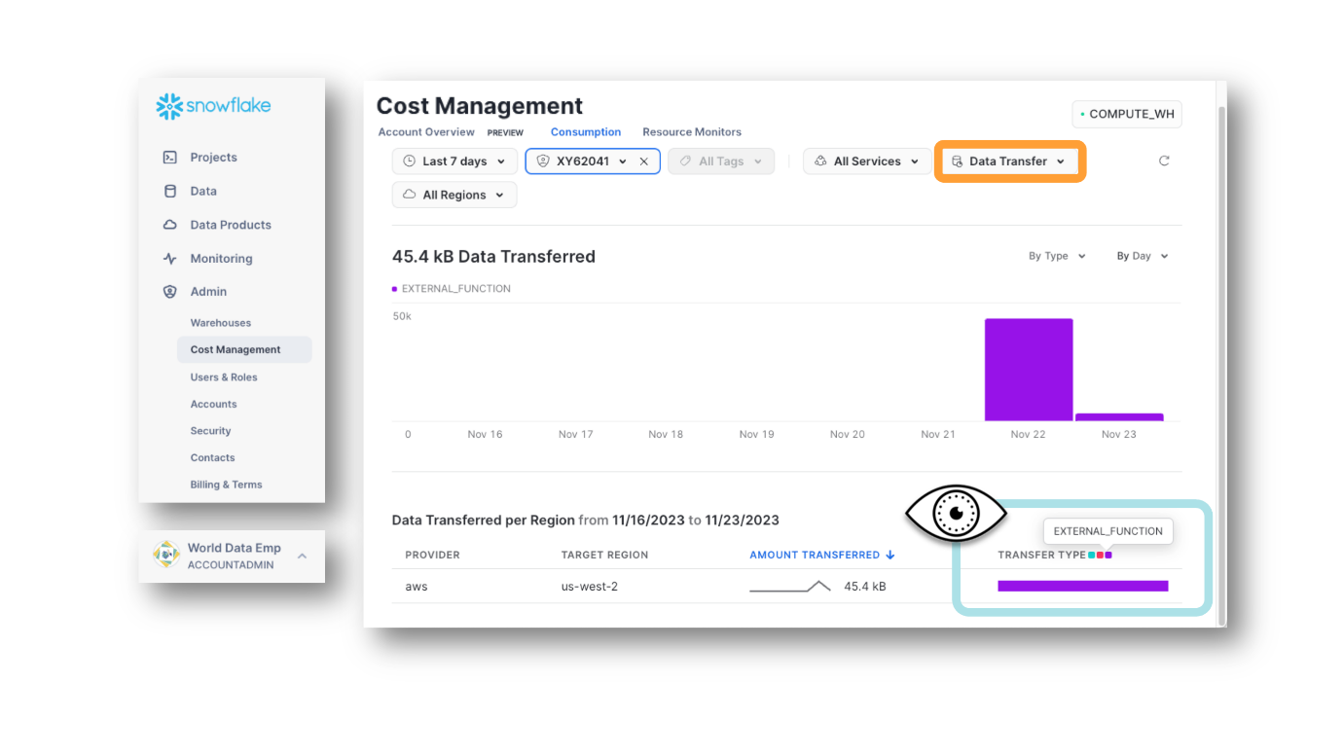

Three types of Data transfer costs are

COPY (COPY INTO Statements) - GREEN

REPLICATION (to other clouds and/or regions) – RED

EXTERNAL FUNCTIONS (Like DORA GRADER) - PURPLE

**🥋 View the ACCOUNTS View Data**

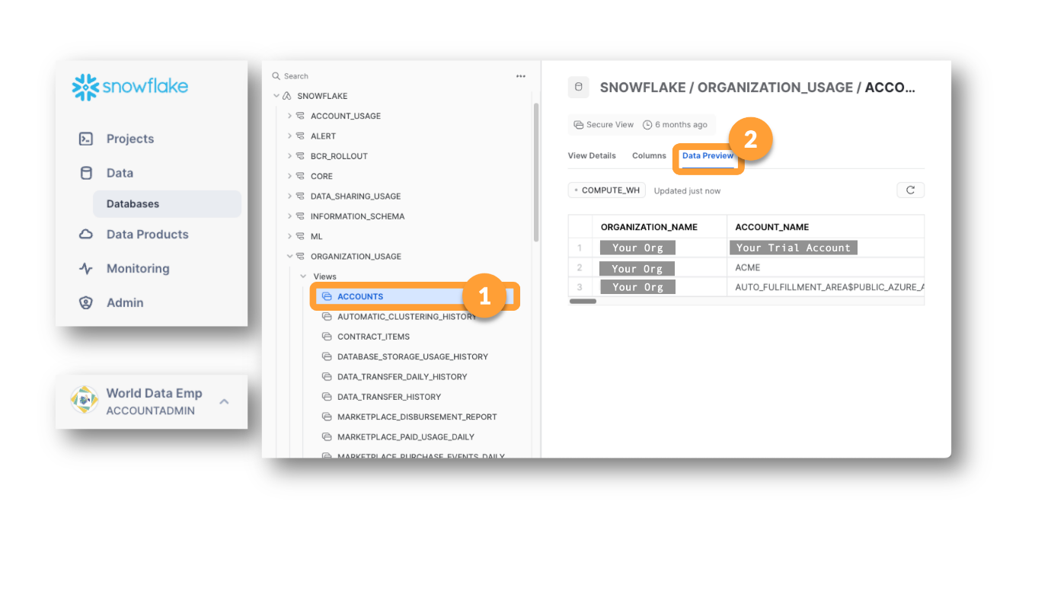

Note that Snowflake seems to have created a secret account in our Organization to help it manage the replication we are doing to send our data from our AWS Trial Account to our Azure ACME Account.

**🥋 Set Up A Resource Monitor to Safeguard Spending on Your Snowflake Trial**

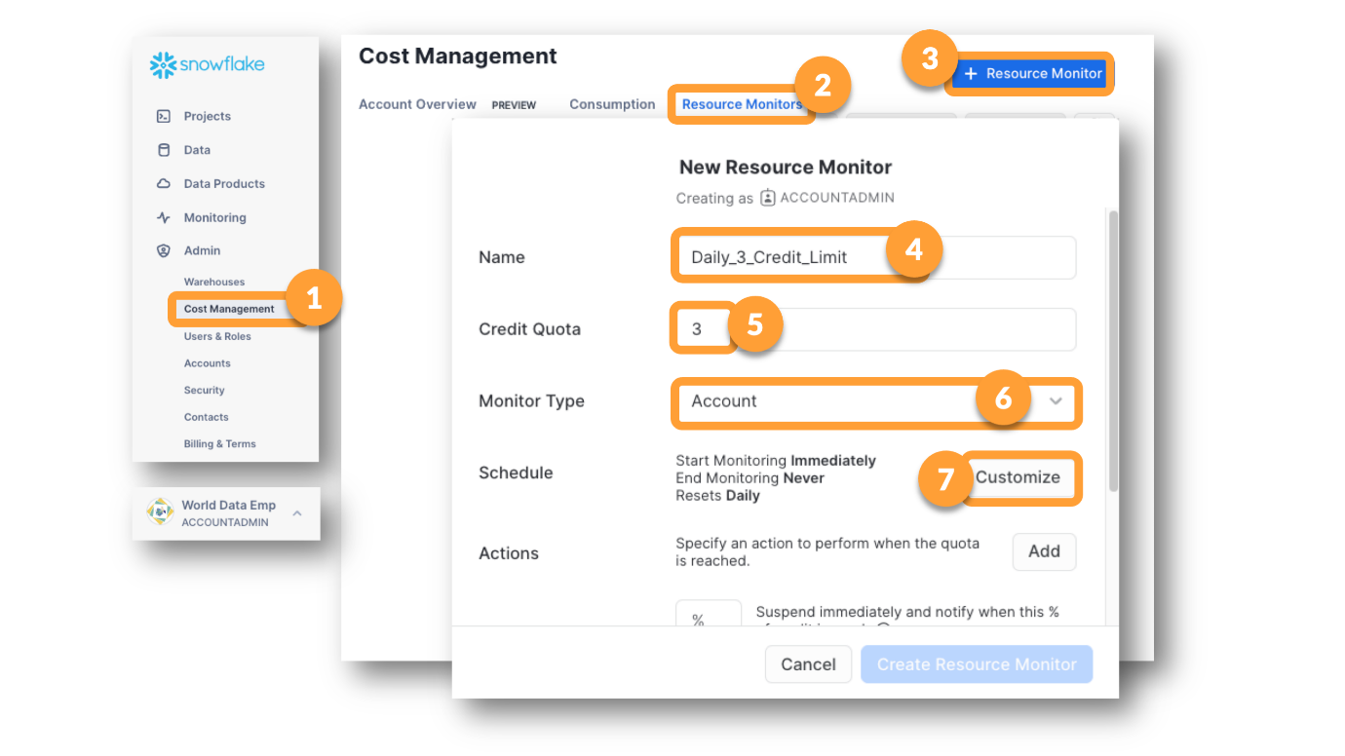 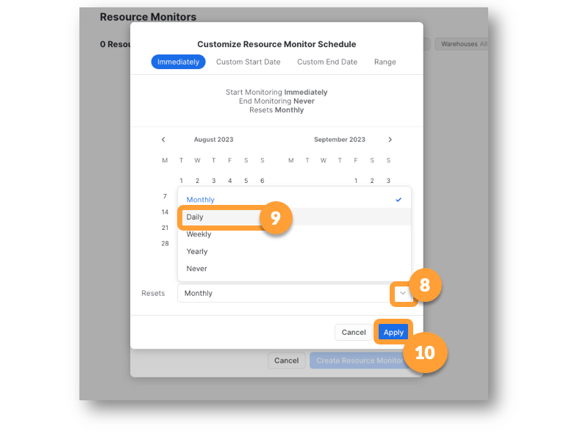 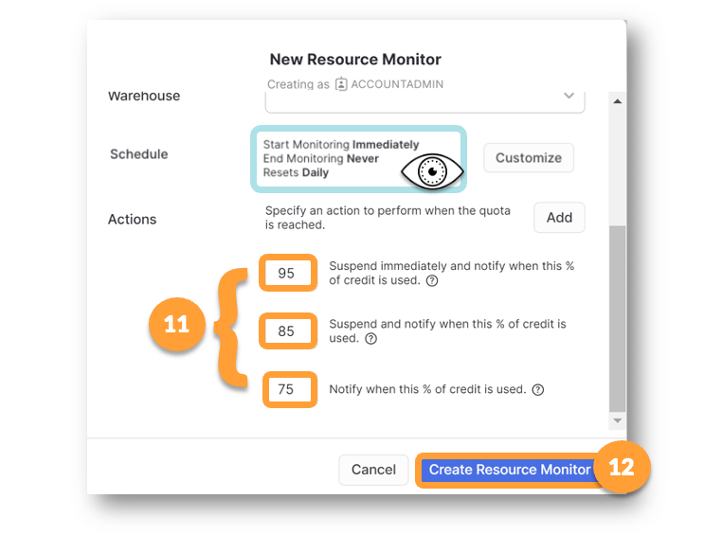 **NOTE:** Just because the the resource monitor notifies and suspends at 95% usage, doesn't mean you won't use 100% of the quota. There is some reporting lag time that can come into play so that your resource monitor is not able to shut things down at exactly 95%. If you need to be more conservative in keeping costs below a certain amount, you might use settings like 70/80/90 or even 65/75/85.

📓 Budgets! New in June 2023

Budgets are a new Snowflake feature.

When Budgets are available you find them on the same page as the Usage graphs. The Budgets "Tab" won't work if you haven't yet activated Budgets for your account.

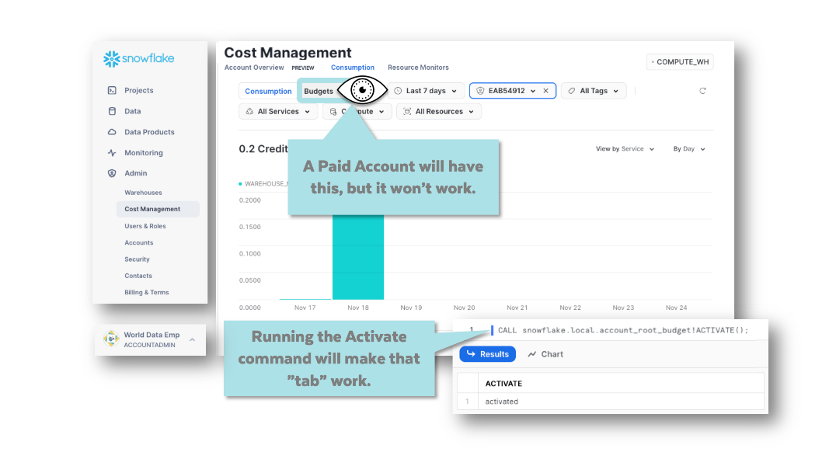

Once you have activated them, you can see projections of where your usage might be heading for the month.

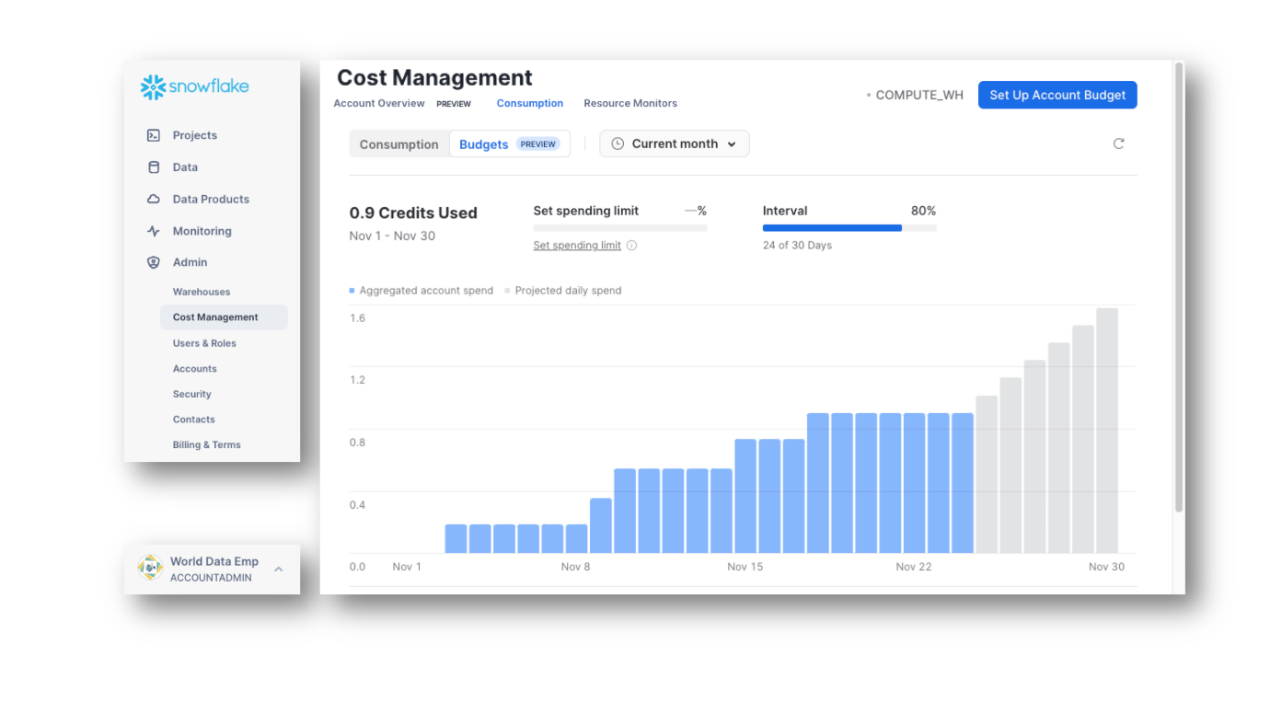

Budgets are only available in Paid Accounts. Once a Trial Account has been converted to paid, Budgets will need to be activated. Budgets are needed in additon to Resource Monitors because they include projections. Budgets are needed in additon to Resource Monitors because they cover more usage types.

--This DORA Check Requires that you RUN two Statements, one right after the other  
show shares in account;  
  
--the above command puts information into memory that can be accessed using result_scan(last_query_id())  
-- If you have to run this check more than once, always run the SHOW command immediately prior  
select grader(step, (actual = expected), actual, expected, description) as graded_results from (

SELECT 'CMCW08' as step

,( select IFF(count(*)>0,1,0)   
 from table(result_scan(last_query_id()))   
 where "kind" = 'OUTBOUND'  
 and "database_name" = 'INTL_DB') as actual

, 1 as expected

,'Outbound Share Created From INTL_DB' as description

);

[Lesson 6: Shopping the Snowflake Marketplace](https://learn.snowflake.com/courses/course-v1:snowflake+CMCW+A/course/#block-v1:snowflake+CMCW+A+type@chapter+block@76b0101e34194942bd1897afc7c39ca1)

The Snowflake Marketplace is like a shopping mall for data and apps.

**🥋 Get a Free Data Share with Weather Information**

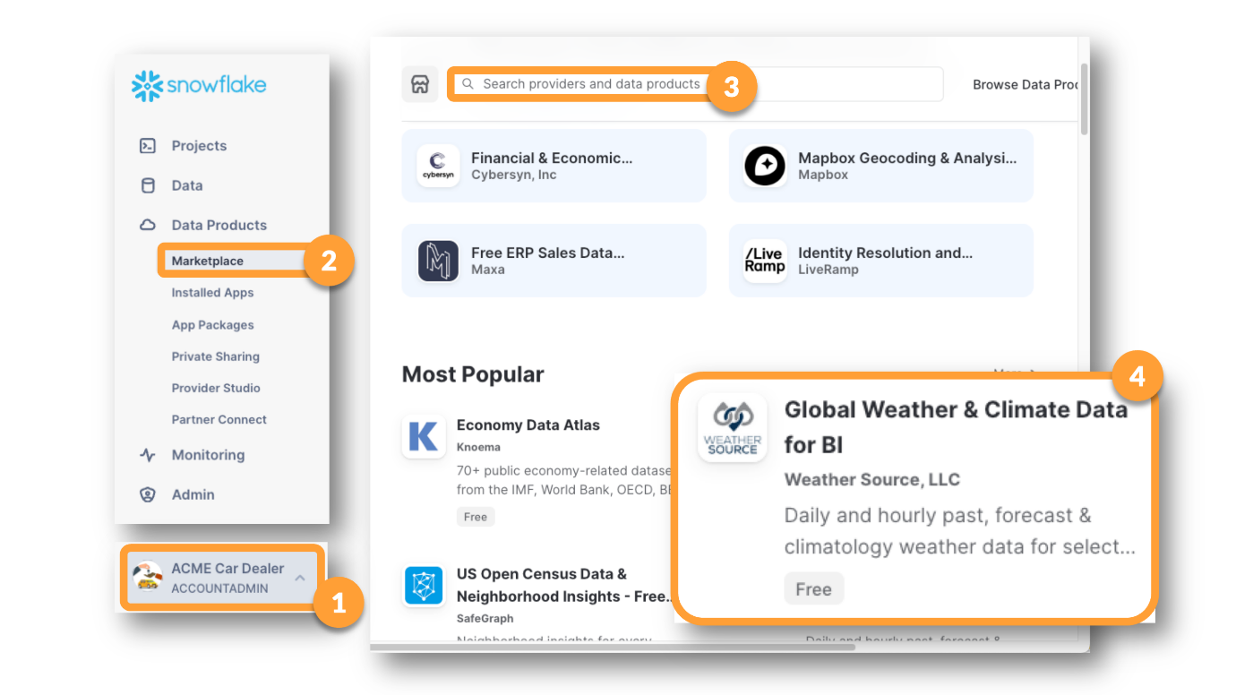

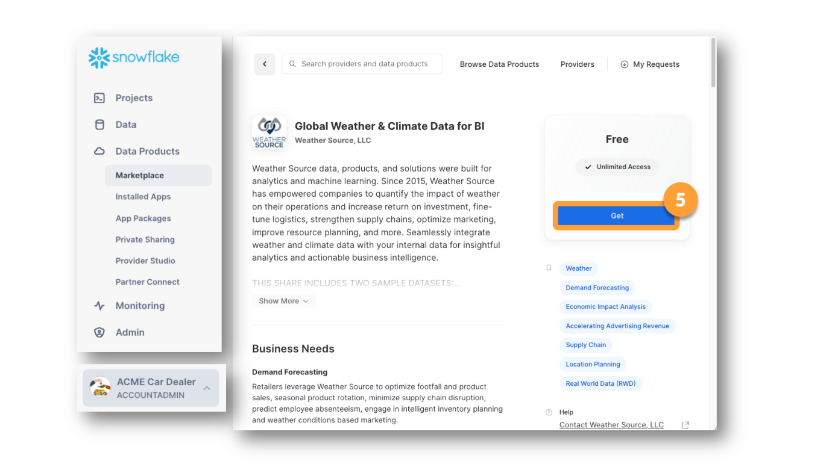 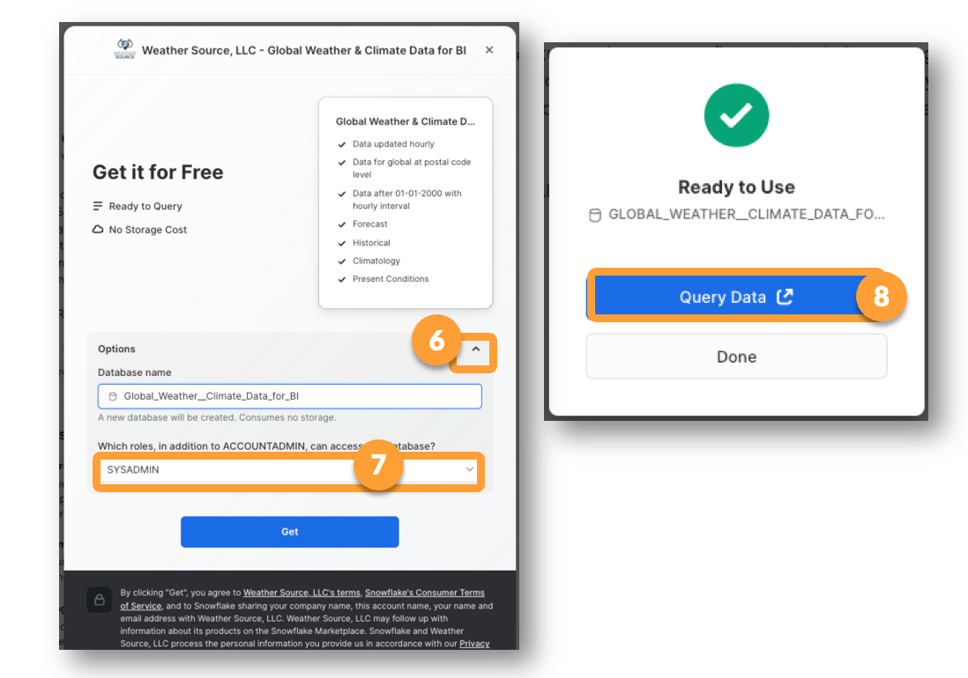 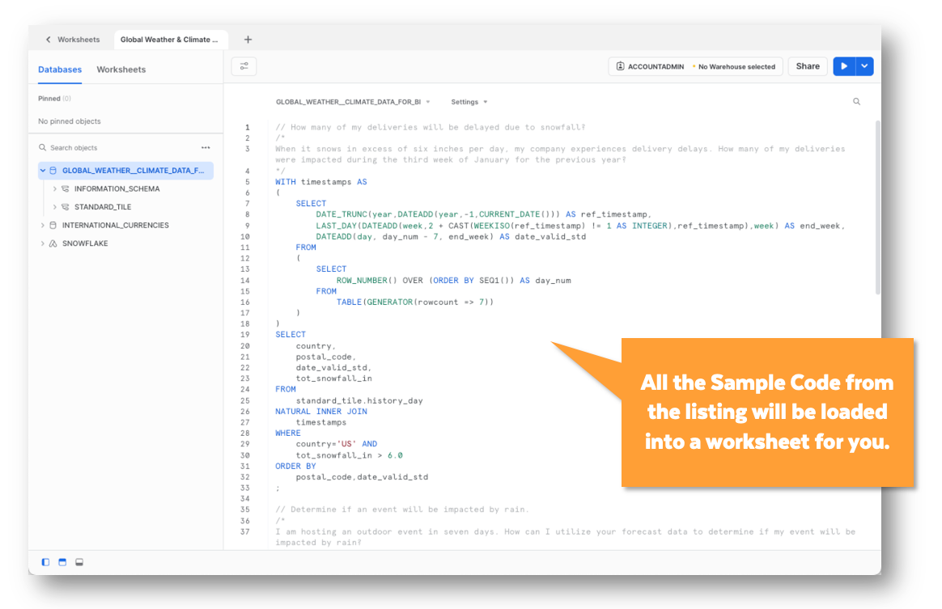

--This DORA Check Requires that you RUN two Statements, one right after the other  
show resource monitors in account;  
  
--the above command puts information into memory that can be accessed using result_scan(last_query_id())  
-- If you have to run this check more than once, always run the SHOW command immediately prior  
select grader(step, (actual = expected), actual, expected, description) as graded_results from (

SELECT 'CMCW09' as step

,( select IFF(count(*)>0,1,0)   
 from table(result_scan(last_query_id()))   
 where "name" = 'DAILY_3_CREDIT_LIMIT'  
 and "credit_quota" = 3  
 and "frequency" = 'DAILY') as actual

, 1 as expected

,'Resource Monitors Exist' as description

);

-- set your worksheet drop lists to the location of your GRADER function  
--DO NOT EDIT ANYTHING BELOW THIS LINE  
  
--THIS DORA CHECK MUST BE RUN IN THE ACME ACCOUNT!!!!!  
select grader(step, (actual = expected), actual, expected, description) as graded_results from (

SELECT 'CMCW10' as step

,( select count(*)

from snowflake.account_usage.databases

where (database_name in ('WEATHERSOURCE','INTERNATIONAL_CURRENCIES')

and type = 'IMPORTED DATABASE'  
 and deleted is null)

or (database_name = 'MARKETING'

and type = 'STANDARD'  
 and deleted is null)  
 ) as actual

, 3 as expected

,'ACME Account Set up nicely' as description

);

-- set the worksheet drop lists to match the location of your GRADER function  
--DO NOT MAKE ANY CHANGES BELOW THIS LINE  
  
--RUN THIS DORA CHECK IN YOUR ACME ACCOUNT  
  
select grader(step, (actual = expected), actual, expected, description) as graded_results from (

SELECT

'CMCW11' as step

,( select count(*)   
 from MARKETING.MAILERS.DETROIT_ZIPS) as actual  
 , 9 as expected

,'Detroit Zips' as description

);

Create new account ADU and create the tables and load them as required.

--We need a table that will allow WMIs to be decoded into Manufacturer Name, Country and Vehicle Type

CREATE TABLE vin.decode.wmi_to_manuf

(

wmi varchar(6)

,manuf_id number(6)

,manuf_name varchar(50)  
 ,country varchar(50)  
 ,vehicle_type varchar(50)  
 );

CREATE FILE FORMAT vin.decode.comma_sep_oneheadrow

type = 'CSV'

field_delimiter = ','

record_delimiter = '\n'

skip_header = 1

field_optionally_enclosed_by = '"'

trim_space = TRUE;

--create a variable and set the value  
set sample_vin = 'SAJAJ4FX8LCP55916';

--check to make sure you set the variable above  
select $sample_vin;  
  
--parse the vin into it's important pieces

SELECT $sample_vin as VIN

, LEFT($sample_vin,3) as WMI

, SUBSTR($sample_vin,4,5) as VDS

, SUBSTR($sample_vin,10,1) as model_year_code

, SUBSTR($sample_vin,11,1) as plant_code

;

**📓 What Can We Do with a Parsed VIN? – Join with other tables**

-- This code must be run in the same worksheet (session) as the [set sample_vin =] statement, otherwise the variable will not 'exist'

select VIN

, manuf_name

, vehicle_type

, make_name

, plant_name

, model_year_name as model_year

, model_name

, desc1

, desc2

, desc3

, desc4

, desc5

, engine

, drive_type

, transmission

, mpg

from

( SELECT $sample_vin as VIN

, LEFT($sample_vin,3) as WMI

, SUBSTR($sample_vin,4,5) as VDS

, SUBSTR($sample_vin,10,1) as model_year_code

, SUBSTR($sample_vin,11,1) as plant_code

) vin

JOIN vin.decode.wmi_to_manuf w

ON vin.wmi = w.wmi

JOIN vin.decode.manuf_to_make m

ON w.manuf_id=m.manuf_id

JOIN vin.decode.manuf_plants p

ON vin.plant_code=p.plant_code

AND m.make_id=p.make_id

JOIN vin.decode.model_year y

ON vin.model_year_code=y.model_year_code

JOIN vin.decode.make_model_vds vds

ON vds.vds=vin.vds

AND vds.make_id = m.make_id;

**📓 A User-Defined (Table) Function**

One way to encapsulate logic is to create a function. This function needs to be SECURE so you can share it. So when you type "**CREATE FUNCTION**" be sure to add the word "**SECURE**", as in "**CREATE SECURE FUNCTION**"

To create a function:

* Give the function a name
* Tell the function what information you will be passing into it.
* Tell the function what type of information you expect it to pass back to you (Return).

**create or replace secure function vin.decode.parse_and_enhance_vin(this_vin varchar(25))**

**returns table (**

**VIN varchar(25)**

**, manuf_name varchar(25)**

**, vehicle_type varchar(25)**

**, make_name varchar(25)**

**, plant_name varchar(25)**

**, model_year varchar(25)**

**, model_name varchar(25)**

**, desc1 varchar(25)**

**, desc2 varchar(25)**

**, desc3 varchar(25)**

**, desc4 varchar(25)**

**, desc5 varchar(25)**

**, engine varchar(25)**

**, drive_type varchar(25)**

**, transmission varchar(25)**

**, mpg varchar(25)**

**)**

**as $$**

**<replace this with the logic needed>**

**$$;**

--notice that we added "or replace" and "secure" to this code that was not shown in the screenshot

create or replace secure function vin.decode.parse_and_enhance_vin(this_vin varchar(25))

returns table (

VIN varchar(25)

, manuf_name varchar(25)

, vehicle_type varchar(25)

, make_name varchar(25)

, plant_name varchar(25)

, model_year varchar(25)

, model_name varchar(25)

, desc1 varchar(25)

, desc2 varchar(25)

, desc3 varchar(25)

, desc4 varchar(25)

, desc5 varchar(25)

, engine varchar(25)

, drive_type varchar(25)

, transmission varchar(25)

, mpg varchar(25)

)

as $$

select this_vin

, manuf_name

, vehicle_type

, make_name

, plant_name

, model_year_name as model_year

, model_name

, desc1

, desc2

, desc3

, desc4

, desc5

, engine

, drive_type

, transmission

, mpg

from

( SELECT this_vin as VIN

, LEFT(this_vin,3) as WMI

, SUBSTR(this_vin,4,5) as VDS

, SUBSTR(this_vin,10,1) as model_year_code

, SUBSTR(this_vin,11,1) as plant_code

) vin

JOIN vin.decode.wmi_to_manuf w

ON vin.wmi = w.wmi

JOIN vin.decode.manuf_to_make m

ON w.manuf_id=m.manuf_id

JOIN vin.decode.manuf_plants p

ON vin.plant_code=p.plant_code

AND m.make_id=p.make_id

JOIN vin.decode.model_year y

ON vin.model_year_code=y.model_year_code

JOIN vin.decode.make_model_vds vds

ON vds.vds=vin.vds

AND vds.make_id = m.make_id

$$;

--In each function call below, we pass in a different VIN as THIS_VIN

select *

from table(vin.decode.PARSE_AND_ENHANCE_VIN($sample_vin));

select *

from table(vin.decode.PARSE_AND_ENHANCE_VIN('SAJAJ4FX8LCP55916'));

select *

from table(vin.decode.PARSE_AND_ENHANCE_VIN('19UUB2F34LA001631'));

select *

from table(vin.decode.PARSE_AND_ENHANCE_VIN('5UXCR6C0XL9C77256'));

show stages in account;

list @vin.decode.AWS_S3_BUCKET;

**🎯 Create a Listing for Max to Share his Function**

These tips should jog your memory but if you need more help, review earlier sections of the workshop.

* While in the ADU account, go to **Data > Provider Studio**.
* Use the blue [**+ Listing]** button.
* Name your listing:   **VIN Parse & Enhance**
* You will only be sharing with your ACME account (a specific consumer, not the Marketplace).
* Set it to refresh the data once a week.
* Put in the real email of your choice.

**🎯 Trigger the Cross-Cloud Replication for Max's Listing**

* Use the **Data Products > Private Sharing**side menu, to "get" the Share ADU pushed to ACME.
* Remember it will need a few minutes to complete the replication!

Why do you think the shares you create have a wait time, but the WeatherSource share was available instantly?

The Weathersource listings are very popular and have already been replicated to cloud+regions all over the world.

The first time a listing is requested by a new cloud+region, it must be replicated, so the first request takes the longest.

I created the listings and was the first to request them so my request triggers the replication process.

--Caden needs a table that stores the ACME Car Inventory

create or replace table stock.unsold.lotstock

(

vin varchar(25)

, exterior varchar(50)

, interior varchar(50)

, manuf_name varchar(25)

, vehicle_type varchar(25)

, make_name varchar(25)

, plant_name varchar(25)

, model_year varchar(25)

, model_name varchar(25)

, desc1 varchar(25)

, desc2 varchar(25)

, desc3 varchar(25)

, desc4 varchar(25)

, desc5 varchar(25)

, engine varchar(25)

, drive_type varchar(25)

, transmission varchar(25)

, mpg varchar(25)

);

-- Fill in the rest of the file name by looking at the files in your new stage  
-- Replace the question marks with the file name (remember AWS is case sensitive)

select $1, $2, $3  
from @stock.unsold.aws_s3_bucket/Lotties_LotStock_Data.csv

select $1 as VIN

, $2 as Exterior, $3 as Interior

from @stock.unsold.aws_s3_bucket/Lotties_LotStock_Data.csv

(file_format => util_db.public.csv_comma_lf_header);

**📓 How to Load a File of 3 Columns into a Table of 18 Columns?**

-- This file format will allow the 3 column file to be loaded into an 18 column table  
-- By parsing the header, Snowflake can infer the column names

CREATE FILE FORMAT util_db.public.CSV_COL_COUNT_DIFF

type = 'CSV'

field_delimiter = ','

record_delimiter = '\n'

field_optionally_enclosed_by = '"'

trim_space = TRUE

error_on_column_count_mismatch = FALSE

parse_header = TRUE;

copy into stock.unsold.lotstock

from @stock.unsold.aws_s3_bucket/Lotties_LotStock_Data.csv

file_format = (format_name = util_db.public.csv_col_count_diff)

match_by_column_name='CASE_INSENSITIVE';

After running the statement above, run a SELECT * on the LOTSTOCK table. The first 3 columns probably look great. But the other columns are all empty,

**🥋 Combining the Table Data with the Function Data**

--A simple select from Lot Stock (choose any VIN from the LotStock table)

select *

from stock.unsold.lotstock

where vin = '5J8YD4H86LL013641';

-- here we use ls for lotstock table and pf for parse function  
-- this more complete statement lets us combine the data already in the table   
-- with the data returned from the parse function

select ls.vin, ls.exterior, ls.interior, pf.*

from

(select *

from table(ADU_VIN.DECODE.PARSE_AND_ENHANCE_VIN('5J8YD4H86LL013641'))

) pf

join stock.unsold.lotstock ls

where pf.vin = ls.vin;

;

**🥋 Use a Variable Instead**

-- We can use a local (session) variable to make it easier to change the VIN we are trying to enhance  
set my_vin = '5J8YD4H86LL013641';

select $my_vin;

select ls.vin, pf.manuf_name, pf.vehicle_type

, pf.make_name, pf.plant_name, pf.model_year

, pf.desc1, pf.desc2, pf.desc3, pf.desc4, pf.desc5

, pf.engine, pf.drive_type, pf.transmission, pf.mpg

from stock.unsold.lotstock ls

join

( select

vin, manuf_name, vehicle_type

, make_name, plant_name, model_year

, desc1, desc2, desc3, desc4, desc5

, engine, drive_type, transmission, mpg

from table(ADU_VIN.DECODE.PARSE_AND_ENHANCE_VIN($my_vin))

) pf

on pf.vin = ls.vin;

**🥋 Don't Just Select It, Store It!**

-- We're using "s" for "source." The joined data from the LotStock table and the parsing function will be a source of data for us.   
-- We're using "t" for "target." The LotStock table is the target table we want to update.  
   
update stock.unsold.lotstock t

set manuf_name = s.manuf_name

, vehicle_type = s.vehicle_type

, make_name = s.make_name

, plant_name = s.plant_name

, model_year = s.model_year

, desc1 = s.desc1

, desc2 = s.desc2

, desc3 = s.desc3

, desc4 = s.desc4

, desc5 = s.desc5

, engine = s.engine

, drive_type = s.drive_type

, transmission = s.transmission

, mpg = s.mpg

from

(

select ls.vin, pf.manuf_name, pf.vehicle_type

, pf.make_name, pf.plant_name, pf.model_year

, pf.desc1, pf.desc2, pf.desc3, pf.desc4, pf.desc5

, pf.engine, pf.drive_type, pf.transmission, pf.mpg

from stock.unsold.lotstock ls

join

( select

vin, manuf_name, vehicle_type

, make_name, plant_name, model_year

, desc1, desc2, desc3, desc4, desc5

, engine, drive_type, transmission, mpg

from table(ADU_VIN.DECODE.PARSE_AND_ENHANCE_VIN($my_vin))

) pf

on pf.vin = ls.vin

) s

where t.vin = s.vin;

-- We can count the number of rows in the LotStock table that have not yet been updated.   
   
set row_count = (select count(*)

from stock.unsold.lotstock

where manuf_name is null);

select $row_count;

**🥋 Combining the Table Data with the Function Data use a SQL Script block**

-- This scripting block runs very slow, but it shows how blocks work for people who are new to using them  
DECLARE

update_stmt varchar(2000);

res RESULTSET;

cur CURSOR FOR select vin from stock.unsold.lotstock where manuf_name is null;

BEGIN

OPEN cur;

FOR each_row IN cur DO

update_stmt := 'update stock.unsold.lotstock t '||

'set manuf_name = s.manuf_name ' ||

', vehicle_type = s.vehicle_type ' ||

', make_name = s.make_name ' ||

', plant_name = s.plant_name ' ||

', model_year = s.model_year ' ||

', desc1 = s.desc1 ' ||

', desc2 = s.desc2 ' ||

', desc3 = s.desc3 ' ||

', desc4 = s.desc4 ' ||

', desc5 = s.desc5 ' ||

', engine = s.engine ' ||

', drive_type = s.drive_type ' ||

', transmission = s.transmission ' ||

', mpg = s.mpg ' ||

'from ' ||

'( select ls.vin, pf.manuf_name, pf.vehicle_type ' ||

', pf.make_name, pf.plant_name, pf.model_year ' ||

', pf.desc1, pf.desc2, pf.desc3, pf.desc4, pf.desc5 ' ||

', pf.engine, pf.drive_type, pf.transmission, pf.mpg ' ||

'from stock.unsold.lotstock ls ' ||

'join ' ||

'( select' ||

' vin, manuf_name, vehicle_type' ||

' , make_name, plant_name, model_year ' ||

' , desc1, desc2, desc3, desc4, desc5 ' ||

' , engine, drive_type, transmission, mpg ' ||

' from table(ADU_VIN.DECODE.PARSE_AND_ENHANCE_VIN(\'' ||

each_row.vin || '\')) ' ||

') pf ' ||

'on pf.vin = ls.vin ' ||

') s ' ||

'where t.vin = s.vin;';

res := (EXECUTE IMMEDIATE :update_stmt);

END FOR;

CLOSE cur;

END;

* Most people put scripting blocks into Stored Procedures, which are another way to encapsulate different bits of code.
* Snowflake was designed for loading and updating large record sets with a single statement, not for updating one row at a time, using a FOR LOOP. There are more efficient ways to achieve the result we achieved above, but this lesson's example allowed you to see how each part became a building block for the next.

--RUN THIS DORA CHECK IN YOUR ORIGINAL TRIAL ACCOUNT

select grader(step, (actual = expected), actual, expected, description) as graded_results from ( SELECT 'CMCW12' as step ,( select count(*) from SNOWFLAKE.ORGANIZATION_USAGE.ACCOUNTS where account_name = 'ACME'   
 and region like 'AZURE_%' and deleted_on is null) as actual , 1 as expected ,'ACME Account Added on Azure Platform' as description );

--RUN THIS DORA CHECK IN YOUR ORIGINAL TRIAL ACCOUNT  
  
select grader(step, (actual = expected), actual, expected, description) as graded_results from (

SELECT

'CMCW13' as step

,( select count(*)

from SNOWFLAKE.ORGANIZATION_USAGE.ACCOUNTS

where account_name = 'AUTO_DATA_UNLIMITED'

and region like 'GCP_%'

and deleted_on is null) as actual  
 , 1 as expected

,'ADU Account Added on GCP' as description

);

-- set the worksheet drop lists to match the location of your GRADER function  
--DO NOT MAKE ANY CHANGES BELOW THIS LINE  
  
--RUN THIS DORA CHECK IN YOUR ACME ACCOUNT  
  
select grader(step, (actual = expected), actual, expected, description) as graded_results from (

SELECT

'CMCW14' as step

,( select count(*)

from STOCK.UNSOLD.LOTSTOCK

where engine like '%.5 L%'

or plant_name like '%z, Sty%'

or desc2 like '%xDr%') as actual  
 , 145 as expected

,'Intentionally cryptic test' as description

);

📓 Budgets! New in June 2023

Budgets are a new Snowflake feature and they are not currently available in Trial Accounts.

Because they are not available in the account you're using for this workshop, we'll simply learn a few facts about them, so that you will know they exist.

When Budgets are available you find them on the same page as the Usage graphs. The Budgets "Tab" won't work if you haven't yet activated Budgets for your account.

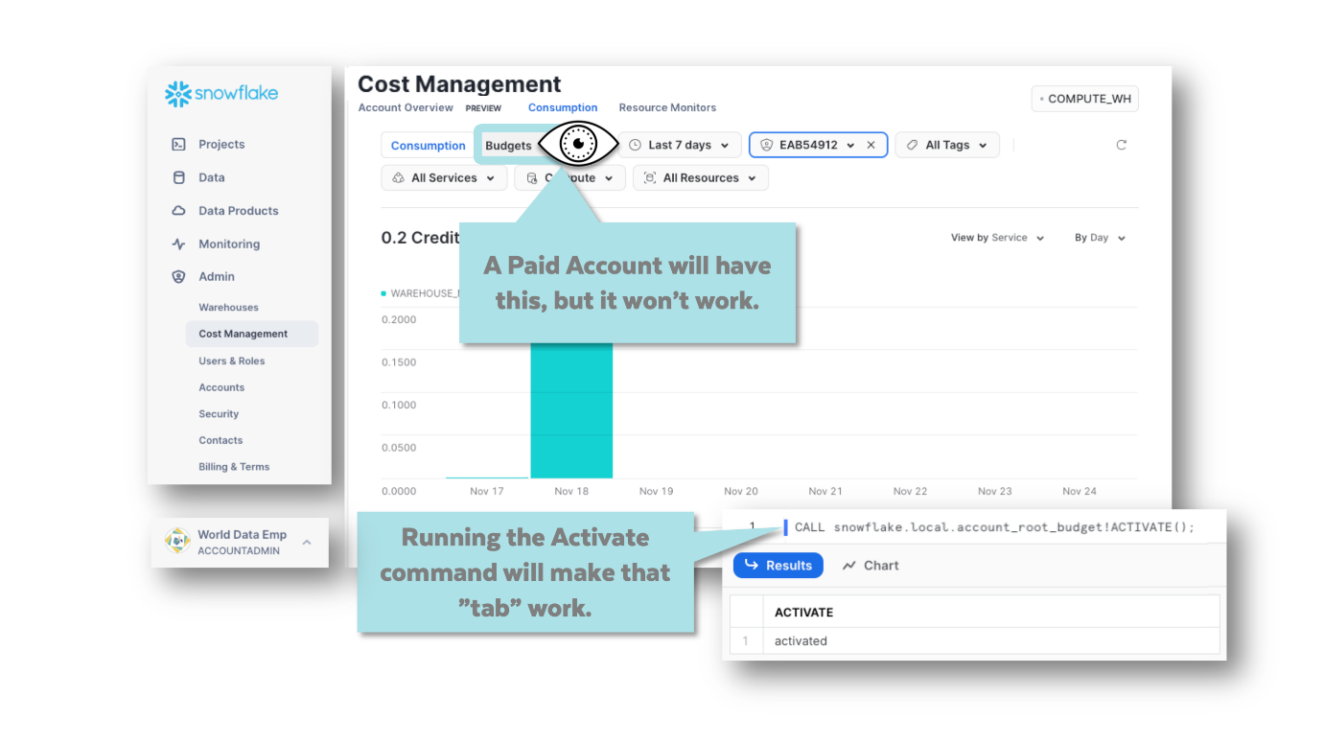

Once you have activated them, you can see projections of where your usage might be heading for the month.

Resource Monitors allow you to track and control Warehouse/Compute usage, but as Snowflake users become more sophisticated using many serverless tasks and advanced features, Budgets have been added so that users have similar tracking and control for other aspects of Snowflake.



To learn more about Budgets, you can [read about them in the DOCs](https://docs.snowflake.com/en/user-guide/budgets#label-enable-budgets).

**ESS-DABW Badge 3: Data Application Builders Workshop**

**📓 First, There Was Snowflake (2012)**

...then, there was [Streamlit (2018)](https://streamlit.io/" \t "[object Object]).

[Snowflake bought Streamlit (2022)](https://techcrunch.com/2022/03/02/snowflake-acquires-streamlit-for-800m-to-help-customers-build-data-based-apps/) and now there are **two versions of Streamlit**.

The other is a highly integrated tool called Streamlit in Snowflake (around here we call it "SiS").

In this hands-on workshop, you will use both Streamlit and SiS. But SiS is simpler to set up, so we'll start there.

DROP WAREHOUSE COMPUTE_WH;

USE ROLE SYSADMIN;

CREATE OR REPLACE WAREHOUSE COMPUTE_WH

WITH WAREHOUSE_SIZE= XSMALL;

create database SMOOTHIES;

**🥋 Create Your Smoothie Order Form SIS App**

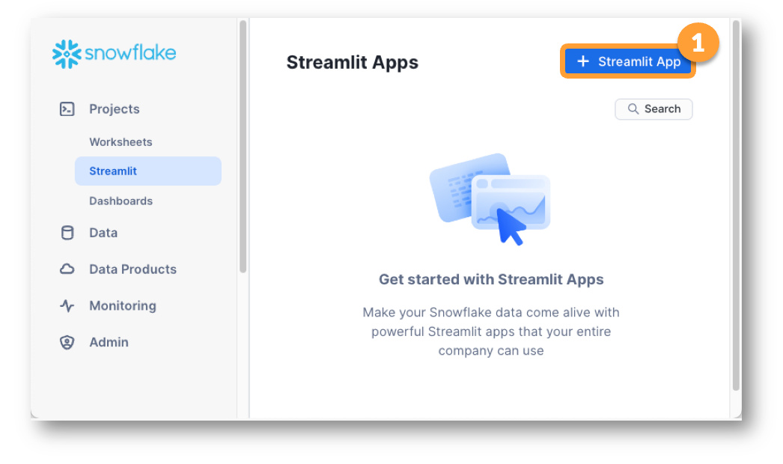 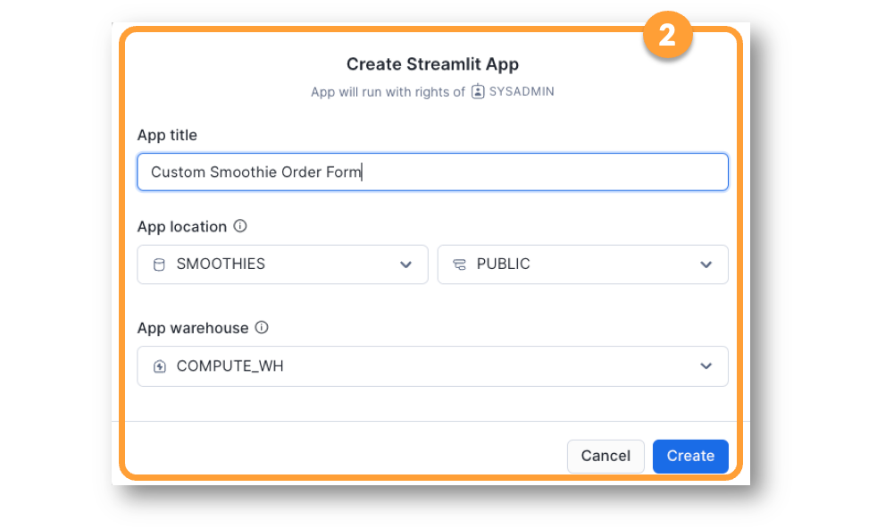 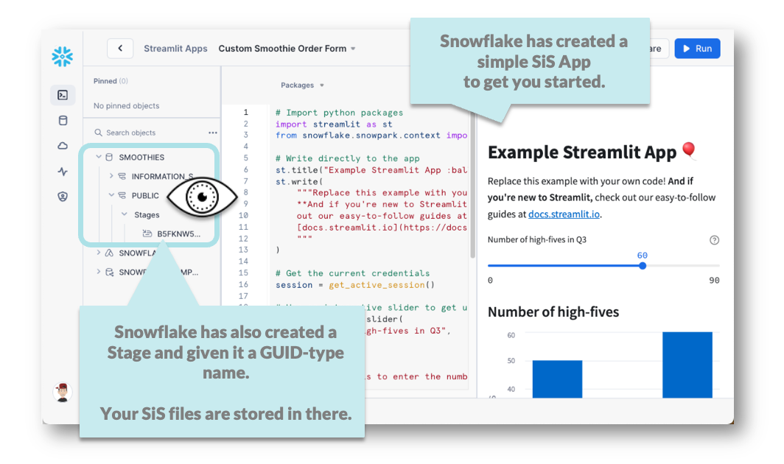

# Import python packages

import streamlit as st

from snowflake.snowpark.context import get_active_session

# Write directly to the app

st.title(":cup_with_straw: Customize Your Smoothie! :cup_with_straw:")

st.write(

"""Choose the Fruits you want in your custome Smoothie! """)

option = st.selectbox ('What is your Fav Fruit?',('Banana', 'Strawberries', 'Peaches') )

st.write('Your Fav Fruit is : ', option)

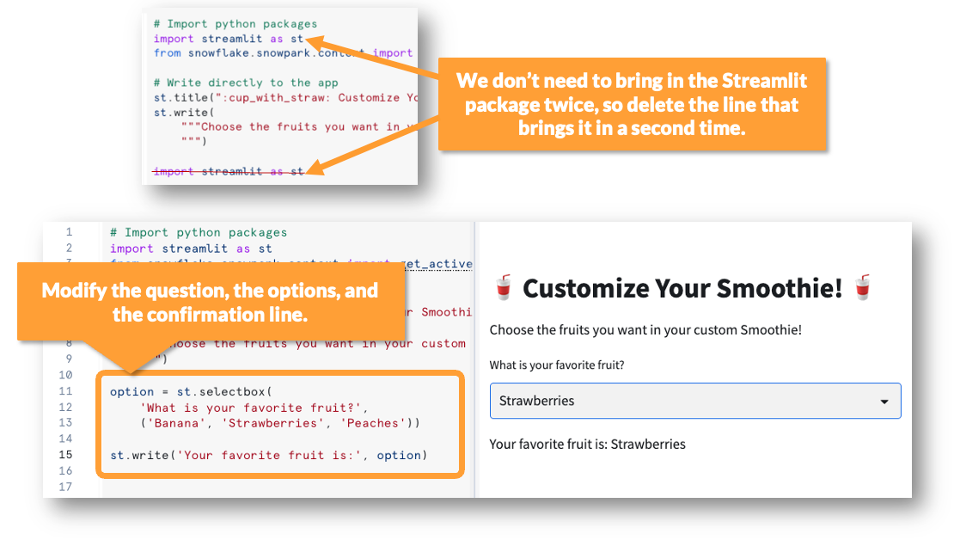

We should store a list of fruits in a database table.

# Import python packages

import streamlit as st

from snowflake.snowpark.context import get_active_session

# Write directly to the app

st.title(":cup_with_straw: Customize Your Smoothie! :cup_with_straw:")

st.write(

"""Choose the Fruits you want in your custome Smoothie!

"""

)

option = st.selectbox ('What is your Fav Fruit?',('Banana', 'Strawberries', 'Peaches') )

st.write('Your Fav Fruit is : ', option)

session = get_active_session()

my_dataframe = session.table("smoothies.public.fruit_options")

st.dataframe(data=my_dataframe,use_container_width=True)

st.write(type(my_dataframe))

st.write(my_dataframe.queries)

**🥋 The Internal Stage that Stores Your SiS App**

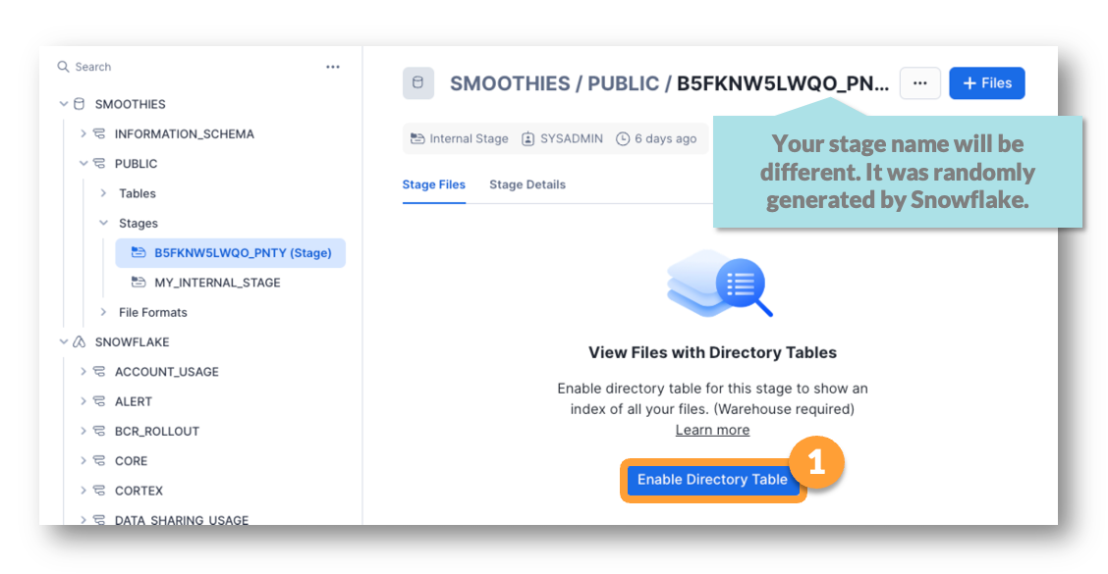 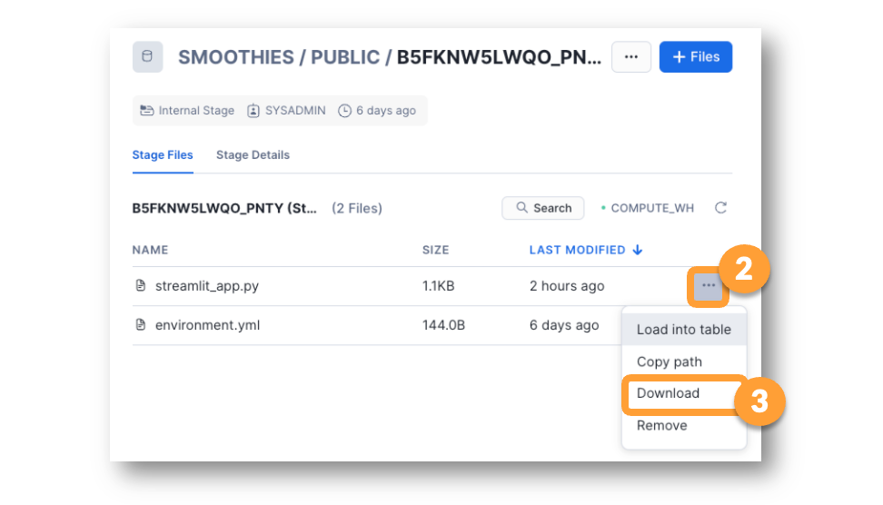 Downloading the files and opening them in a text editor we can see the **streamlit_app.py** file is just a copy of our code. The **environment.yml** file has configuration details.

**📓 How SiS Apps Run**

Remember that when we first set up the App, we chose a WAREHOUSE to associate with it.  There are some important things to know about how SiS apps use their assigned warehouse. If you need to check which compute resource you associated with your app, it is easy to check.

A warehouse will usually shut down within a few minutes of being idle (check the Auto-Suspend setting of the warehouse), but when a warehouse is associated with a SiS app, it runs for a minimum of 15 minutes by default.

Keeping the webpage of the SiS app open, will keep the warehouse active and can end up draining your Trial Account credits. So, exit the SiS app page anytime you take a break from this workshop.

Sometimes it's hard to remember to shut down the SiS App page, so let's set up a resource monitor to make sure we don't leave our app running 20 hours a day! If we run out of credits and want to keep working, we can always edit the resource monitor to allow more credits.

The good news is that many libraries are supported in Snowflake Snowpark!  You can refer to a list of them here:  <https://repo.anaconda.com/pkgs/snowflake/>

But, beware. Not all packages in the Anaconda channel for Snowpark can be used for SiS. Because of this, use the list as a starting point and then test the packages you want to use in your SiS app by typing in the import statement for the library you want to use.

-- DO NOT EDIT ANYTHING BELOW THIS LINE

select GRADER(step, (actual = expected), actual, expected, description) as graded_results from (

SELECT 'DABW003' as step

,(select ascii(fruit_name) from smoothies.public.fruit_options

where fruit_name ilike 'z%') as actual

, 90 as expected

,'A mystery check for the inquisitive' as description

);

We can't add a column with a UNIQUE ID if the table has rows in it already. Truncate the Orders table to remove all rows.

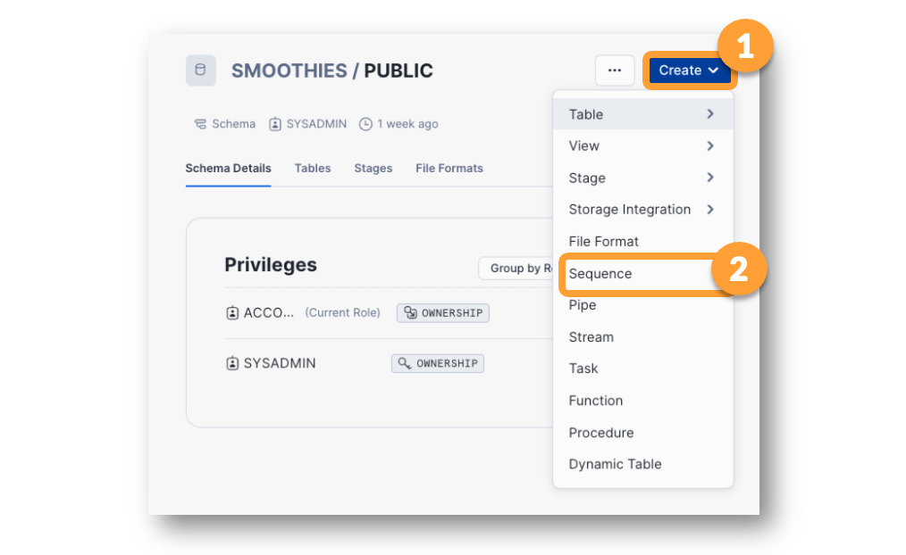

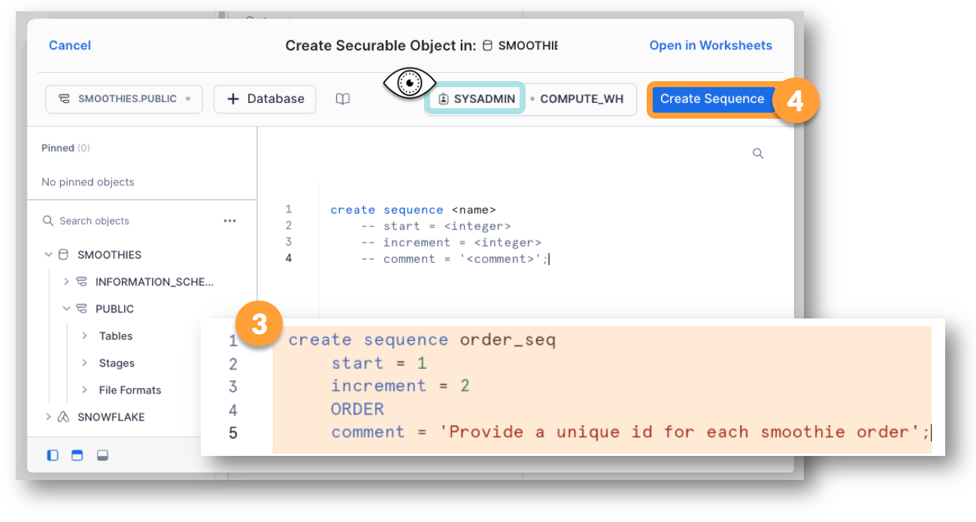

**NOTE:** A worksheet is considered a "session" in Snowflake.

You can create variables in a Snowflake Worksheet and then use them in other commands, as long as the commands are run from the same worksheet.

**🥋 Create a Simple User Defined Function (UDF)**

Create function sum_mystery_bag_vars (var1 number, var2 number,

Var3 number)

Returns number as ‘select var1+var2+var3’;

select sum_mystery_bag_vars(12,36,204);

**🥋 Combine Local Variables & Function Calls**

set this = -10.5;

set that = 2;

set the_other = 1000;

select sum_mystery_bag_vars($this,$ that,$ the_other);

select GRADER(step, (actual = expected), actual, expected, description) as graded_results from (

SELECT 'DABW006' as step

,( select util_db.public.sum_mystery_bag_vars($this,$that,$the_other)) as actual

, 991.5 as expected

,'Mystery Bag Function Output' as description

);

**📓  Snowflake Functions versus User-Defined Functions**

Your Snowflake account comes with hundreds of functions already defined. When you define your own functions, you can use the system functions as part of the logic for your user-defined functions!

You can learn about the various system functions by looking in docs.snowflake.com.

Or

show functions in account;

In the next lab, we'll use a system function called INITCAP() to update a string. INITCAP() reformats any words by making the first letter (the initial letter) a capital letter, and all subsequent letters in the word, lower case.

**🥋 Using a System Function to Fix a Variable Value**

set alternating_caps_phrase = 'wOW SnoWFLake Can do A LoT oF THINgs wItH InBUilt FunCTiOnS';

select $alternating_caps_phrase;

select initcap($alternating_caps_phrase);

Create function UTIL_DB.PUBLIC.NEUTRALIZE_WHINING (str_in varchar)

Returns varchar as 'select initcap(str_in)';

select UTIL_DB.PUBLIC.NEUTRALIZE_WHINING($alternating_caps_phrase);

-- DO NOT EDIT ANYTHING BELOW THIS LINE

select GRADER(step, (actual = expected), actual, expected, description) as graded_results from (

SELECT 'DABW007' as step

,( select hash(neutralize_whining('bUt mOm i wAsHeD tHe dIsHes yEsTeRdAy'))) as actual

, -4759027801154767056 as expected

,'WHINGE UDF Works' as description

);

**🥋 Create a New Repo in Your GitHub Account (Required)**

GitHub is like Facebook, LinkedIn, [Reddit](https://www.reddit.com/r/snowflake/), and Twitter because GitHub is (among other things) a Social Network! GitHub is a way to share code with coder friends! What makes GitHub really confusing (it can be SO confusing) is that it is also a version management system. You not only store and share code, but people can ask for and get copies of your code and add to it.

Streamlit requires you to have a GitHub account.

**🥋 Create a New Repo in Your GitHub Account (Required)**

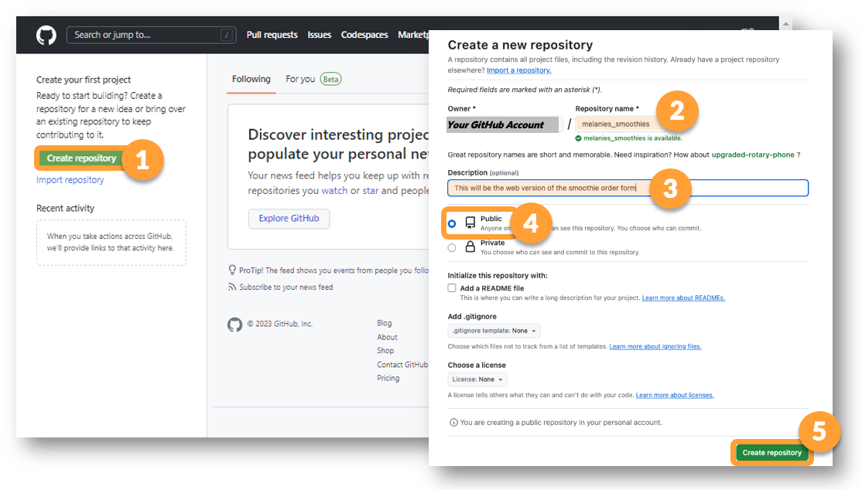 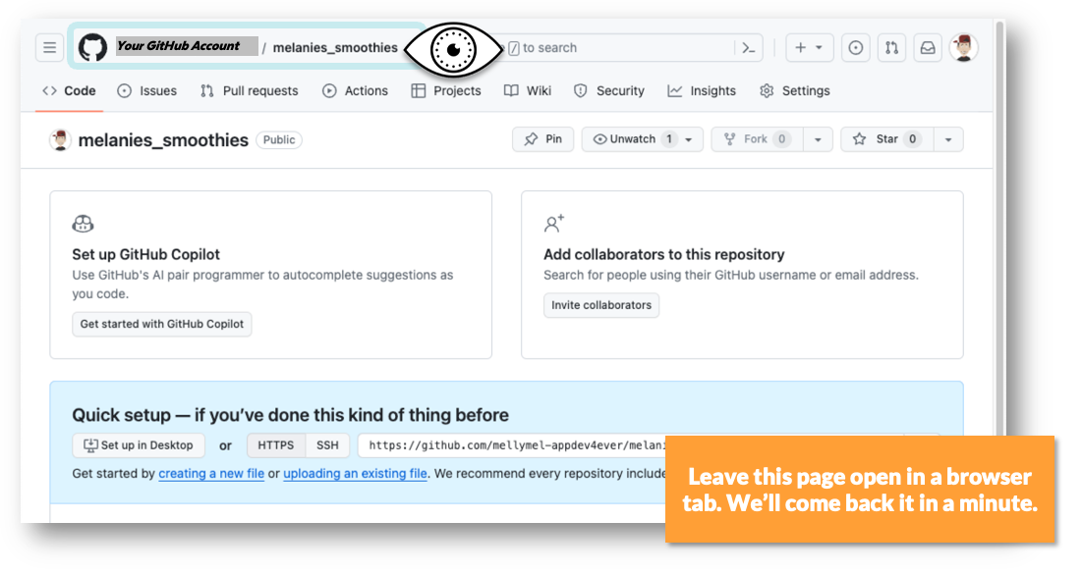

**🥋 Download the Python File from Your SiS App**

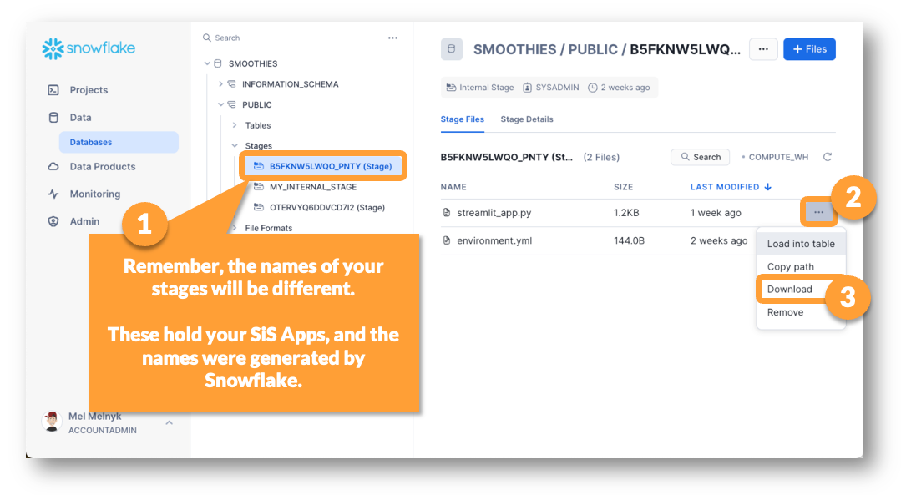

**🥋 Create a streamlit_app.py File in Your Repo**

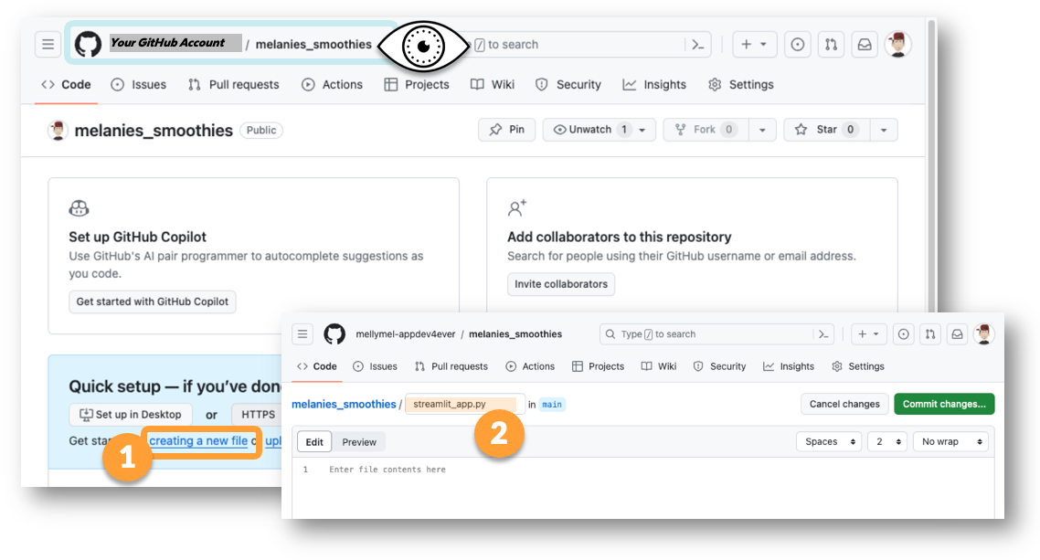 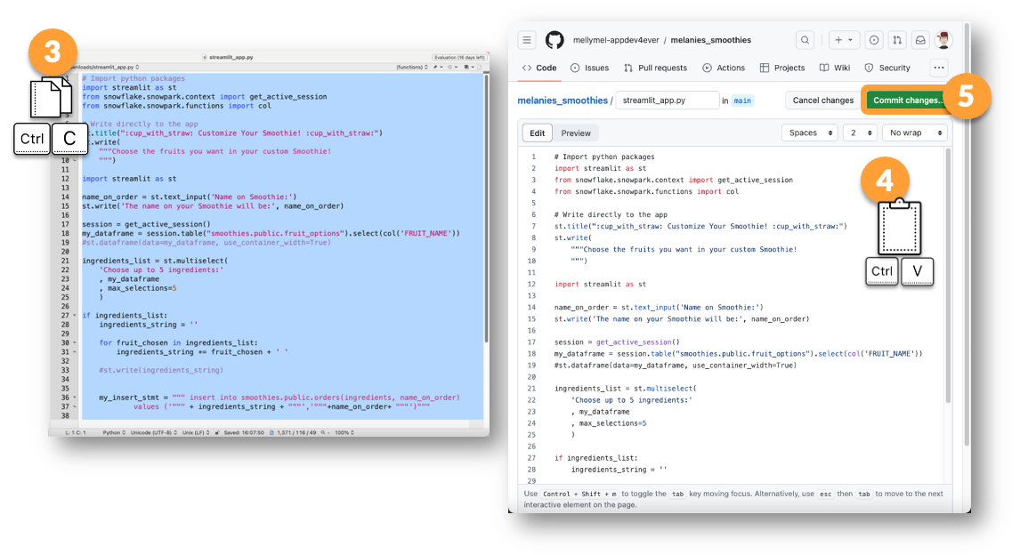

**🎯 Make a Second File for your Repo**

The other file that makes up your SiS app is called **environment.yaml**. Download that file.  Create a second file in your Repo called **requirements.txt**. Copy the contents of the **environment.yaml** file into the **requirements.txt** file and save the file in your repo.

**📓 Changes Needed When Moving from SiS to SniS**

The biggest differences between SiS and SniS are:

1) How users connect to your app.    
2) How you connect your app to Snowflake.

With SniS, users will be able to connect to your app more easily. You can set up your SniS app in a way that doesn't require them to log in or have a USER in your Snowflake account. In fact, Streamlit will host your app for free if you make it open to the public.

Connecting your app to Snowflake is less easy in SniS than it was in SiS. In SiS, the connection happened automatically. In Streamlit, we'll need to carry out a number of steps.

We'll begin by making a few changes to the **streamlit_app.py** file in your GitHub Repo.

#from snowflake.snowpark.context import get_active_session

cnx = st.connection("snowflake") # Add this line

session = cnx.session() # Add this line

#session = get_active_session()

**🎯 Edit the requirements.txt File**

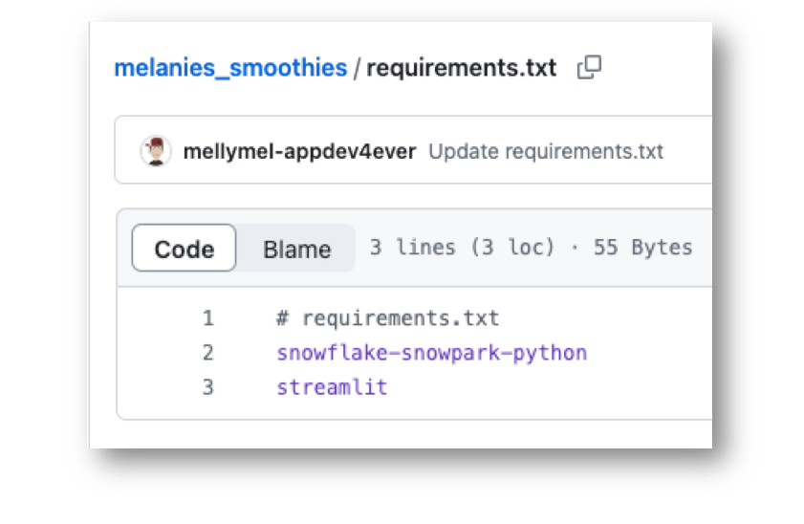

**🧰 Set Up a Streamlit Account and Give It Access to Your GitHub Account**

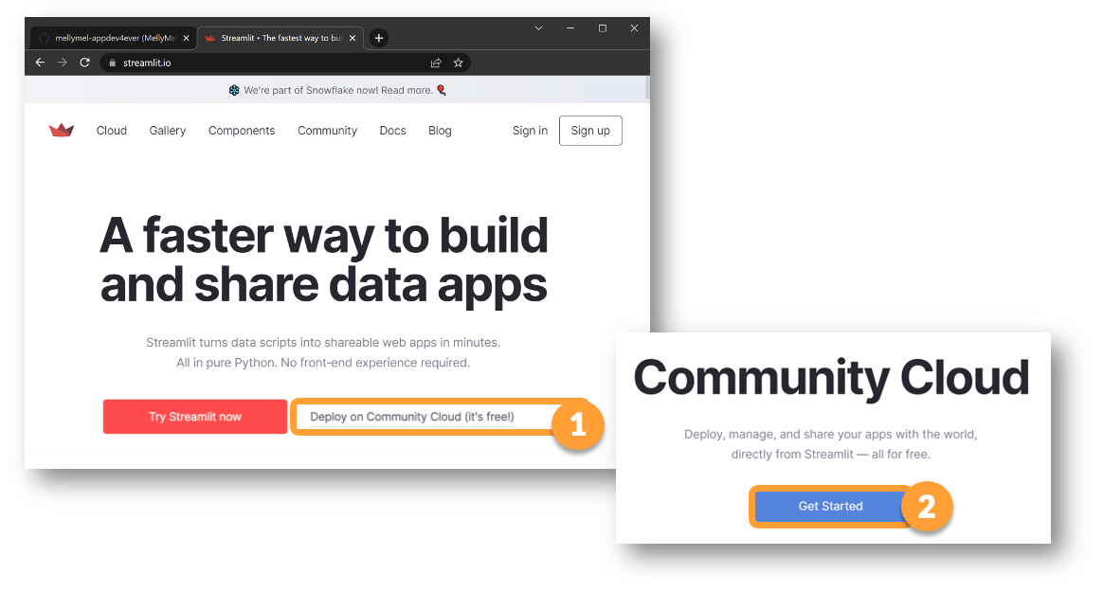 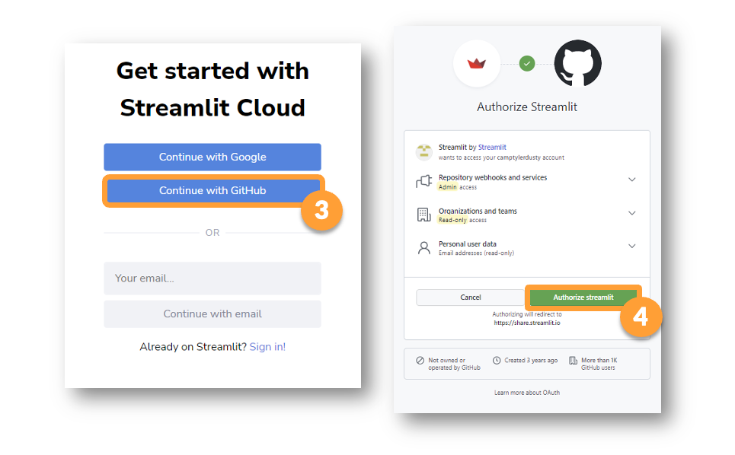 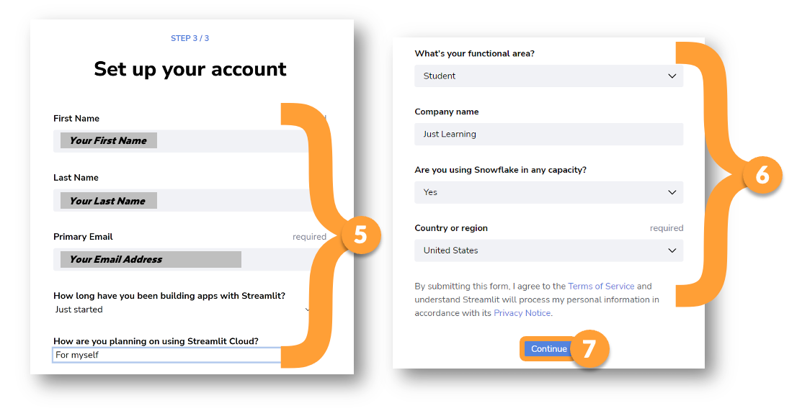 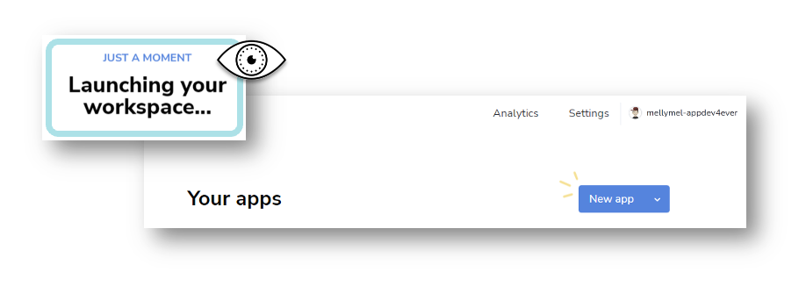

**🥋 Create an App in Streamlit**

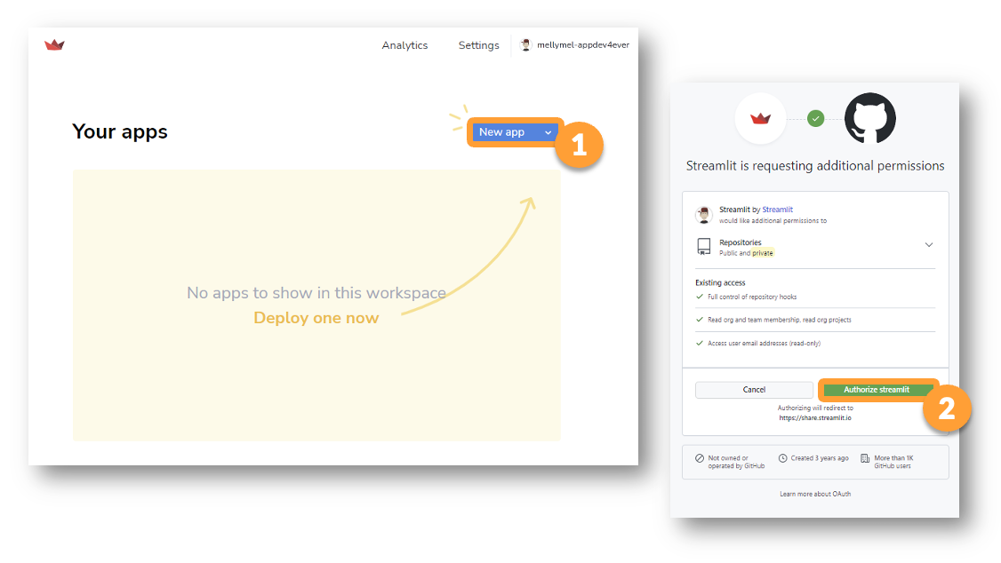

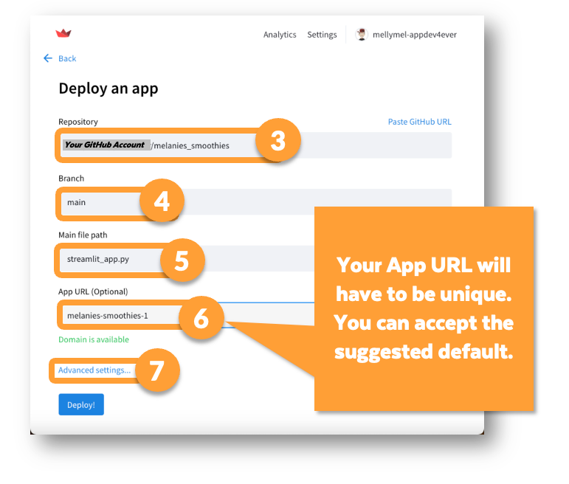 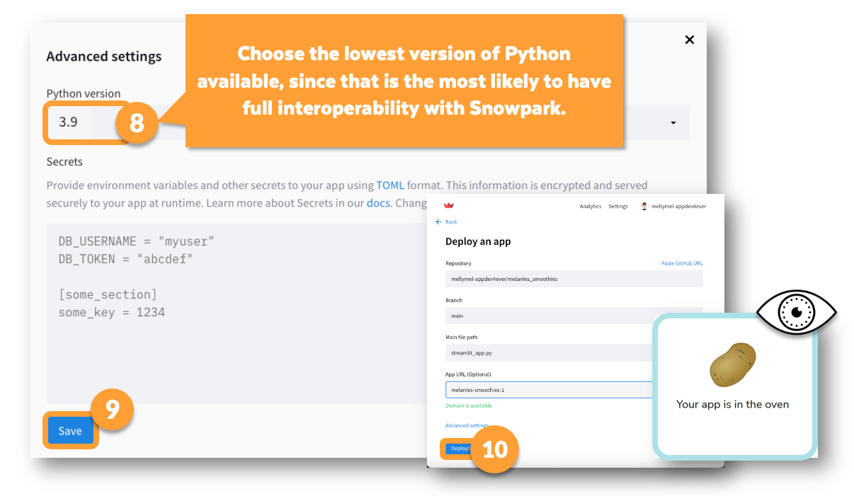 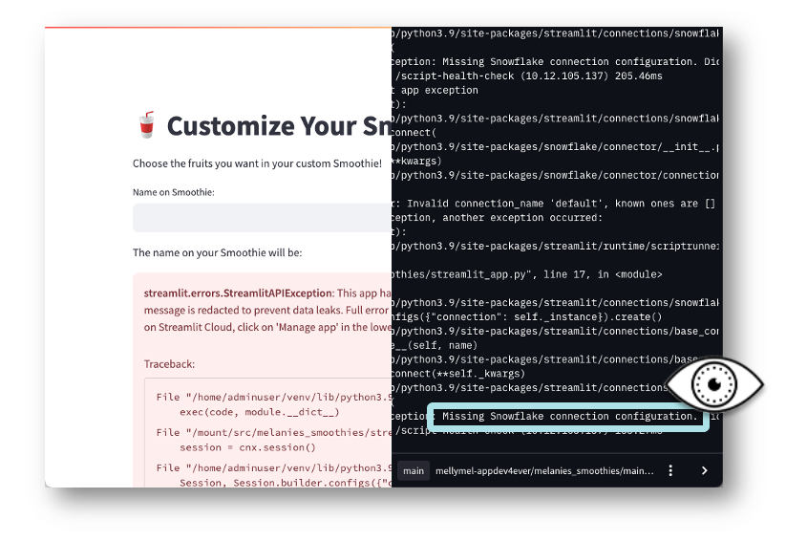

**🥋 View the Error and Update the Settings**

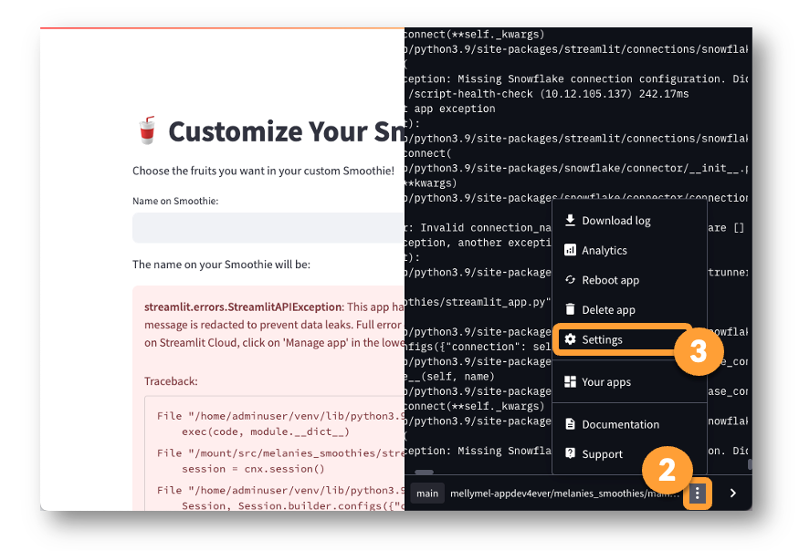 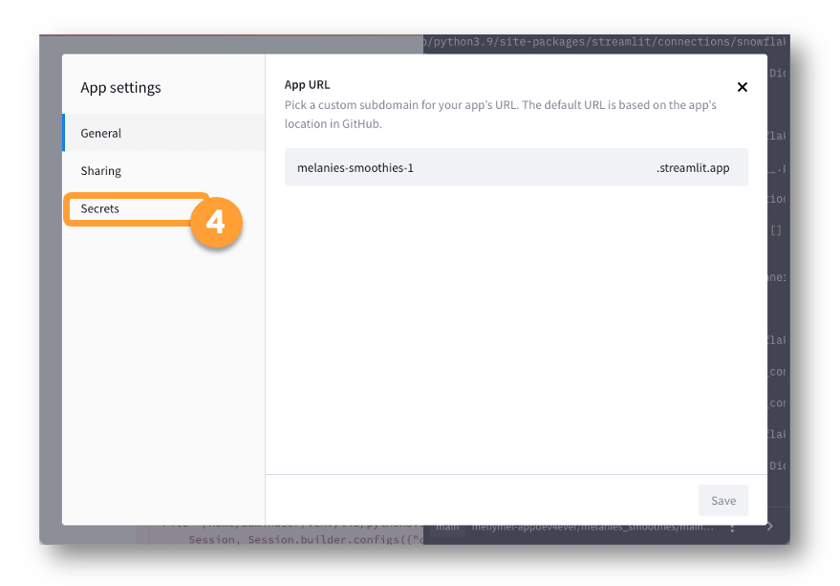

[connections.snowflake]

account = "SJB46229"

user = "nesanawsenter"

password = "youpR@1ndr0p"

role = "SYSADMIN"

warehouse = "COMPUTE_WH"

database = "SMOOTHIES"

schema = "PUBLIC"

client_session_keep_alive = true

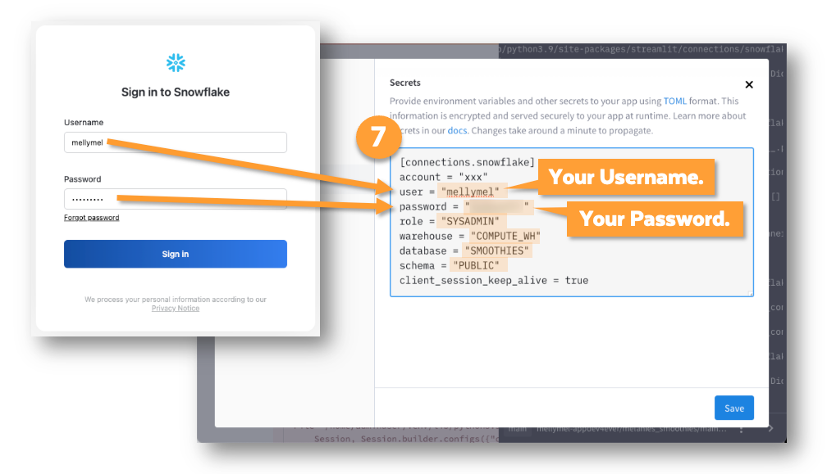

**Copy your Account Identifier.**

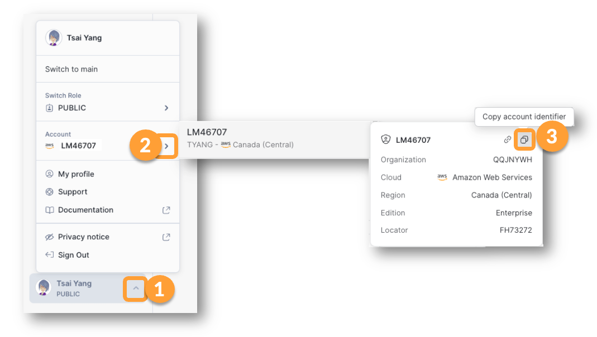

**📓 Adding the Requests Python Library to our SniS Project**

To add any package to a SniS app, you need two steps:

* + 1) Add the library to the **requirements.txt** file so that Streamlit knows to install it when starting up the project.
  + 2) Add the import statement to the body of the **streamlit_app.py** file so it is ready to be used in the code.

Keep these rules in mind also.

* + Anytime you change the **streamlit_app.py** file, and commit the changes in GitHub, the app will **automatically start using the changes**.
  + However, anytime you make changes to the **requirements.txt** file, you will need to **reboot** the app.

**🥋 Let's Call the Fruityvice API from Our SniS App!**

import requests

fruityvice_response = requests.get("https://fruityvice.com/api/fruit/watermelon")

st.text(fruityvice_response.json()) # Convert the response into Json

fv_df = st.dataframe(data= fruityvice_response.json(), use_container_width=True) # convert the response JSON into dataframe

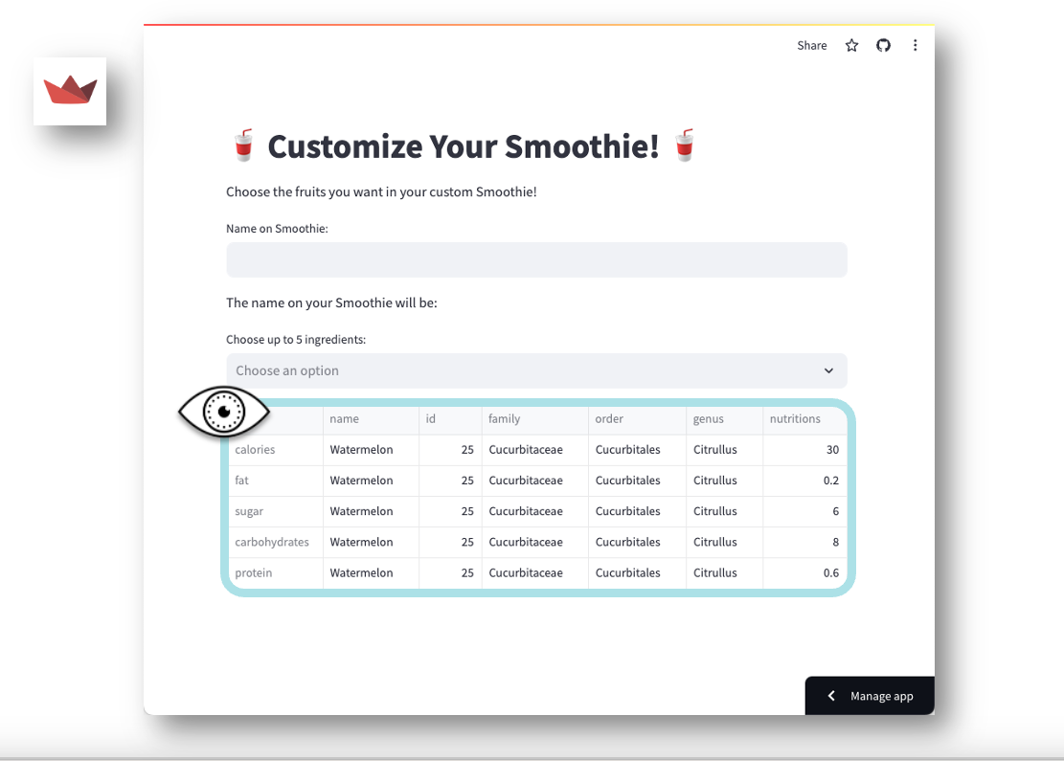

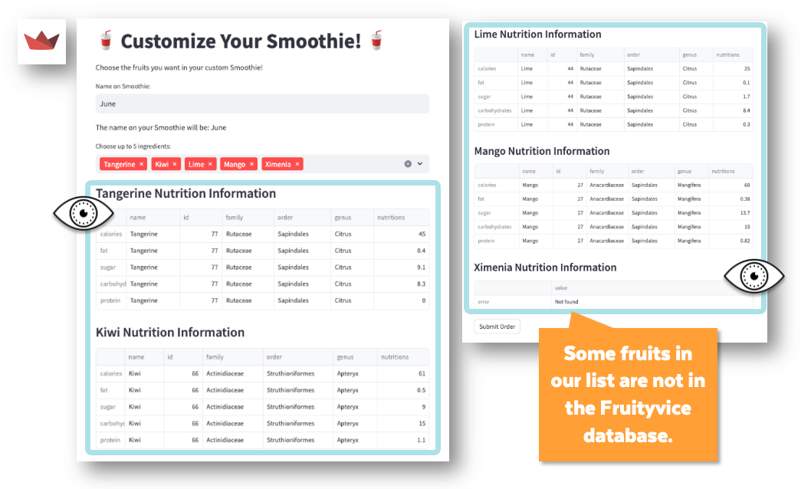

# Import python packages

import streamlit as st

import requests

#from snowflake.snowpark.context import get_active_session

from snowflake.snowpark.functions import col

# Write directly to the app

st.title(":cup_with_straw: Customize Your Smoothie! :cup_with_straw:")

st.write(

"""Choose the Fruits you want in your custome Smoothie!

"""

)

name_on_order = st.text_input('Name on Smoothie:')

st.write('The name on your Smoothie will be :', name_on_order)

cnx = st.connection("snowflake")

session = cnx.session()

#session = get_active_session()

# Instead of hardcoded choices bring data from table

# option = st.selectbox ('What is your Fav Fruit?',('Banana', 'Strawberries', 'Peaches') )

# st.write('Your Fav Fruit is : ', option)

# Fetch only the Fruit_name column from table

# my_dataframe = session.table("smoothies.public.fruit_options")

my_dataframe = session.table("smoothies.public.fruit_options").select(col('FRUIT_NAME'))

# Add a Multiselect instead of table display

#st.dataframe(data=my_dataframe,use_container_width=True)

ingredients_list = st.multiselect (

'Choose upto 5 ingredients:',

my_dataframe,

max_selections = 5

)

# Display the choices by customer only when atleast one fruit is selected

# Take all the choices as string in ingredients_string

if ingredients_list:

#st.write(ingredients_list)

#st.text(ingredients_list)

ingredients_string=''

for fruit_chosen in ingredients_list:

ingredients_string += fruit_chosen + ' '

st.subheader(fruit_chosen + 'Nutrition Information')

fruityvice_response = requests.get('https://fruityvice.com/api/fruit/' + fruit_chosen)

fv_df = st.dataframe(data= fruityvice_response.json(), use_container_width=True) # convert the response JSON into dataframe

st.text(fruityvice_response)

#st.write(ingredients_string)

my_insert_stmt = """ insert into smoothies.public.orders(ingredients,NAME_ON_ORDER)

values ('""" + ingredients_string + """','"""+ name_on_order + """')"""

#st.write(my_insert_stmt)

#st.stop()

time_to_insert = st.button("Submit Order")

#if ingredients_string:

if time_to_insert:

session.sql(my_insert_stmt).collect()

st.success('Your Smoothie is ordered!', icon="✅")

#st.write(my_dataframe.queries)

**DLKW Badge 4: Data Lake Workshop**

We can load the images into stage and use materialized views to make the image and metadata to behave like a table.

when we talk about "Stages" there are actually 3 parts. The cloud folder is the stage's storage location, the files within those locations are "staged data", and the objects we create in Snowflake are not locations, instead they are connections to cloud folders - which metaphorically can also be called "windows", or shown as loading bay doors on diagrams.

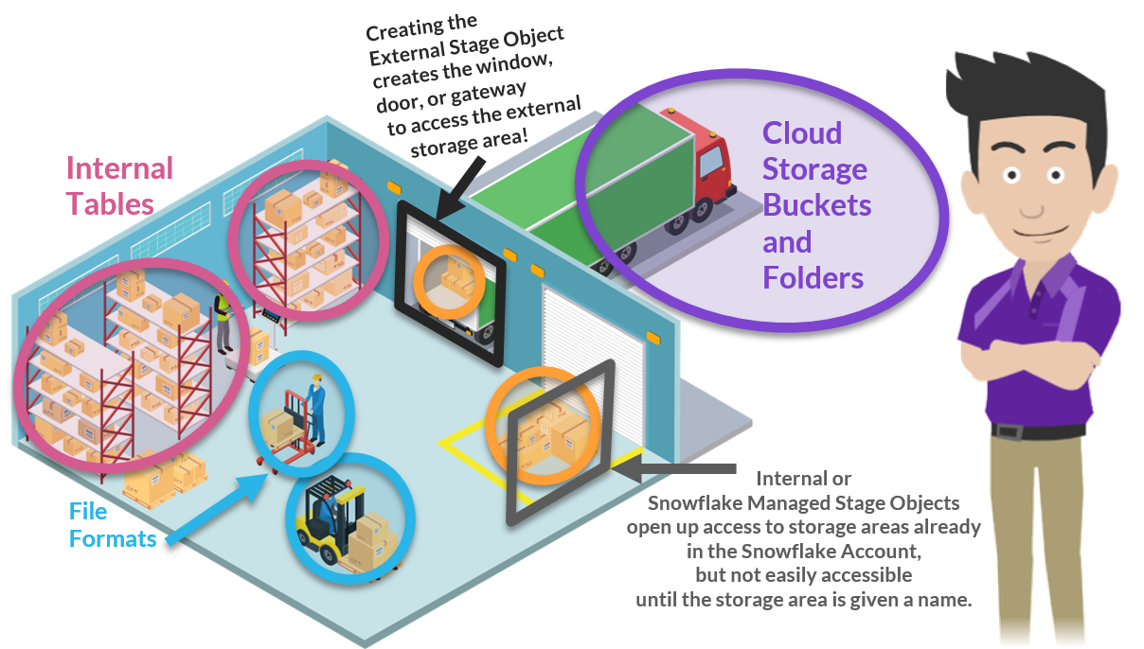

As it turns out, a Snowflake Stage Object can be used to connect to and access files and data you never intend to load.

Zena can create a stage that points to an external or internal bucket. Then, instead of pulling data through the stage into a table, she can reach through the stage to access and analyze the data where it is already sitting.

She does not have to load data, she can leave it where it is already stored, but still access it AND if she uses a File Format, she can make it appear almost as if it is actually loaded! (weird, but true!)

We already know that in the wider world of Data Warehousing, we can use the word "stage" to mean "a temporary storage location", and we can also use "stage" to mean a cloud folder where data is stored -- but now, more than ever, we should open our mind to the idea that a defined **Snowflake Stage Object** is most accurately thought of as a named gateway into a cloud folder where, presumably, data files are stored either short OR long term.

list @product_metadata;

list @zenas_athleisure_db.products.product_metadata;

select $1

from @product_metadata; -- Selects first column from all three files in the stage

-- One file at a time view first column

select $1

from @product_metadata/product_coordination_suggestions.txt; -- ^

select $1

from @product_metadata/sweatsuit_sizes.txt; -- ;

select $1

from @product_metadata/swt_product_line.txt; -- |

Snowflake hasn't been told anything about how the data in these files is structured so it's just making assumptions.  Snowflake is presuming that the files are CSVs because CSVs are a very popular file-formatting choice. It's also presuming each row ends with CRLF (Carriage Return Line Feed) because CRLF is also very common as a row delimiter.

Many data files use CRLF (Carriage Return Line Feed) as the record delimiter, so if a different record delimiter is used, the CRLF can end up displayed or loaded! When strange characters appear in your data, you can refine your select statement to deal with them.

SQL has a function, **CHR()** that will allow you to reference ASCII characters by their numbers.  So, **chr(13)** is the same as the **Carriage Return character** and**chr(10)** is the same as the **Line Feed character**.

In Snowflake, we can **CONCATENATE** two values by putting **||** between them (a double pipe). So we can look for CRLF by telling Snowflake to look for:

**chr(13)||chr(10)**

REPLACE($1, chr(13||char(10))

REPLACE($1, concat(chr(13),chr(10)))

REPLACE($1, '\r\n')

Select REPLACE($1, chr(13)||char(10)) as size, $2,$3

from @product_metadata/swt_product_line.txt

(file_format => zmd_file_format_2 );

File formats come in 6 flavors - CSV, JSON, XML, PARQUET, ORC, & AVRO. Notice that nothing in that list says "PDF" or "Image" or "PNG" or "JPG."

select REPLACE(relative_path, '_', ' ') as no_underscores_filename

, REPLACE(no_underscores_filename, '.png') as just_words_filename

, INITCAP(just_words_filename) as product_name

from directory(@sweatsuits);

Did you notice that Zena was able to define a column using the AS syntax, and then use that column name in the very next line of the same SELECT? This is not true in many other database systems and can be very convenient when developing complex syntax.

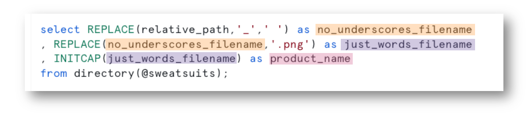

Same is achived by nesting the functions as below

select INITCAP(REPLACE(REPLACE(relative_path, '_', ' '),'.png')) as product_name

from directory(@sweatsuits);

Zena was able to use functions on the directory table, just as she would if it was a regular, internal Snowflake table.

Can she also join a directory table to a regular, internal Snowflake table?  She wants to try it. If that works, can she join the directory table and the regular internal table to one of the views she created earlier on the external staged data? She wants to try that, too!

We can do this with a quick CROSS JOIN.  Cross Joins are also called "cartesian products" and many times when data professionals talk about cartesian products they are describing a bad join that resulted in many more records than they intended.

Remember that Cross Joins are different than Outer Joins. While both joins can result in an "explosion" of rows, the resulting columns look different.

select *

from product_list p

cross join sweatsuit_sizes;

The Data Lake metaphor was introduced to the world in 2011 by James Dixon, who was the Chief Technology Officer for a company called Pentaho, at that time.

***If you think of a data mart as a store of bottled water -- cleansed and packaged and structured for easy consumption -- the data lake is a large body of water in a more natural state. The contents of the data lake stream in from a source to fill the lake, and various users of the lake can come to examine, dive in, or take samples.***

When we talk about Data Lakes at Snowflake, we tend to mean data that has not been loaded into traditional Snowflake tables. We might also call these traditional tables "native" Snowflake tables, or "regular" tables.

Structured and Semi-structured data that is sitting outside of Snowflake tables can be easily accessed and analyzed using familiar Snowflake tools like views, file formats, and SQL queries.

We've also seen how Unstructured data, not loaded into Snowflake, can be accessed with a special Snowflake tool called a Directory Table. We've also seen how Directory Tables can be used in combination with functions, joins, internal tables, and standard views to access that non-loaded data.

Depending on your role in a data-driven organization:

* You may have the power to move data into Snowflake tables, or you may not.
* You may have the power to update data already loaded in Snowflake tables, or you may not.
* You may have the power to copy data from one stage to another, or you may not.

Snowflake makes it possible for you to do WHAT you can, WHERE you can, because Snowflake keeps adding new HOW-You-Cans to the Snowflake toolset.

# Import python packages

import streamlit as st

from snowflake.snowpark.context import get_active_session

from snowflake.snowpark.functions import col

# Write directly to the app

st.title("Zean's Amazing Athleisure Catalog")

# Get the current credentials

session = get_active_session()

table_colors = session.sql("select color_or_style from catalog_for_website")

pd_colors = table_colors.to_pandas()

# Oyt the list of colors into a drop list selector

option = st.selectbox('Pick a sweatsuit color or style:', pd_colors)

product_caption = 'Our warm, comfortable, ' + option + ' sweatsuit!'

# use the color selected to go back and get all the info from the database

table_prod_data = session.sql("select file_name, price, size_list, upsell_product_desc, file_url from catalog_for_website where color_or_style = '" + option + "';")

pd_prod_data = table_prod_data.to_pandas()

df_sel = table_prod_data.filter(col('color_or_style')==option)

#st.write(pd_prod_data)

#st.write(type(pd_prod_data))

# assign each column of the row returned to its own variable

price = '$' + str(pd_prod_data['PRICE'].iloc[0])+'0'

file_name = pd_prod_data['FILE_NAME'].iloc[0]

size_list = pd_prod_data['SIZE_LIST'].iloc[0]

upsell = pd_prod_data['UPSELL_PRODUCT_DESC'].iloc[0]

url = pd_prod_data['FILE_URL'].iloc[0]

file_link="https://sjb46229.snowflakecomputing.com/api/files/ZENAS_ATHLEISURE_DB/PRODUCTS/SWEATSUITS/"+file_name

# display the info on the page

st.write(file_name)

st.write(file_link)

st.write(url)

#st.image(image=file_name, width=400, caption=product_caption)

st.image(image=url, width=400, caption=product_caption)

st.markdown('**Price:** '+ price)

st.markdown('**Sizes Available:** ' + size_list)

st.markdown('**Also Consider:** ' + upsell)

st.stop()

* Go to [www.openstreetmap.org](https://www.openstreetmap.org/)
* Go to WKT Playground located at: [clydedacruz.github.io/openstreetmap-wkt-playground/](https://clydedacruz.github.io/openstreetmap-wkt-playground/)

OpenStreetMap is an open source alternative to Google Maps that can be very handy for getting geospatial data displayed. Did you notice that both WKT Playground and the GeoJSON.io site use OpenStreetMap to display the data?

Melanie's Café isn't a real place but we'll choose a location to use for Mel's calculations. Cut and paste from below to see the chosen location in one or more of the mapping tools we've been using.

**GOOGLE MAPS:** 39.76471253574085, -104.97300245114094

**WKT PLAYGROUND:**POINT(-104.9730024511  39.76471253574)

**GEOJSON.IO:** Paste between the square brackets.

**{**

**"type": "Feature",**

**"properties": {**

**"marker-color": "#ee9bdc",**

**"marker-size": "medium",**

**"marker-symbol": "cafe",**

**"name": "Melanie's Cafe"**

**},**

**"geometry": {**

**"type": "Point",**

**"coordinates": [**

**-104.97300870716572,**

**39.76469906695095**

**]**

**}**

**}**

Basically, it means that you can have different ways of running the same function and Snowflake will figure out which way to run the UDF, based on what you send it. So if you send the UDF two numbers it will run our first version of the function and if you pass it one geography point, it will run the second version.

CREATE OR REPLACE FUNCTION distance_to_mc(lng_and_lat GEOGRAPHY)

RETURNS FLOAT

AS

$$

st_distance(

st_makepoint('-104.97300245114094','39.76471253574085')

,lng_and_lat

)

$$

;

CREATE OR REPLACE FUNCTION MELS_SMOOTHIE_CHALLENGE_DB.LOCATIONS.distance_to_mc(loc_lng number(38,32),loc_lat number(38,32))

RETURNS FLOAT

AS

$$

st_distance(

st_makepoint('-104.97300245114094','39.76471253574085')

,st_makepoint(loc_lng,loc_lat)

)

$$

;

Above two are overloaded functions with different arguments

But in our case, it's:

* Materialized Views, and
* External Tables, and
* Iceberg Tables!

In short, all of these objects are attempts to make your less-normalized (possibly non-loaded) data look and perform like more-normalized (possibly loaded) data.

**A Materialized View** is like a view that is frozen in place (more or less looks and acts like a table).

The big difference is that if some part of the underlying data changes,  Snowflake recognizes the need to refresh it, automatically.

People often choose to create a materialized view if they have a view with intensive logic that they query often but that does NOT change often.  We can't use a Materialized view on any of our trails data because you can't put a materialized view directly on top of staged data.  But. You CAN put a Materialized View over an External Table, even if that External Table is based on a Stage!!

In other words, you CAN put a Materialized View over staged data, as long as you put an External Table in between them, first!

**An External Table** is a table put over the top of non-loaded data (sounds like our recent views, right?).

An External Table points at a stage folder(yep, we know how to do that!) and includes a reference to a file format (or formatting attributes) much like what we've been doing with our views for most of this workshop! Seems very straightforward and something within reach-- given what we've already learned in this workshop!

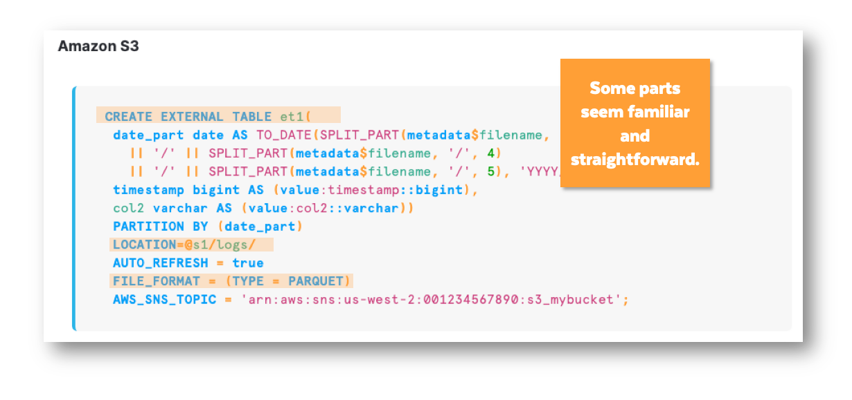

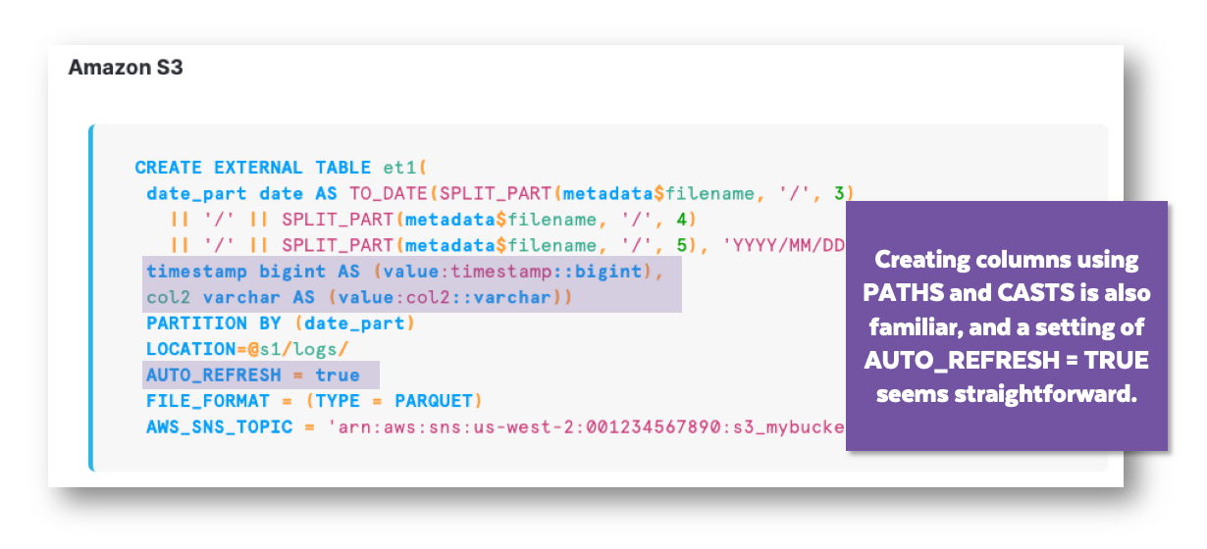

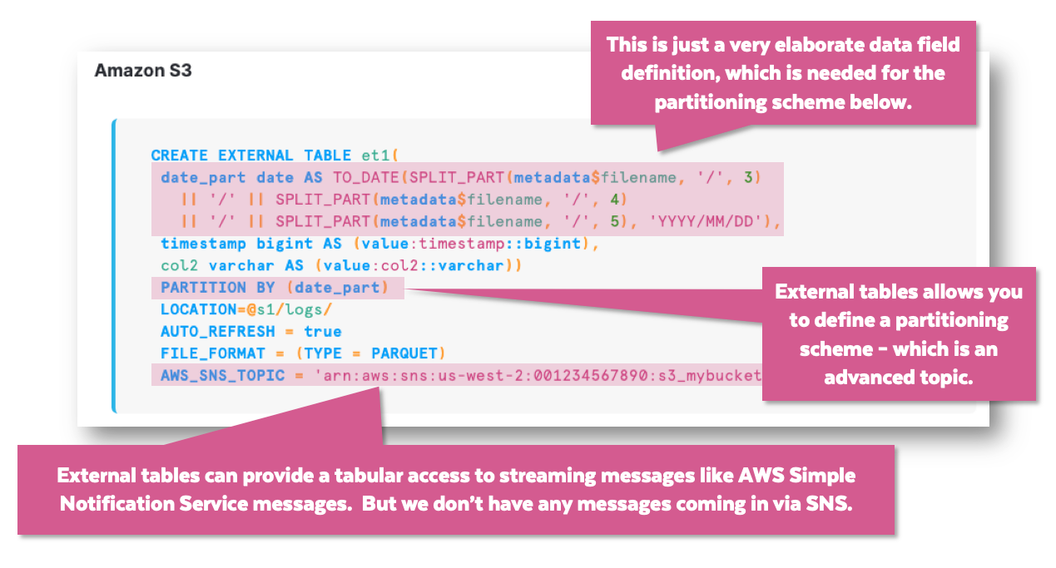

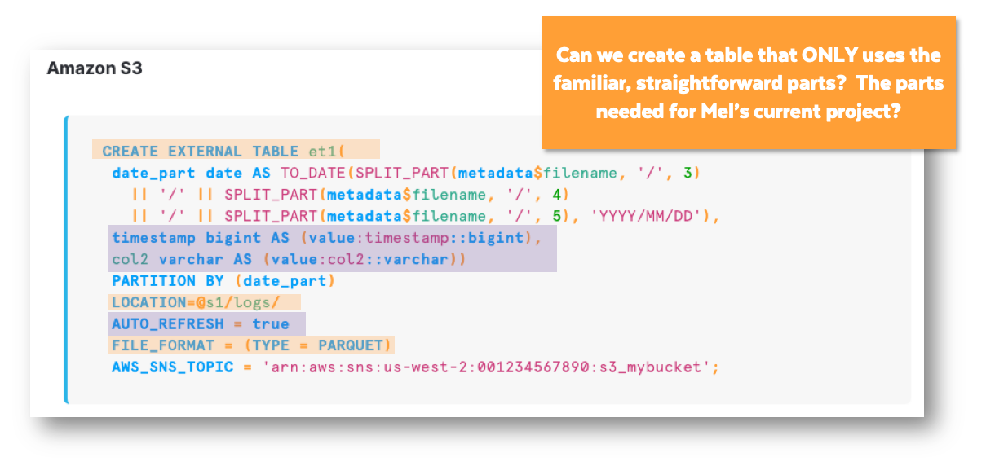

As you might suspect from the name, External tables were actually created with External Storage in mind.  Below gives error **Cannot use internal stage TRAILS_PARQUET as the location for an external table.**

create or replace external table T_CHERRY_CREEK_TRAIL(

my_filename varchar(100) as (metadata$filename::varchar(100))

)

location= @trails_parquet

auto_refresh = true

file_format = (type = parquet);

But most of the time organizations avoid loading data because:

* + They don't want to fully denormalize it yet, or
  + They can't move the data into Snowflake for security or governance reasons, or
  + They don't want multiple copies of data and the data has to be available to some other system, or
  + They're trying to avoid vendor lock in with Snowflake.

So most of the time, when engineers choose not to load data into Snowflake, it's being stored outside of Snowflake and the tools you've been learning help them do just that.

Externally stored data is usually in Azure Blob storage, GCP Buckets or AWS S3 Buckets.

In the Essentials Badge Workshops, we try not to make you sign up for Azure, GCP or AWS accounts so whenever we step outside of Snowflake, we often do that work for you, and have you follow steps that simulate parts of the process.

In this case, we have set up an AWS S3 bucket and loaded the same Cherry Creek Trail Parquet file into it. That way, you can continue exploring External Tables, without setting up your own AWS account.

**🥋 Create a Materialized View Version of Our New External Table**

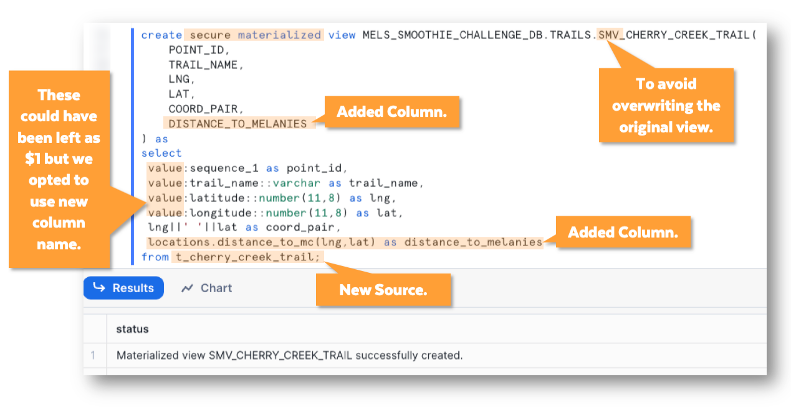

create secure materialized view MELS_SMOOTHIE_CHALLENGE_DB.TRAILS.SMV_CHERRY_CREEK_TRAIL(

POINT_ID,

TRAIL_NAME,

LNG,

LAT,

COORD_PAIR,

DISTANCE_TO_MELANIES

) as

select

value:sequence_1 as point_id,

value:trail_name::varchar as trail_name,

value:latitude::number(11,8) as lng,

value:longitude::number(11,8) as lat,

lng||' '||lat as coord_pair,

locations.distance_to_mc(lng,lat) as distance_to_melanies

from t_cherry_creek_trail;

Iceberg is an open-source table type. The Apache Iceberg technology is owned by Apache and provided using an open-source license.  Iceberg Tables are a layer of functionality you can lay on top of parquet files (just like the Cherry Creek Trails file we've been using) that will make files behave more like loaded data. In this way, it's like a file format, but also MUCH more.

Iceberg Table data that can be editable via Snowflake! Read that again. Not just the tables are editable (like the table name), but the data they make available (like the data values in columns and rows). So, you will be able to create an Iceberg Table in Snowflake, on top of a set of parquet files that have NOT BEEN LOADED into Snowflake, and then run INSERT and UPDATE statements on the data using SQL 🤯.

* **We DID** create a bucket named **uni-dlkw-iceberg**. It is publicly viewable (like most the buckets we create for badge courses).
* **We DID** create a policy that grants access to our **uni-dlkw-iceberg** bucket. We named our policy **dlkw-iceberg-learner-access-policy**.
* **We DID** create a role named **dlkw_iceberg_role** and for the External ID we used **dlkw_iceberg_id.**
* **When** it was time to create an external volume, **we copied the code and edited it for you so that you can run it**.

Think of an external volume like an external hard drive of the 1990's. It's just a block of storage and in this case it is outside of Snowflake (but still in the cloud)

**🥋 Create an External Volume**

For the remainder of this workshop, you should do your work using the **ACCOUNTADMIN** Snowflake role.

-- For the remainder of this workshop, you should do your work using the ACCOUNTADMIN Snowflake role.

CREATE OR REPLACE EXTERNAL VOLUME iceberg_external_volume

STORAGE_LOCATIONS =

(

(

NAME = 'iceberg-s3-us-west-2'

STORAGE_PROVIDER = 'S3'

STORAGE_BASE_URL = 's3://uni-dlkw-iceberg'

STORAGE_AWS_ROLE_ARN = 'arn:aws:iam::321463406630:role/dlkw_iceberg_role'

STORAGE_AWS_EXTERNAL_ID = 'dlkw_iceberg_id'

)

);

DESC EXTERNAL VOLUME iceberg_external_volume;

-- {"NAME":"iceberg-s3-us-west-2","STORAGE_PROVIDER":"S3","STORAGE_BASE_URL":"s3://uni-dlkw-iceberg","STORAGE_ALLOWED_LOCATIONS":["s3://uni-dlkw-iceberg/*"],"STORAGE_AWS_ROLE_ARN":"arn:aws:iam::321463406630:role/dlkw_iceberg_role","STORAGE_AWS_IAM_USER_ARN":"arn:aws:iam::841162691199:user/ejvr0000-s","STORAGE_AWS_EXTERNAL_ID":"dlkw_iceberg_id","ENCRYPTION_TYPE":"NONE","ENCRYPTION_KMS_KEY_ID":""}

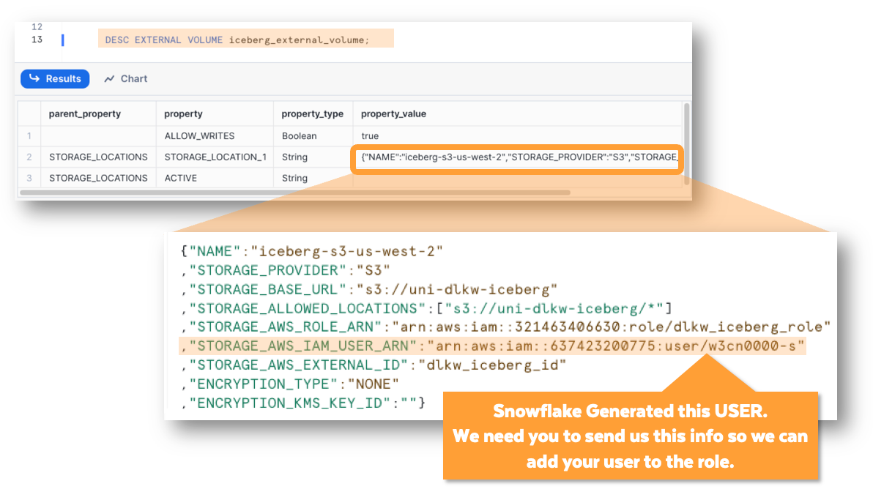

**📓  Apache Iceberg Tables**

* Iceberg is an open-source table type. The Apache Iceberg technology is owned by Apache and provided using an open-source license.
* Iceberg Tables are a layer of functionality you can lay on top of parquet files (just like the Cherry Creek Trails file we've been using) that will make files behave more like loaded data. In this way, it's like a file format, but also MUCH more.
* Iceberg Table data that can be editable via Snowflake! Read that again. Not just the tables are editable (like the table name), but the data they make available (like the data values in columns and rows). So, you will be able to create an Iceberg Table in Snowflake, on top of a set of parquet files that have NOT BEEN LOADED into Snowflake, and then run INSERT and UPDATE statements on the data using SQL 🤯.

Iceberg tables in Snowflake will make it possible to edit Parquet files using INSERT and UPDATE statements.

* **We DID** create a bucket named **uni-dlkw-iceberg**. It is publicly viewable (like most the buckets we create for badge courses).
* **We DID** create a policy that grants access to our **uni-dlkw-iceberg** bucket. We named our policy **dlkw-iceberg-learner-access-policy**.
* **We DID** create a role named **dlkw_iceberg_role** and for the External ID we used **dlkw_iceberg_id.**
* When it was time to create an external volume, **we copied the code and edited it for you so that you can run it**. Think of an external volume like an external hard drive of the 1990's.

**🥋 Create an External Volume**

CREATE OR REPLACE EXTERNAL VOLUME iceberg_external_volume

STORAGE_LOCATIONS =

(

(

NAME = 'iceberg-s3-us-west-2'

STORAGE_PROVIDER = 'S3'

STORAGE_BASE_URL = 's3://uni-dlkw-iceberg'

STORAGE_AWS_ROLE_ARN = 'arn:aws:iam::321463406630:role/dlkw_iceberg_role'

STORAGE_AWS_EXTERNAL_ID = 'dlkw_iceberg_id'

)

);

DESC EXTERNAL VOLUME iceberg_external_volume;



create database my_iceberg_db

catalog = 'SNOWFLAKE'

external_volume = 'iceberg_external_volume';

set table_name = 'CCT_'||current_account();

create iceberg table identifier($table_name) (

point_id number(10,0)

, trail_name string

, coord_pair string

, distance_to_melanies decimal(20,10)

, user_name string

)

BASE_LOCATION = $table_name

AS SELECT top 100

point_id

, trail_name

, coord_pair

, distance_to_melanies

, current_user()

FROM MELS_SMOOTHIE_CHALLENGE_DB.TRAILS.SMV_CHERRY_CREEK_TRAIL;

select $table_name;

select current_user();

select * from CCT_SJB46229;

create iceberg table identifier($table_name) (

point_id number(10,0)

, trail_name string

, coord_pair string

, distance_to_melanies decimal(20,10)

, user_name string

)

BASE_LOCATION = $table_name

AS SELECT top 100

point_id

, trail_name

, coord_pair

, distance_to_melanies

, current_user()

FROM MELS_SMOOTHIE_CHALLENGE_DB.TRAILS.SMV_CHERRY_CREEK_TRAIL;

select * from CCT_SJB46229;

-- Same as above query

select * from identifier($table_name);

update identifier($table_name)

set user_name = 'I am amazing!!'

where point_id = 1;

update identifier($table_name)

set TRAIL_NAME = 'I am amazing!!'

where point_id = 1;

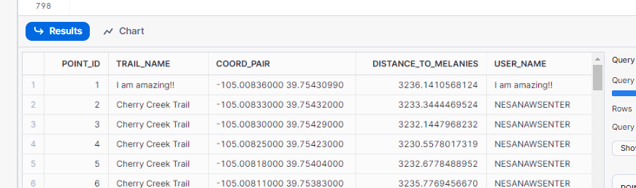

Snowflake's new Iceberg features give your C-Suite confidence that they are not locked in with Snowflake -- if that's something they are worried about. They can store the data outside of Snowflake when that makes the most sense for a particular data set, without giving up all the things that make Snowflake easy to learn and easy to use.

Even while your trial account has a default time zone of "America/Los_Angeles" (UTC-7), you can change the time zone of each worksheet, independently.

In many organizations, a Data Engineer is given access to extracted data, and told what the end goals are (the final, transformed state). Then, it is within their power and discretion to decide what steps they will follow to get there.   
  
These choices are called "design" and the structures and processes that result are called the "architecture." In this workshop we'll give you hands-on experience with the components, but design and architecture decisions are something it takes years to learn and we don't attempt to teach them in this beginner course.

The team discusses alternative ways to get time zone information for each gamer.  Kishore notes that IP Addresses can be geo-located and that geolocation can be used to infer a time zone.

Agnie mentions that the use of VPNs can mess up IP Geolocation. That's a problem, but the team agrees that using the IP address, even with the VPN issue, is better than not having any time zone information at all.

After running a query, especially one that he plans to run often, Kishore will need to make sure it will be "performant." He can do that by examining the Query Profile of any command he runs.  Let's run some commands that might not perform all that well and then look at the query profiles for each.

**🥋 View the Query Profile of the Code You Just Ran**

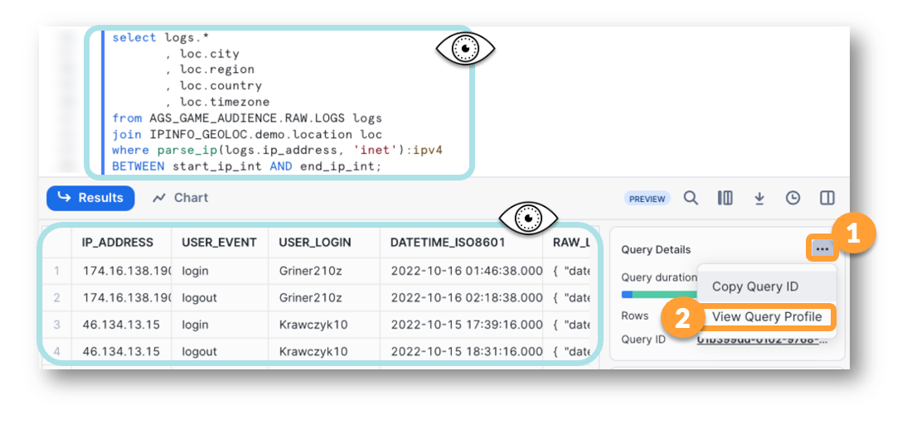

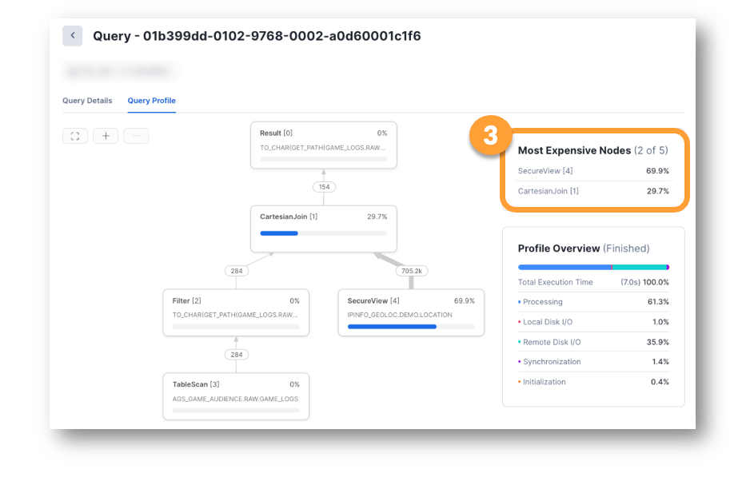

**NOTE:** If you run the query more than once, the profile the second time around (and 3rd, 4th, 5th, etc) will be very different. This is due to CACHING. Please see our Level Up on Caching if you would like to understand Caching in Snowflake better.

Query profile of same query during second run

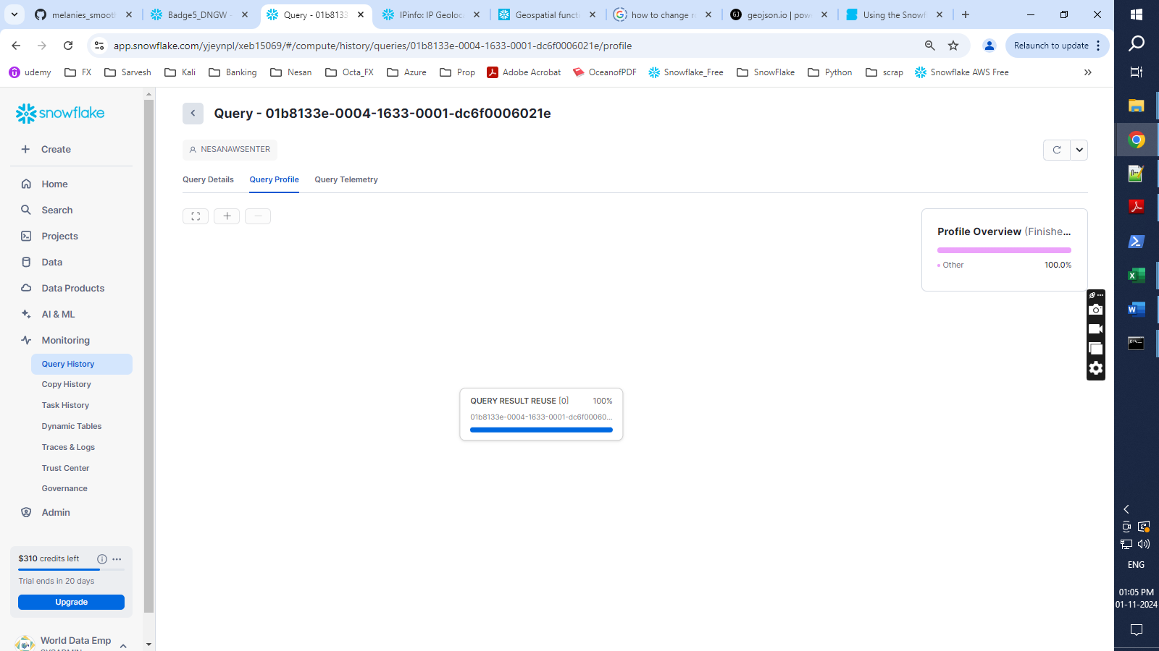

**📓 Functions As Part of the Share**

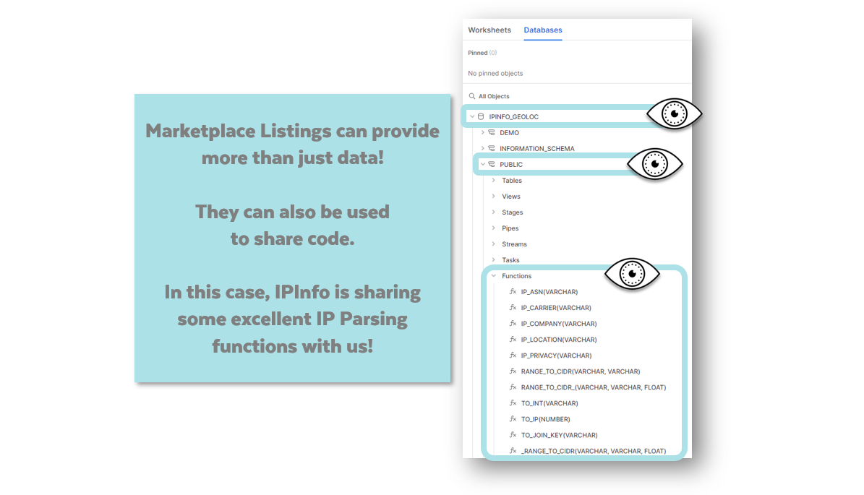

We are especially interested in using two of the functions IPInfo has provided to us.

* The **TO_JOIN_KEY** function reduces the IP down to an integer that is helpful for joining with a range of rows that might match our IP Address.
* The **TO_INT** function converts IP Addresses to integers so we don't have to try to compare them as strings!

--Use two functions supplied by IPShare to help with an efficient IP Lookup Process!

SELECT logs.ip_address

, logs.user_login

, logs.user_event

, logs.datetime_iso8601

, city

, region

, country

, timezone

from AGS_GAME_AUDIENCE.RAW.LOGS logs

JOIN IPINFO_GEOLOC.demo.location loc

ON IPINFO_GEOLOC.public.TO_JOIN_KEY(logs.ip_address) = loc.join_key

AND IPINFO_GEOLOC.public.TO_INT(logs.ip_address)

BETWEEN start_ip_int AND end_ip_int;

**🥋 Create a Simple Task**

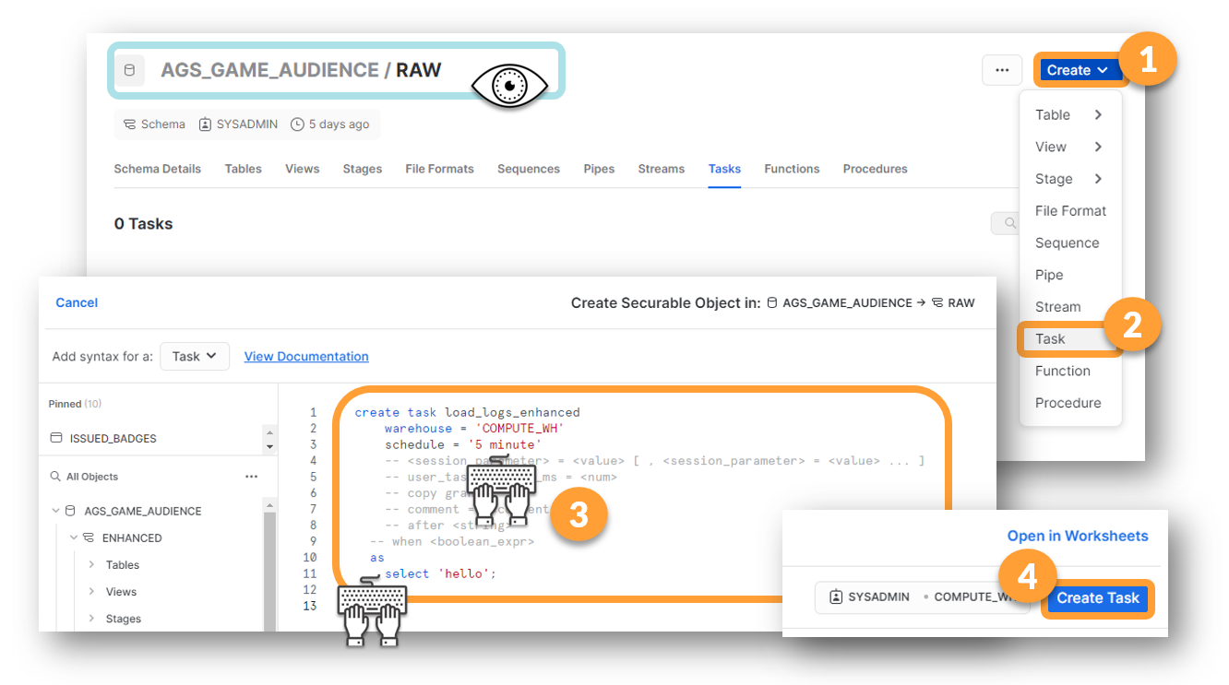

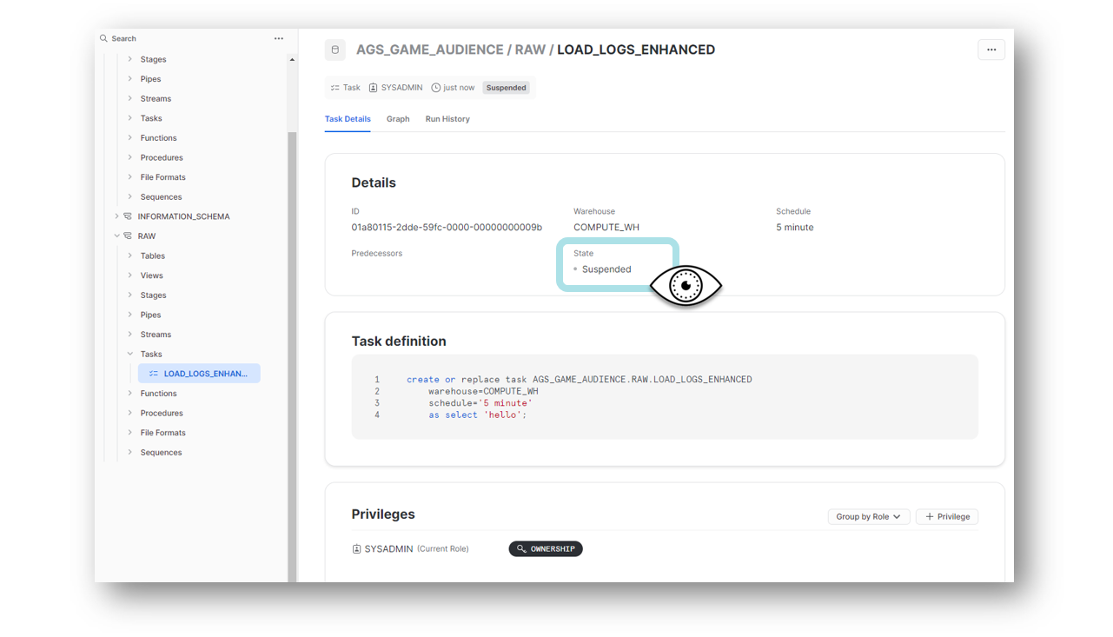

This is where we learn a new, fancy term: IDEMPOTENCY.

In short, it means, Kishore can't just write cool stuff that loads data, he has to design a solution that ONLY loads each record one time.

Snowflake has some built in help for IDEMPOTENCY, especially when the file is first picked up from the stage, and we'll talk more about how Snowflake can help with that, but right now we'll focus on making this particular step IDEMPOTENT.

**📓 Rebuild and Replace**

Another method that was used in the early days of data warehousing was a database replace. A whole new warehouse would be built each night and when it was complete, the old one would be given an archival name, and the new one would be given the standard name.

Cloning is a very powerful tool, doesn't cost much, and doesn't take long. Cloning is more efficient than copying (you can read more about cloning at [docs.snowflake.com](https://docs.snowflake.com/)).   Snowflake has the ability to CLONE databases, schemas, tables

We can also use cloning to make back ups of things we feel more comfortable having a safe copy of while we are in heavy development. Let's make a back up copy of our LOGS_ENHANCED table.  We're about to start testing some complex logic and we might want to look back at this table, later.

**🥋 Create a Backup Copy of the Table**

--clone the table to save this version as a backup  
--since it holds the records from the UPDATED FEED file, we'll name it _UF  
create table ags_game_audience.enhanced.LOGS_ENHANCED_UF   
clone ags_game_audience.enhanced.LOGS_ENHANCED;

-- Here's some merge code we can start with:

MERGE INTO ags_game_audience.ENHANCED.LOGS_ENHANCED e

USING ags_game_audience.RAW.LOGS r

ON r.user_login = e.GAMER_NAME

AND r.datetime_iso8601 = e.GAME_EVENT_UTC

AND r.user_event = e.GAME_EVENT_NAME

WHEN MATCHED THEN

UPDATE SET IP_ADDRESS = 'Hey I updated matching rows!';

If we had not used the CLONE feature to make a copy of the table, we could use TIME TRAVEL to go back to the table right before we wiped out all the IP_ADDRESS values. Check out the documentation for TIME TRAVEL if you are interested in learning more.  The combination of CLONING and TIME TRAVEL can help you fix a lot of otherwise disastrous mistakes!!

**📓 Merges Are Powerful**

You've just seen a merge example that could be called an UPDATE MERGE. Now we'll write an INSERT MERGE. These aren't really two different things, just two different ways of using a MERGE.

Be aware that you can write very complex merge statements that do lots of things at one time. A single MERGE statement can insert new rows, update changed rows, and delete other rows.

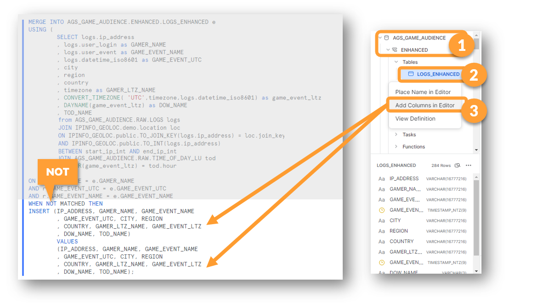

-- Insert merge

MERGE INTO ENHANCED.LOGS_ENHANCED e

USING (

SELECT logs.ip_address

, logs.user_login as GAMER_NAME

, logs.user_event as GAME_EVENT_NAME

, logs.datetime_iso8601 as GAME_EVENT_UTC

, city

, region

, country

, timezone as GAMER_LTZ_NAME

, CONVERT_TIMEZONE( 'UTC',timezone,logs.datetime_iso8601) as game_event_ltz

, DAYNAME(game_event_ltz) as DOW_NAME

, TOD_NAME

from ags_game_audience.raw.LOGS logs

JOIN ipinfo_geoloc.demo.location loc

ON ipinfo_geoloc.public.TO_JOIN_KEY(logs.ip_address) = loc.join_key

AND ipinfo_geoloc.public.TO_INT(logs.ip_address)

BETWEEN start_ip_int AND end_ip_int

JOIN ags_game_audience.raw.TIME_OF_DAY_LU tod

ON HOUR(game_event_ltz) = tod.hour

) r --we'll put our fancy select here

ON r.GAMER_NAME = e.GAMER_NAME

and r.GAME_EVENT_UTC = e.game_event_utc

and r.GAME_EVENT_NAME = e.game_event_name

WHEN NOT MATCHED THEN

insert (IP_ADDRESS, GAMER_NAME, GAME_EVENT_NAME, GAME_EVENT_UTC, CITY, REGION, COUNTRY, GAME_EVENT_LTZ, DOW_NAME, TOD_NAME) --list of columns

values (IP_ADDRESS, GAMER_NAME, GAME_EVENT_NAME, GAME_EVENT_UTC, CITY, REGION, COUNTRY, GAME_EVENT_LTZ, DOW_NAME, TOD_NAME) --list of columns (but we can mark as coming from the r select)

;

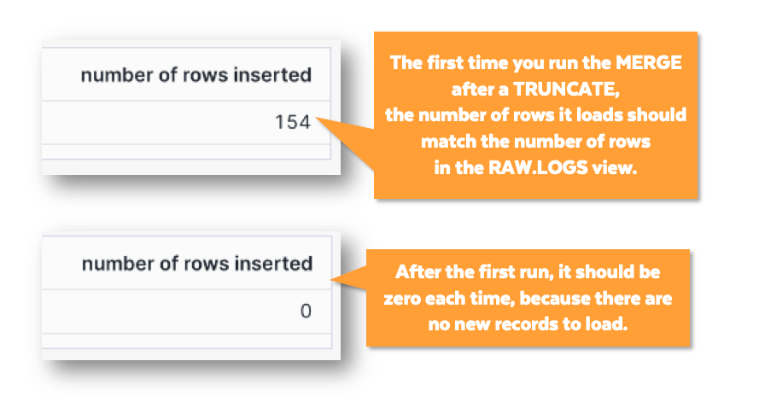

By "data pipeline" we mean:

* A series of steps...
* that move data from one place to another...
* in a repeated way.

**📓 Idempotent COPY INTO**

So, did you notice that the **COPY INTO** is smart enough to know which files it already loaded and it doesn't load the same file, twice?

Snowflake is designed like this to help you. Without any special effort on your part, you have a process that doesn't double-load files.  In other words, it automatically helps you keep your processes IDEMPOTENT.

**But, what if, for some crazy reason, you *wanted* to double-load your files?**

You could add a **FORCE=TRUE;** as the last line of your **COPY INTO** statement and then you would double the number of rows in your table.

**Then, what if you wanted to start over and load just one copy of each file?**

You could **TRUNCATE TABLE PL_GAME_LOGS;** , set **FORCE=FALSE** and run your **COPY INTO** again.